HOW CAN I HELP?

The Heritage Lottery Fund want to see whether people living in the local community are signed up to supporting any venture they invest in. Likewise the Diocese want to see that any changes made to the building are justifiable and likely to attract use by the people who live nearby. The more we can demonstrate interest and involvement the better.

- Right now, we need donations, preferably regular, to complete the work in the Lady Chapel and the Chancel as this would encourage commitments from funding bodies. In the future, for a project of the size being considered for the nave and the kitchen, we would have to raise 5% of the cost to receive ‘matched funding’. Information about how you can help in this way is included as an insert with this leaflet.

- We need volunteers and helpers. Do you have any particular practical skills or experience that might be of value to the project as it moves on?

- Can your organisation see a potential use for the renewed Lady Chapel and also the large space created by the removal of pews? Can you summarise this and send us even as little as a simple statement about how you might see St Paul’s Church offering a venue that you might use?

- Would you like to receive an occasional email updating you on progress or letting you know when we need some specific help? An email distribution list is good evidence of community support.

If you have any comments, questions, offers of help, particular skills or would like to see relevant documentation described here then please contact Heather Bayly (heather@bayly.org). If you think you can help with fundraising events, then please contact Maggie Booth on maggieboothphoto@gmail.com.
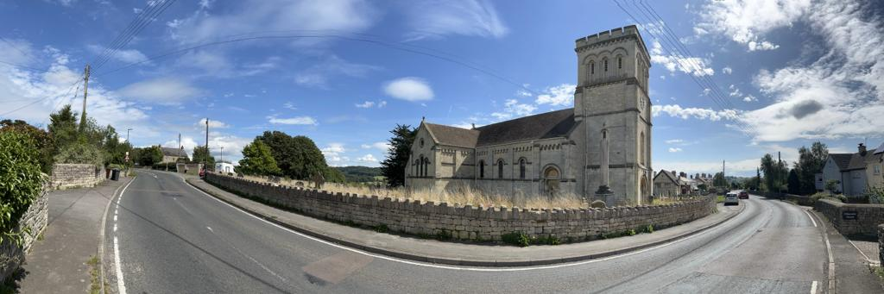
Version 7 April 2026
Photo by Rev Simon Howell

WHAT ARE THE PLANS FOR ST PAUL’S CHURCH?

INTRODUCTION

‘We need a warm comfortable building for worship, and a welcoming flexible space for the whole community’

Following the failure of the oil tanks, there has been no heating in the church since October 2021, the building is deteriorating, and the congregations are very small now. A group has formed to take plans for improvements forward to make the building not just a centre for worship, memorial services and festivals but a space that the whole community might want to use for a wider range of activities. The building is valued and without such a radical change it is difficult to see a long-term future for St Paul’s. Any changes proposed need to have the support and permission of the Diocesan Advisory Committee (DAC).

PROPOSED CHANGES NOW

The first priority, installing heating in the Lady Chapel, was achieved in February 2026 with help of a Diocesan grant and our dedicated team of fund-raisers. The control of this system will be much easier when we also have WiFi. This would also support the use of the Lady Chapel for small group meetings, and multimedia during services now that we have a Church Video License and a projector and screen thanks to a grant from the Parish Council. A number of activities beyond worship have been suggested such as a toddler group, hobby clubs, a children’s library, a homeschooling centre, and a venue for talks or workshops.

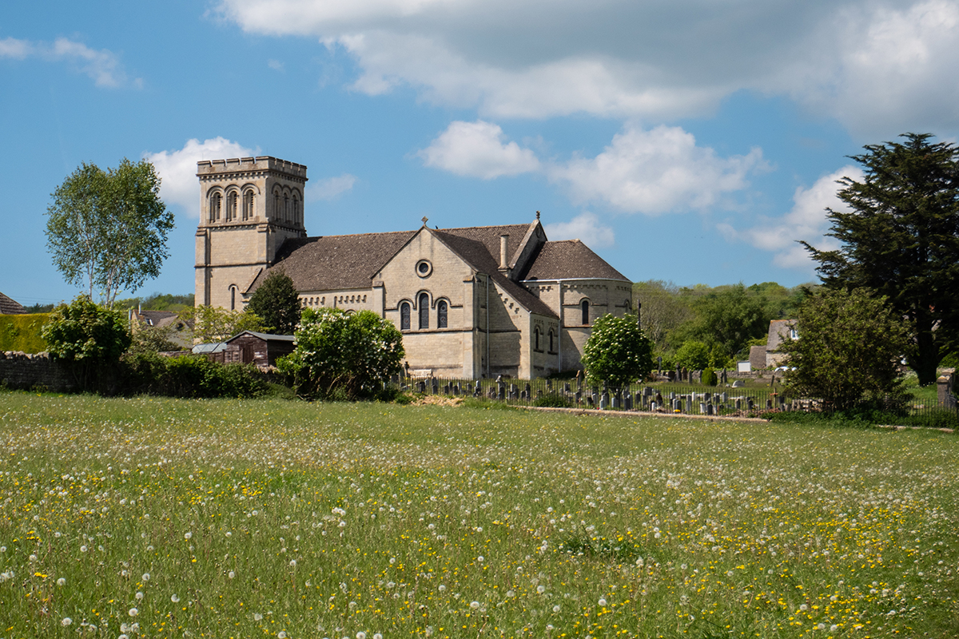
Various types of electric heaters were considered as fossil fuel systems are rightly no longer permitted by the Diocese. The preferred solution chosen for the Lady Chapel are specialist panel convector radiators (ChurchEcoMiser). The electrical supply was inadequate and so a new submain has been installed. There is some damp penetration, and we are planning to carry out some repairs to the building in the future, particularly the copings on the south gable and finally give it a coat of paint.

PROPOSED CHANGES IN THE FUTURE

Having met with the DAC and the local representative from the Heritage Lottery Fund (HLF), we have been led to believe that the vision, described right at the start of this leaflet, could become a reality, but only if we have community support.

The Chancel
The wall paintings by the Stanton sisters in the sanctuary are historically important and affected by damp penetration. If visiting the church, you will find an information point in the chancel up by the altar describing the background to these paintings. The Heritage Lottery Fund who invested heavily in the restoration of the organ, which is also suffering from high humidity, are keen to support renovation in this area. Nonetheless it is worth commissioning a condition survey by an expert in this area of specialist restoration. We have received a grant covering most of the cost of this from Church Care and when they read the resulting report, have offered to pay for a specialist building environment performance assessment. They indicated we would be eligible for a grant towards the identified conservation work.

The kitchen area
This is situated in the outer vestry and is in a terrible state of repair. While we would want better designed and modern kitchen facilities as part of the long-term renovation of the building, it is clear that an interim measure is going to be necessary to support small groups using the Lady Chapel or when large church events are held. We propose seeking out salvaged kitchen furniture to create a hygienic area from which to serve cold food and hot drinks.

The Nave
The DAC members seemed to be entirely supportive of proposals to remove the pews and provide a cleared space in the nave with flexible seating, provided we can justify it. There have been lots of ideas about how the space could be used. A fundamental repurposing of the largest space in the building would mean professional involvement for a proper measured survey by an architect with experience of historic buildings. It is especially important to understand the relationship between internal floor levels and external ground levels. It will be necessary to design an appropriate heating system. Suggestions include ‘air-sourced’ heat pumps, overhead far-infrared ‘Halo’ units, underfloor heating and panel radiators. All have their advantages and disadvantages. A 3-phase electrical supply would be needed, possibly supplemented with solar panels and battery storage. The job would also require input from a paid project lead and require grant applications. It is likely also there will be a need for structural engineers, quantity surveyors, ecologists and archaeologists, among others. The costs would be very high. The different stages of the overall project are summarised in the annotated floor plan that is available for download from the web page https://www.achurchnearyou.com/church/14068/news/.

Background photo by Maggie Booth

