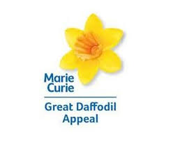
Tea and Cakes in aid of Marie Curie

Please come and join us for tea/coffee and delicious homemade cakes.
Also cakes to buy and a raffle to win.
Saturday 18th April
4pm
Back of St Thomas Church
Tea and Cakes in aid of Marie Curie

Please come and join us for tea/coffee and delicious homemade cakes.
Also cakes to buy and a raffle to win.
Saturday 18th April
4pm
Back of St Thomas Church
Tea and Cakes in aid of Marie Curie

Please come and join us for tea/coffee and delicious homemade cakes.
Also cakes to buy and a raffle to win.
Saturday 18th April
4pm
Back of St Thomas Church
Tea and Cakes in aid of Marie Curie

Please come and join us for tea/coffee and delicious homemade cakes.
Also cakes to buy and a raffle to win.
Saturday 18th April
4pm
Back of St Thomas Church

