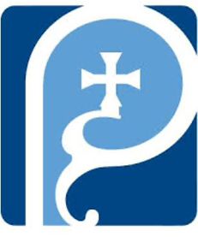
St Augustine of Hippo
Grimsby

A Forward in Faith Parish

Parish Magazine



April 2026

Our Giving
Bank details for standing orders or donations are:
TSB Bank
St Augustine of Hippo PCC
Sort Code: 30-93-72 Account Number: 00159954

You may have seen that many charity bank accounts have started
charging fees for every day transactions. It costs us money to bank cheques and cash, which devalues the amount of the donation/payment. We are therefore asking that, wherever possible, people donate money using online banking, even for small amounts. This doesn't cost us a penny. Please indicate in the reference field who it's from, and what for, then we can Gift Aid your donation wherever possible. Gift aid forms should be completed for regular giving by standing order if applicable. Thank you.


Donating by card or phone

We have a card machine positioned at the back of church near the south door as an alternative way of giving. Please bear in mind that a percentage of all giving using this method (between 1% and 2%) is taken by the provider.

Regular Sunday giving by oﬀertory collection plate


It is no longer necessary to use gift aid envelopes for cash donations of £30 or less. This again keeps administration down. However, should you wish to make a higher donation, please use gift aid envelopes as usual.
Anniversary of Deaths / Year’s Mind Parish Records for April
Date Year Forename Surname Age
2 Christine Read
3 2015 Reg Piper
9 2024 Jackie Piper
10 2024 Stuart Dixon
11 2011 Kenneth Ellis 86
14 2013 Laurence James 84
14 1961 Lavinia Cullum
20 1994 Elsie Maud Goldberg 92
22 1982 Mary Rebecca Maria Kendall 72

If you have any additional information to complete any gaps for those
listed, or information relating to anyone you know of who should be
included please let me know on mrs.maria.mason@gmail.com

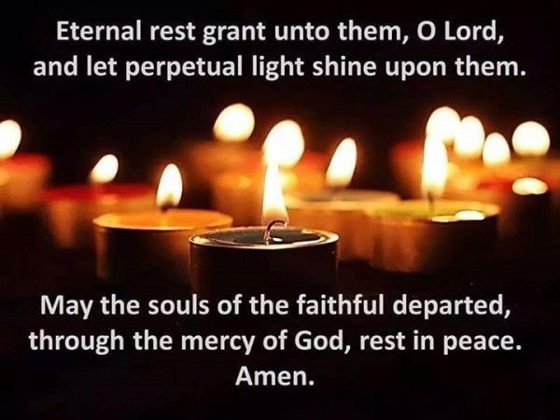

April Worship Times

Holy Week
Wednesday 1 April 6.30pm Said Mass
Thursday 2 April 7pm Mass of the Last Supper with Foot Washing
Friday 3 April 11am Stations of the Cross
3pm Good Friday Liturgy
Saturday 4 April 7pm Easter Vigil

Easter Week
Sunday 5 April 10am Sung Parish Mass
Wednesday 8 April 10am Said Mass

Second Week of Easter
Sunday 12 April 10am Sung Parish Mass
5pm Evensong and Benediction
Tuesday 13 April 6.30pm Said Mass
Wednesday 14 April 10am Said Mass followed by Coffee Morning

Third Week of Easter
Sunday 19 April 10am Sung Parish Mass
Tuesday 21 April 6.30pm Said Mass
Wednesday 22 April 10am Said Mass followed by Coffee Morning

Fourth Week of Easter
Sunday 26 April 10am Sung Parish Mass
Tuesday 28 April 6.30pm Said Mass
Wednesday 29April 6.30pm Said Mass


April 2026 Calendar
Dates, Observances and Prayer Intentions
Month of Devotion The Blessed Sacrament
Date Feast Intentions
1 Wednesday of Holy Week The Parish
2 Maundy Thursday The Parish
3 Good Friday The Parish
4 Holy Saturday The Parish
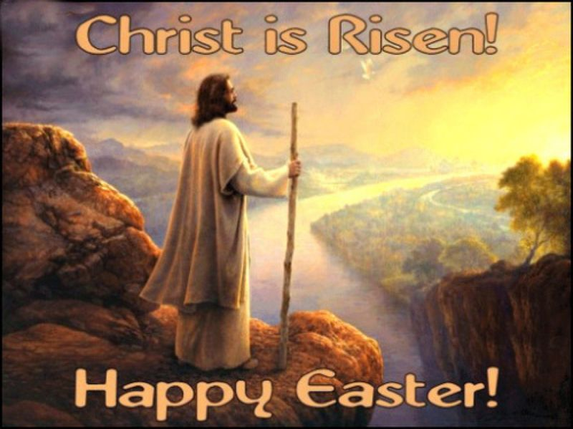
5 Easter Day The Parish

6 Easter Monday The Parish
7 Easter Tuesday The Parish
8 Easter Wednesday The Parish
9 Easter Thursday The Parish
10 Easter Friday The Parish
11 Easter Saturday The Parish
12 Divine Mercy Sunday The Parish
13 St. Martin Bishop Luke
14 Tuesday of Easter 2 Bishop Paul Oswestry

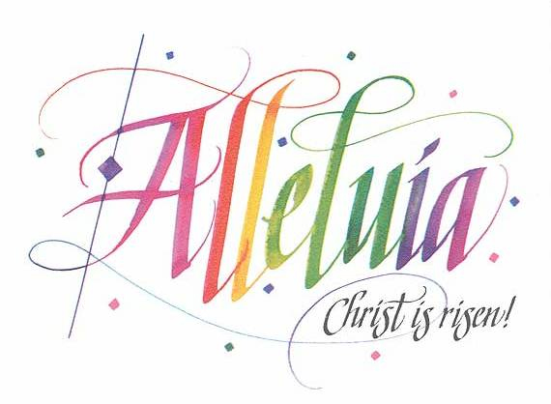

15 Wednesday of Easter 2 Bishop Stephen Beverley
16 Thursday of Easter 2 Bishop Stephen (Lincoln)
17 Friday of Easter 2 Bishop Nicholas Acting Lincoln
18 Saturday of Easter 2 Bishop Jean Grimsby
19 3rd Sunday of Easter The Parish
20 Monday of Easter 3 The Society of Wilfred and Hilda
21 Tuesday of Easter 3 The Society LMP
22 Wednesday of Easter 3 Lisle Marsden Academy
23 St George The Parish
24 Friday of Easter 3 Edward Heneage School
25 St Mark The Parish
26 4th Sunday of Easter The Parish
27 Monday of Easter 4 Our Organist and Choir
28 St Peter Chanel Our Servers
29 St Catherine of Sienna The Parish
30 Thursday of Easter 4 Our PCC

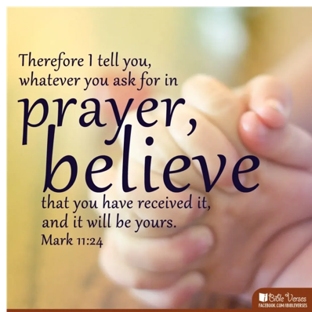

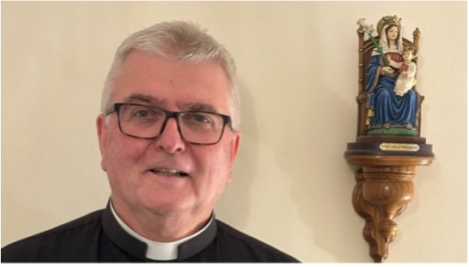

Fr Adrain Writes

Life has its up and downs!

If we join in wholeheartedly with the liturgical year, we as Christians know some of those ups and downs. If we take the calendar seriously we join in the emotions of Jesus; His conception, His birth, His temptation, His ministry, his royal entry into Jerusalem turning into His Last Supper, arrest, trial and death; then the Resurrection and Ascension. We share His ups and downs.
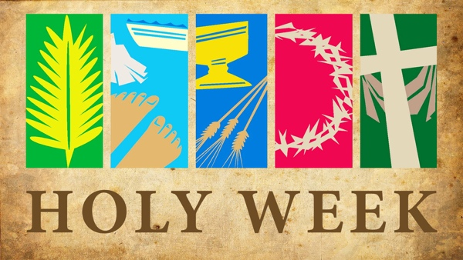

This year at the beginning of April we dive straight into the greatest of these ups and downs, the second half of Holy Week.

Thursday April 2 is Maundy Thursday. It gets its name from the word mandatory, because it was on the first Maundy Thursday when Jesus celebrated the Last Supper that he commanded, gave a mandate, to
do this in remembrance of me” and “love one another”.

This point in the week is poignant when to mood changes. Up to Down. Jesus is arrested later the same day. Then comes the sham trial.

Jesus is condemned to execution by crucifixion by a corrupt court. Another low.

Friday April 3 is Good Friday. Surely it should be called Bad Friday so many people think. Is it a high or a low? It is both! It is a low because Jesus is executed, he does die. It is also a high because the work of Jesus on the cross, means that sin also is crucified. He died for His people. If we are entering into this properly, that is us; one of the best highs to share.

April 4 is Holy Saturday (NOT Easter Saturday-that’s a week later). It is a day of limbo. With the benefit of hindsight we know how it works out. As the sun sets, we move into the next day; we move into Sunday in the Jewish tradition and the Christian tradition.

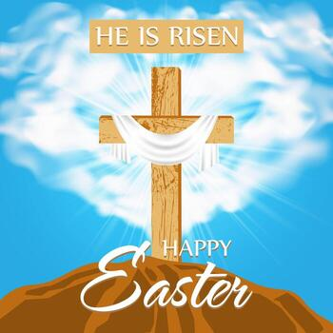
Sunday 5th is Easter Day. It is the day Our Lord rose from the dead and opened for His followers the gates of heaven. This is the big high. We celebrate it on the Saturday evening in our liturgy moving gently from darkness to light. From sorrow to joy. From down to up. Then on Sunday morning we proclaim afresh “Christ is risen: He is risen indeed! Alleluia!

Let’s not just join in: let’s immerse ourselves in it all. Let’s feel the highs and lows. By doing this we can feel the real depths of Easter Joy and embolden our faith.

Every blessing

Fr Adrian

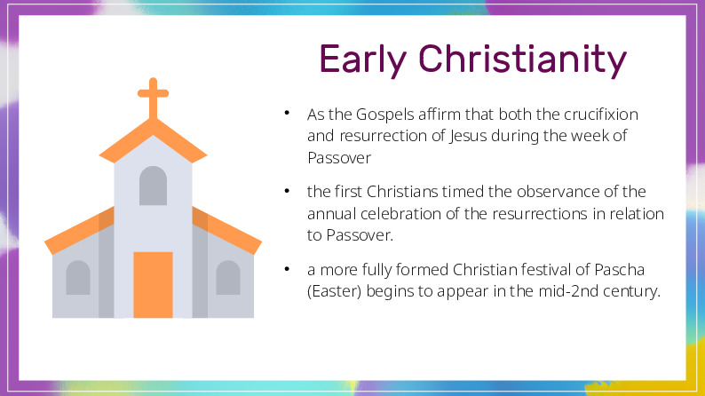
How Early Christians Celebrated Easter
Like Christmas and other Catholic holy days, Easter is often misunderstood and mis-celebrated. Either its origins are said to be based on pagan holidays (a myth we will bust), or we treat it as a day to binge after a season of fasting. So, to fully embrace Easter, let’s look at how the early Christians understood and celebrated the day of Christ’s resurrection.
What was Easter like in the early Church? Well, to begin with, they didn’t call it “Easter” — that word would be meaningless to them. The early Christians believed that Jesus’ passion and resurrection were the central part of the whole story of God’s saving activity in the world. These events were not seen as a single, isolated moment in history, but part of the great trajectory of God’s providential interventions.
More specifically, the passion and resurrection of Jesus were understood to be a continuation and fulfilment of the events of the Passover and the Exodus. And not coincidentally, the crucifixion and resurrection of Jesus happened at the time of the festival of Passover, so when the early Christians referred to the annual commemoration of Jesus’ passion and the celebration of his resurrection, they simply called it Passover.
It’s just like the way that Pentecost continues to be named after a Hebrew festival, even though it is given new meaning in the Church as the celebration of the gift of the Holy Spirit.
And so in the early Church, the feast day of the Resurrection of the Lord was simply called Passover, or some translation of that word, as it still is to this day in most languages of the world. This is where we get the word “paschal” in the Paschal Mystery. That just means, “the Passover Mystery.”
So what about the English word “Easter”? Where did that come from? Near as we can figure, it comes from an Old German word for “dawn,” as in, facing toward the dawn — facing east.
So then where did the English word “Easter” come from? Before we can answer that, we have to bust a myth or two.
The word “Easter” is not derived from a pagan fertility gods or anything like that. It used to be popular to say that Christianity had borrowed holidays from paganism, supposedly as a way to make it easier for people to transition from paganism into Christianity, and the two most famous examples of that were said to be Christmas and Easter.
The myth goes like this: The dates for Christmas and Easter were originally pagan festivals, perhaps the winter solstice and spring equinox, or maybe Roman festivals like Saturnalia and Lupercalia. Then, the name for the one that comes in the spring (Easter) supposedly came from one of the pagan deities — a fertility goddess who represented “new life” after winter is over.
But when one actually studies the early Church, it’s very easy to see that all of this is nonsense. The early Christians would be horrified for anyone to think they had borrowed from paganism, and the apologetic documents from the early Church prove this point in how critical they were of paganism.
As far as the dates go, the date for Christmas is exactly nine months after the feast of the Annunciation (the conception of Jesus), and although there was a lot of debate over the date of Easter in the early Church — a debate we don’t need to go into here — the debate itself proves that the date was not based on anything other than the date of Passover. The question was not when to celebrate the Resurrection but how to calculate the precise date relative to Passover.
In any case, nothing pagan to see here.
So what about the English word “Easter”? Where did that come from? Near as we can figure, it comes from an Old German word for “dawn,” as in, facing toward the dawn — facing east. This is a bit of an oversimplification, but think of the way we can talk about a storm that’s heading in the northeastern direction, and call it a “nor’easter.”
By the same logic, the day we face the dawn in anticipation of our own resurrection is called “easter.” At least that’s how it comes into English, translated from Old German. But it helps to remember that “Easter” is only a word used in English. Most other languages still call it something that is a version of the word for Passover. For example, in Italian, it’s Pasqua.
Just as the Eucharist was never just a “remembering” of the passion of Christ, the Pasch was never just an “anniversary celebration” of his resurrection. The celebration of the Pasch every spring was a way to relive the events of that week in a way that brings them back around so that we can participate in them — just like the celebration of the Passover brought back the events of the Exodus for faithful Jews.
“Past history made present mystery,” as they say.
In fact, in Hebrew theology, a recurrence of the Passover happens in providential ways at certain significant times throughout history. In the Rabbinic commentaries on the Torah, there is a poetic expansion on the Exodus that speaks of not one, but four Passovers — and all of them were said to take place on the same date in the Hebrew calendar: the 14th day of the month of Nisan, the same day as the Passover at the time of the Exodus. This poem on the Passover is called “The Poem of the Four Nights.”
The first Passover “night” is the creation of the universe, and in Hebrew thought there is a specific date given for creation — also the 14th day of Nisan. This concept of tracing God’s saving acts in history all the way back to creation is why we start with Genesis when we read the whole story of salvation from the Scriptures during the Easter Vigil.
The celebration of the Pasch every spring was a way to relive the events of that week in a way that brings them back around so that we can participate in them — just like the celebration of the Passover brought back the events of the Exodus for faithful Jews.
The second Passover “night” is the binding of Isaac, when Abraham was tested by God’s command to sacrifice his son (cf. Gn 22). The Church fathers all saw this event as a foreshadowing of the passion of Christ.
Just as a ram caught in the thorns became the substitute for the son of Abraham, so Jesus was the Lamb in the crown of thorns who became the substitution for all of Abraham’s children — both his literal descendants and his spiritual children. And yes, the Hebrew scholars believed that this event also took place on the 14th day of Nisan.
The third Passover night was exactly the one you’d think — the one associated with the Exodus, the main event remembered in the ongoing Jewish tradition of the Passover, which was always celebrated on the 14th day of Nisan.
Then the fourth Passover “night” was to be in the future, from the perspective of the Hebrews; this would be the messianic banquet at the “Day of the Lord.” Of course, they didn’t expect that the “Day of the Lord” would actually be two “days”: a first advent of the Messiah, and a later second coming, at which time the final revelation of the kingdom of God would take place.
We live in the time between these two “days.” So we, as Christians, actually have five Passovers. The hope of the messianic banquet was partly fulfilled at the Last Supper, when Jesus instituted the sacrament of the Eucharist. But then he said he would not drink from that cup again until the final consummation at the wedding banquet of the Lamb when the kingdom of God is fully revealed, after the final resurrection. (Jesus hinted at this in his parable of the wedding banquet in Matthew 22.)
There was also a certain way in which the early Christians treated Resurrection Day like the beginning of a new year, in the same sense that we might make New Year’s resolutions to improve ourselves and our habits. So the early Christians used Lent, and then the Pasch, to solidify ways in which they wanted to take their spiritual lives to the next level.
In a beautiful Paschal sermon Pope St. Leo the Great preached in the fifth century, he encouraged the people to use the season to make real changes in their lives, and after Lent, not just go back to their old ways. So it could be said that a homily for Resurrection Day was a real call to conversion, for as St. Leo said, no one who is proud, or greedy, or who denies the reality of Christ’s divinity and his bodily resurrection, can properly celebrate his Resurrection Day. Here is an excerpt from St. Leo’s sermon (I’ve paraphrased it a bit to make it easier to understand in English):
“I want everyone to remember that you are a new creation in Christ, and in all seriousness, understand what this means — that by identifying with Jesus Christ in your baptism you have been adopted by God the Father. Therefore, do not let anything that God makes new in you slide back into the old ways. This is what Jesus meant when he said that no one who puts his hand to the plough looks backward — to do the work of ploughing you need to keep your eyes on the row ahead of you.
“Don’t fall back into the old version of you, no matter how hard it is, or how weak you think you are — if you think you’re weak or not healthy enough — remember that being strong and healthy means following Jesus through death into resurrection. You did this in your baptism, back when it was easier.
“Now you need to keep following in the path of resurrection that Jesus set for you. Then no matter how slippery the path of life is, you won’t slide into the quicksand, but your feet will stay on solid ground. Keep all this in mind, my beloved, not only for this Paschal season, but all year round and all your life, for the sake of your sanctification.”
So on the one hand, the Pasch is not just one day, or even the anniversary of one day; it is a part of the recurring cycle of God’s past providential intervention in history, and the seasonal rhythm of our present participation in it.
On the other hand, it was also not just one feast day, as in “Easter Sunday.” For the early Christians, it was the whole Triduum.
Technically the Triduum is from sundown on Holy Thursday to sundown on Resurrection Sunday. But in the early Church, not all Christians reckoned the day in the Jewish way, beginning at sundown, and so it wasn’t even limited to three days. For them, the Pasch extended from Jesus’ betrayal on Wednesday, through the Last Supper and Jesus’ unjust condemnation and all that he suffered up through his crucifixion, all the way to the end of Resurrection Day. That whole thing was considered a single “holiday/holy day” in which Christians participated in Christ’s passion and resurrection.
In fact, the big picture includes much more than Holy Week. For the Church fathers, salvation was not just about the crucifixion, or even just about the cross and the empty tomb. It was the whole of the Incarnation and life of Christ, starting with his conception at the Annunciation.
And notice that we don’t usually wear little empty tombs around our necks or make the “sign of the empty tomb.” The sign of the cross is the sign that encompasses every aspect of the incarnation — Christ’s life, as much as his death, and of course his resurrection.
Methodius, in a Paschal homily from the early fourth century, wrote that the cross is both a trophy of victory and a ladder to heaven. And this is why we make the sign of the cross on our bodies.
Back then, Christians made the sign of the cross on their foreheads, and the Church fathers taught that the forehead of a person was like the lintel of the doorway to his life — in other words, just as the sign in blood on the door lintels at the Exodus saved the children of Israel, making the sign of the cross on the “lintel” of our bodies is a sign of what saves us — But, again, what saves us is not only the death of Jesus, but his whole life.
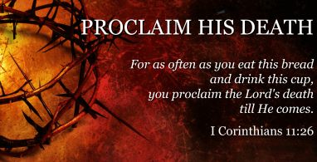
So the Resurrection was never disconnected from the Passion, and the Passion was never disconnected from the Incarnation. And this sign — just like the ashes we got at the beginning of Lent, which were in the shape of the cross — is a witness to the world that we “proclaim the death of the Lord until he comes” (1 Cor 11:26).
Easter Celebration

Season of freshness, green in sap and bud.
Frost-locked all Winter, Earth breaks her sleep
In the strengthening sun.
She brings out her stores of variegated flowers,
Litters of young and multitudes of birdsong,
To refresh the human heart.
Bright, sparky new life.

A seed that dies and falls to the ground
Produces new life.
He comes to Earth from Heaven,
The chosen Seed of Adam’s race;
To pay our debt.
Earth encloses him, but it cannot hold him.
He has Life in himself,
The One who created all things.

He comes to bring Life,
Where death once reigned;
He frees us from the ancient curse.
Death is not the end; it has no sting.
For Christ is Risen;
We are risen in Him.

By Mark Fletcher.

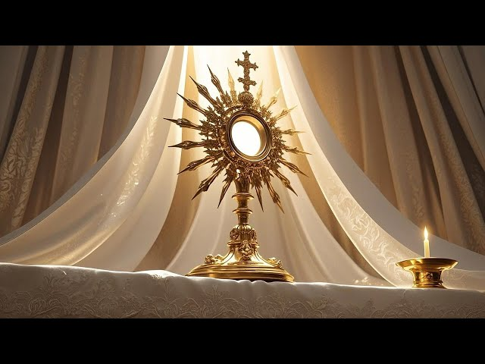
Month of Devotion to the Blessed Sacrament

Since the 16th century Catholic piety has assigned entire months to special devotions. The Church traditionally encouraged the month of April for increased devotion to Jesus in the Holy Eucharist. "The Church in the course of the centuries has introduced various forms of this Eucharistic worship which are ever increasing in beauty and helpfulness; as, for example, visits of devotion to the tabernacles, even every day; Benediction of the Blessed Sacrament; solemn processions, especially at the time of Eucharistic Congresses, which pass through cities and villages; and adoration of the Blessed Sacrament publicly exposed . . . These exercises of piety have brought a wonderful increase in faith and supernatural life to the Church militant upon earth and they are re-echoed to a certain extent by the Church triumphant in heaven, which sings continually a hymn of praise to God and to the Lamb 'Who was slain.'" --Pope Pius XII

Prayer:
ACT OF ADORATION I adore Thee, 0 Jesus, true God and true Man, here present in the Holy Eucharist, humbly kneeling before Thee and united in spirit with all the faithful on earth and all the blessed in heaven. In deepest gratitude for so great a blessing, I love Thee, my Jesus, with my whole heart, for Thou art all perfect and all worthy of love.
Give me grace nevermore in any way to offend Thee, and grant that I, being refreshed by Thy Eucharistic presence here on earth, may be found worthy to come to the enjoyment with Mary of Thine eternal and everblessed presence in heaven. Amen.
FAITH IN THE EUCHARIST O my God, I firmly believe that Thou art really and corporally present in the Blessed Sacrament of the altar. I adore Thee here present from the very depths of my heart, and I worship Thy sacred presence with all possible humility. O my soul, what joy to have Jesus Christ always with us, and to be able to speak to Him, heart to heart, with all confidence. Grant, O Lord, that I, having adored Thy divine Majesty here on earth in this wonderful Sacrament, may be able to adore it eternally in Heaven. Amen.
PETITION Believing that Thou, my God, hast in any way revealed to us--grieving for all my sins, offenses and negligences--hoping in Thee, O Lord, who wilt never let me be confounded--thanking Thee for this supreme gift, and for all the gifts of Thy goodness--loving Thee, above all in this sacrament of Thy love--adoring Thee in this deepest mystery of Thy condescension: I lay before Thee all the wounds and wants of my poor soul, and ask for all that I need and desire. But I need only Thyself, O Lord; I desire none but Thee--Thy grace, and the grace to use well Thy graces, the possession of Thee by grace in this life, and the possession of Thee forever in the eternal kingdom of Thy glory.
FOR THE PEACE OF CHRIST O most sacred, most loving heart of Jesus, Thou art concealed in the Holy Eucharist, and Thou beatest for us still. Now as then Thou sayest, "With desire I have desired." I worship Thee, then, with all my best love and awe, with my fervent affection, with my most subdued, most resolved will. O make my heart beat with Thy heart. Purify it of all that is earthly, all that is proud and sensual, all that is hard and cruel, of all perversity, of all disorder, of all deadness. So fill it with Thee, that neither the events of the day nor the circumstances of the time may have power to ruffle it; but that in Thy love and Thy fear it may have peace. --Cardinal Newman
ACT OF LOVE I believe Thou art present in the Blessed Sacrament, O Jesus. I love Thee and desire Thee. Come into my heart. I embrace Thee, O never leave me. I beseech Thee, O Lord Jesus, may the burning and most sweet power of Thy love absorb my mind, that I may die through love of Thy love, who wast graciously pleased to die through love of my love. --St. Francis of Assisi
ACT OF REPARATION Saint Margaret Mary Alacoque, well known in connection with devotion to the Sacred Herat of Jesus, led the way in making reparation to Jesus in the Blessed Sacrament for the coldness and ingratitude of men. This prayer of hers can become our own as we attempt to make amends for our own and others' neglect of the great Sacrament of His love, the Eucharist. O kind and merciful saviour, from my heart I earnestly desire to return Thee love for love. My greatest sorrow is that Thou art not loved by men, and, in particular, that my own heart is so cold, so selfish, so ungrateful. Keenly aware of my own weakness and poverty, I trust that Thy own grace will enable me to offer Thee an act of pure love. And I wish to offer Thee this act of love in reparation for the coldness and neglect that are shown to Thee in the sacrament of Thy love by Thy creatures. O Jesus, my supreme good, I love Thee, not for the sake of the reward which Thou hast promised to those who love Thee, but purely for Thyself. I love Thee above all things that can be loved, above all pleasures, and above myself and all that is not Thee, promising in the presence of heaven and earth that I will live and die purely and simply in Thy holy love, and that if to love Thee thus I must endure persecution and suffering I am completely satisfied, and I will ever say with Saint Paul: Nothing "will be able to separate us from the love of God." 0 Jesus, supreme master of all hearts, I love Thee, I adore Thee, I praise Thee, I thank Thee, because I am now all Thine own. Rule over me, and transform my soul into the likeness of Thyself, so that it may bless and glorify Thee forever in the abode of the saints. --Saint Margaret Mary Alacoque
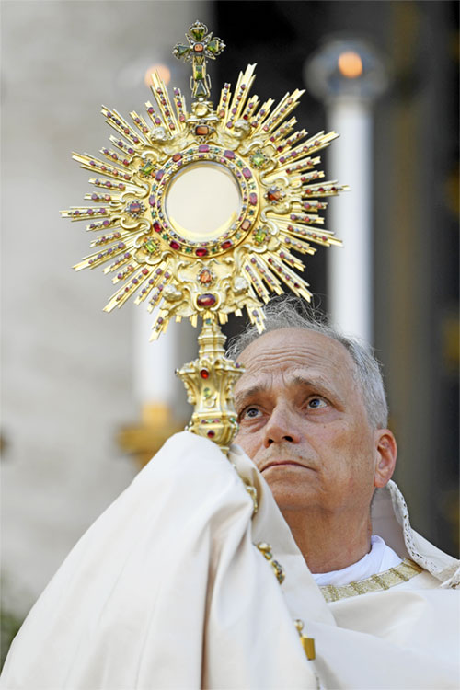
OFFERING My Lord, I offer Thee myself in turn as a sacrifice of thanksgiving. Thou hast died for me, and I in turn make myself over to Thee. I am not my own. Thou hast bought me; I will by my own act and deed complete the purchase. My wish is to be separated from everything of this world; to cleanse myself simply from sin; to put away from me even what is innocent, if used for its own sake, and not for Thine. I put away reputation and honour, and influence, and power, for my praise and strength shall be in Thee. Enable me to carry out what I profess. Amen. --Cardinal Newmans

Celebrating St Mark the Evangelist: A Beacon of Faith and Inspiration – 25 April

On 25 April the Church celebrates the feast day of Saint Mark the Evangelist, commemorating the life and legacy of one of the four evangelists who wrote the Gospels. This day offers us an opportunity to reflect on the contributions of Saint Mark to the spread of the Gospel message and to draw inspiration from his example of unwavering faith and dedication to proclaiming the Good News.
Saint Mark holds a special place in the history of Christianity as the author of the earliest Gospel account, which serves as a foundational document of our faith. His Gospel, characterised by its vivid storytelling and emphasis on Jesus’ teachings and miracles, continues to inspire and guide believers around the world.
Mark’s Gospel portrays Jesus as a powerful and compassionate healer, teacher and saviour, inviting readers into a deeper relationship with Christ and a deeper understanding of the kingdom of God. Through his writings, Saint Mark invites us to encounter Jesus in new ways and to respond to His call to discipleship with faith and devotion.
As Catholics, we are called to emulate the example of Saint Mark by boldly proclaiming the Gospel message in our own lives and communities. Saint Mark’s commitment to evangelisation serves as a reminder that the Good News is meant to be shared with all people, regardless of nationality, ethnicity or background. In a world marked by division and discord, Saint Mark’s message of hope and reconciliation resonates deeply, challenging us to be instruments of God’s peace and unity in the world.
Saint Mark’s feast day also offers us an opportunity to reflect on the virtues exemplified in his life, including courage, perseverance and humility. Despite facing persecution and hardship, Saint Mark remained steadfast in his mission to spread the Gospel, trusting in God’s providence and guidance every step of the way. His unwavering commitment to the truth serves as a source of inspiration for all who seek to live out their faith with integrity and conviction.
On this feast day of Saint Mark the Evangelist, let us offer prayers of gratitude for his life and witness, and let us ask for his intercession as we strive to follow in his footsteps. may we be inspired by his example of faithfulness and zeal for the Gospel, and may we be empowered by the Holy Spirit to be bold and courageous witnesses to the love and mercy of Jesus Christ in our own time and place.
In the words of Saint Mark himself, “Go into all the world and proclaim the Gospel to the whole creation” (Mark 16:15). Let us follow this call with joy and enthusiasm, knowing that we do so in communion with Saint Mark and all the saints who have gone before us, and with the guidance and blessing of our loving God.
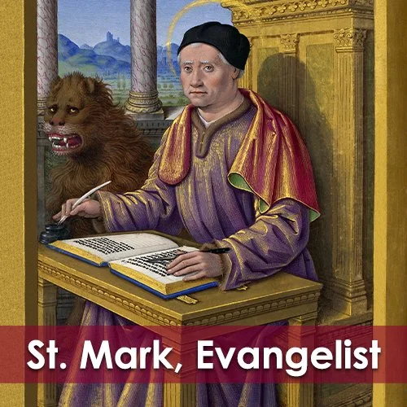

Magazine Sponsorship for April

This month’s magazine is sponsored by Neil and Cheryl James in memory of their relatives Laurie James and Lavinia Callum.


Moving forward as a way of covering some of the ongoing costs we would like to further promote the concept of sponsorship.

An example is the sponsorship of the printing costs of our parish magazine. Another example is covering the cost of the sanctuary light which is always alight (except following the Good Friday Liturgy until it is lit again to celebrate the risen Lord at the Easter Vigil) and the candles in the Lady Chapel and St Monica’s Chapel.

Sponsorship would be on a weekly or monthly basis, although monthly sponsorship would make administering the process an easier task, and could be in memory of a loved one who has died or something else such as a birthday that is close to your heart. Sponsors and their special intention will be published in this magazine each month.

Sponsorship money should be paid at the beginning of the month
preferably by bank transfer using the reference box to indicate that it is
sponsorship money or you could give your sponsorship money in cash
to our treasurer, Tracy Poole.

If you would like to participate in this, please email Maria the month, what you are sponsoring and your intention to:

mrs.maria.mason@gmail.com

It is of course possible to have more than one sponsor for any category in
any month and all sponsors with their intention will be published.

Item | Duration | Suggested Donation
Parish Magazine | Monthly | £50
Sanctury Lamp | Monthly | £15
St Monica’s Chapel Lamp | Monthly | £10

Could you sponsor the magazine, or any of the above items, for a month moving forward?


POEM

What is it like to die ?
To be lifted up above the sky ?
What will be up there
Will I see God on his golden chair ?

What will Peter say
When I reach the gates that day ?

It's early closing; I pray ….
take a seat in that bay.
Have you filled in the forms ?
You need your passport and so on
You must use a black pen
'Say when you get to page ten.'

You'll have to hurry you see
You've got to complete fifty-three.
God can't see you today.

But just prolong your stay,
Quite soon all will come clear
But now I must leave you I fear.

Pauline Murdoch


St George – 23 April
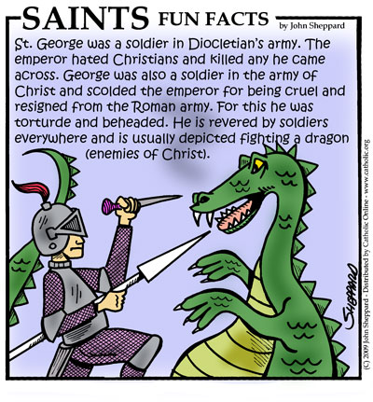
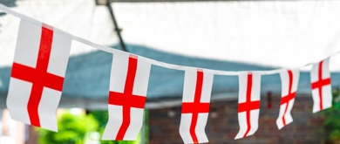

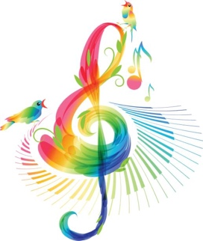
Have you thought about becoming a Friend of St Augustine’s Church for 2026?

First of all, a big thank you for your support in 2025. We had a record season for audience, which is very encouraging. We have listened to those of you who have completed feedback forms and based this year’s season on those comments.

Once again, we have a tremendous line up of artists and do hope that you will continue to enjoy the concerts that we have on offer. There is a small increase to ticket prices as follows:

Adults: £14 Friends: £12
Students under 22: £5 Children under 12: Free


All tickets include a complimentary glass of wine or fresh fruit juice.

Please note that single membership costs just £15 per year, joint membership is £25, so to those of you who are not Friends at the moment, you may wish to consider joining!

A concert brochure is being prepared and will be distributed in early February, however, see the following page for advance notice.

Further Dates for Concert Season 2026

Friday, 24th April Alex Wilson (cello), Karen Beer (oboe) and David Beer (piano)

Friday, 15th May DC Quartet – Easy listening jazz

Friday, 5th June Josh Hughes - classical guitar

Friday, 17th July Bradley Creswick (violin) & David Murray (Piano)
Saturday, 18th July Violin/piano masterclass for young artists led by Bradley & David

Summer Lunchtime organ recitals:
Every Wednesday from 22nd July to 19th August

Malcolm Pentelow 22nd July, Michael Baron 19th August
Graham Burrell, Steven Maxson, Barry Whitfield to perform on the other dates.

Friday, 25th September Adele Dixon & Barry Whitfield
Friday, 16th October DC Quartet – Easy listening jazz
Friday, 13th November Louth Male Voice Choir
Friday, 27th November Music for Advent – St Augustine’s Consort
Friday, 18th December Adele Dixon & Barry Whitfield & Friends
A light-hearted Christmas evening with carols for all!

Book early to avoid disappointment! Tel: 07398 566677 or email staugustinesfriends@gmail.com

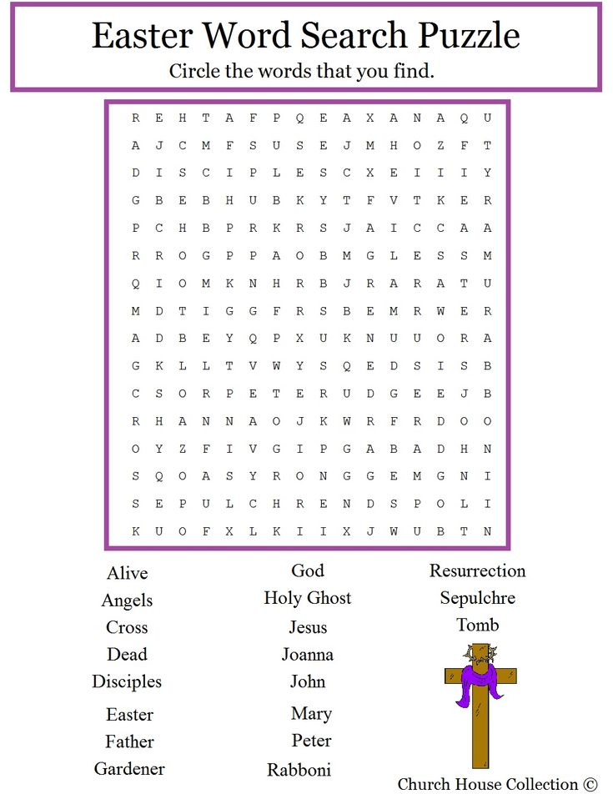

28 Historic Events that took place in April

1st April, 1748

The ruins of Pompeii were rediscovered by Spanish engineer Rocque Joaquin de Alcubierre and his team.

The city had been buried under millions of tonnes of volcanic ash after Mount Vesuvius erupted in 79 AD.

3rd April, 1721

Robert Walpole became Britain’s first ever Prime Minister. In 1735, he received the gift of 10 Downing Street from King George II – making it the permanent residence of the Prime Minister.

Serving from 1721 to 1742, Walpole is the longest serving Prime Minister in British history.

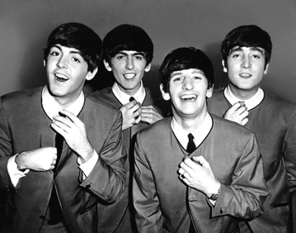
4th April, 1964

English rock band, The Beatles, filled the top five places of the US singles chart with ‘Please Please Me’, ‘I Want to Hold Your Hand’, ‘She Loves You’, ‘Twist and Shout’, and ‘Can’t Buy Me Love’.

Many regard The Beatles as the most influential band of all time due to the integral role they played in the development of 1960s counterculture and the recognition of popular music as a form of art.

4th April, 1968

Civil Rights Leader Martin Luther King was shot and killed by a sniper while standing on a balcony outside his second-floor room at the Lorraine Hotel in Memphis, Tennessee.

King had championed non-violent protests to bring racial oppression to an end, and was awarded the Nobel Peace Prize in 1964.

He is best remembered for his speech, I Have a Dream, delivered in 1963 during the Civil Rights March in Washington. His efforts helped deliver the passage of the Civil Rights Act of 1964 and the Voting Rights Act of 1965.

6th April, 1199
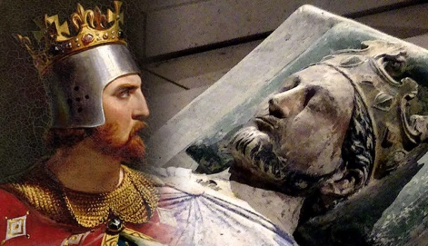
England’s King Richard I – later known as Richard the Lion Heart – died from an infected wound while besieging Chalus Castle in France.

Richard is famous for his considerable victories in the Third Crusade against Muslim leader, Saladin – although he finalised a peace treaty and ended his campaign without retaking Jerusalem.

Interestingly, despite reigning for 10 years, Richard only spent six months in England.

6th April, 1896

After a 1500 year break, the first modern-era Summer Olympics was held in Athens, Greece, from 6th to 15th April.

With the exception of US athletes, all participants were European, and over 65% were Greek.

7th April, 1739

Travellers across England were relieved to hear that the most notorious of highwaymen, Dick Turpin, was hanged in York.

Turpin was a member of the violent Gregory Gang and became a highwayman when they split up – poaching, burgling, killing, and stealing horses.

7th April, 1948

The World Health Organization (WHO) was formed by the United Nations to connect nations and promote global health.

Its main functions include developing partnerships with other global health initiatives, conducting research, and monitoring health trends around the world.

9th April, 1866

Despite a veto by American President Andrew Johnson, the US Civil Rights Bill was passed by Congress.

This declared all people born in the US to be citizens, “without distinction of race or colour, or previous condition of slavery or involuntary servitude.”

10th April, 1633


England got its first ever glimpse of a new fruit – the banana – when Thomas Johnson displayed a bunch in his shop in Holborn, London.

It’s believed that Johnson’s bananas came from Bermuda – though how they managed to arrive in a state fit for display is not known by historians.

Johnson was a highly esteemed herbalist and physician who later died as a result of his wounds during the English Civil war.

12th April, 1981

The first space shuttle flight occurred when Columbia was launched from NASA’s Kennedy Space Centre with astronauts John Young and Robert Crippen on board.

Columbia spent 54 hours in space and made 36 orbits before landing at Edwards Air Force Base in California.

14th April, 1983

The first ever cordless telephone went on sale in Britain. It was made by Fidelity and British Telecom and sold for £170.

14th April, 1912

The world’s largest ocean liner, RMS Titanic, hit an iceberg at 11:40pm off of Newfoundland and sank in the early hours of 15th April – just four days after she left Southampton on her maiden voyage.

As Titanic sank, the band famously played on. There were around 2,200 passengers on board, but only lifeboats to carry 1,178 people. And tragically, through the panic, most of the lifeboats left the ship with around 400 empty seats.

As a result, there was a loss of between 1,490 and 1,635 people.

17th April, 1969

With the passing of the Representation of the People Act, the voting age in Britain was moved from 21 to 18.

17th April, 2012

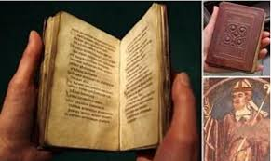

Europe’s oldest intact book, the 8th century St. Cuthbert Gospel, was purchased by the British Library for £9 million.

Cuthbert is regarded as the patron saint of Northumbria and the gospel book was removed from his coffin in 1104 during a transfer of the saint’s remains to a new shrine in Durham Cathedral.

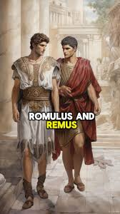
21st April, 753 BC

According to legend, twin brothers Romulus and Remus – descendants of Aeneas, sons of goddess Aphrodite, and princes of the domed Greek city of Troy – founded Rome.

To this day, Rome celebrates its birthday every year on this date.

21st April, 1509

After the death of his father, Henry VIII became King of England. He’s most famous for having six wives and breaking with the Roman Catholic church.

As the second son of King Henry VII, Henry was never destined for the throne, but became first in line after the death of his older brother Arthur in 1502.

22nd April, 1870

Vladimir Lenin was born in Simbirsk, Russia. Lenin led the Russian Revolution of 1917 which turned Russia into a communist country.

The 1917 revolution is linked with various events in history, including the reign of Stalin and the Cold War (1947-1991) between the Western World and the Communist World – led mainly by the Soviet Union.

22nd April, 2016

The Paris Agreement – a legally binding international treaty on climate change – was signed by 195 nations in New York.

The Agreement’s goal was (and remains) to limit global warming and work towards limiting temperature rise to well below 2 degrees, maybe even 1.5 degrees (compared to pre-industrial levels).

23rd April, 1616

Famous playwright and poet, William Shakespeare, died on his 52nd birthday.

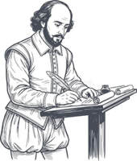
Shakespeare left behind his wife Anne, two daughters, Judith and Susanna, as well as a wealth of literary treasures that are still read and studied today – the most famous of which include Romeo and Juliet, King Lear, and Macbeth.

24th April, 1858

On the second attempt, Big Ben, the largest bell in the world, was finally ready to be hung in the clock tower of Westminster Palace in London.

The bell weighs more than 13 tonnes and each dial is seven metres in diameter.

27th April, 1828

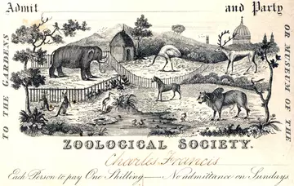
The Zoological Society of London opened a zoo. It was originally intended for scientific study and in the early 1830s animals from the Tower of London’s menagerie (collection of wild animals kept in captivity for exhibition) were transferred to the zoo’s collection.

Doors were opened to the public in 1847 to help with funding. Today, the ZSL London Zoo is home to thousands of different species and one of the largest collections of animals in the UK.

28th April, 1770

English naval explorer James Cook reached the east coast of Australia, where he began proceeding north to Botany Bay in Sydney.

Cook and his crew became the first known Europeans to arrive there.

28th April, 1945

Twenty-three years of Fascist rule ended in Italy when Italian partisans shot former Dictator Benito Mussolini and his mistress Clara Petacci, as they attempted to flee to Switzerland.

Italian Fascism was rooted in the desire to restore and expand Italian territories and Mussolini had allied with Adolf Hitler during World War II in order to boost his leadership.

29th April, 1884

Oxford University agreed to allow female students to take examinations. However, women were not allowed to be awarded degrees.

In 1878, The University of London became the first UK university to award degrees to women.

30th April, 1945

In his hideaway bunker in Berlin, Nazi leader Adolf Hitler shot himself while Eva Braun, his wife of 48 hours and former mistress, took a cyanide capsule.

In line with Hitler’s instructions, both of their bodies were later burnt.

30th April, 1948

Palestinian Jews declared their independence from British rule and established the new State of Israel – the first Jewish state in 2,000 years.

30th April, 1989

World Wide Web (WWW) was first launched in the public domain by British scientist Tim Berners-Lee.

The Web was originally created and developed to allow scientists in different universities and institutes around the world to share information.

The Life and Times of Thomas Augustus,
The Vicarage Cat


I said I would try and be more active during this last month and I have really tried my best. I have been doing a little research into the number of hours sleep I should have in a 24-hour period to keep me healthy and happy. Using the latest AI technology I have learned that, as a senior cat, I should have between 16 and 20 hours sleep in a 24-hour period. I do my very best to act on this recommendation so that I can stay as healthy as possible.


With this in mind I try to use my waking hours to my best advantage. I of course have to eat my favourite foods at the times that best suit me. I have been told that Fr Adrian is not keen on getting up sometime between 2am and 4am when I seem to be most hungry. However, I can usually persuade him that it is a good idea.

Around 8am I go into church to join Fr Adrian in saying morning prayer. Sometimes he finds this helpful however other times he thinks I am a not helpful at all!

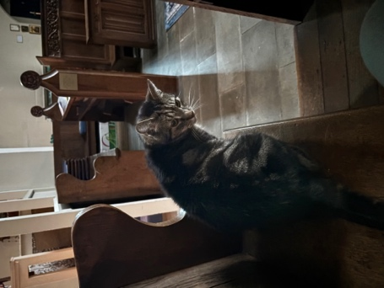
When I am left alone in the church I like to find a place where I can be comfortable. I then count my many blesssings. Being a vicarage cat is like being part of a much bigger family.

I can catch up on a few hours sleep in this peaceful place before someone comes looking for me.

Priest-in-Charge | Fr Adrian Mason | fr.adrian.mason@gmail.com 07824 467333
Church Wardens | Adele Dixon Janet Nixon | adele.dixon90@gmail.com  janet.nixon59@gmail.com
Lay Chair of PCC | Adele Dixon | adele.dixon90@gmail.com
PCC Secretary | Barry Whitfield | barrywwhitfield@gmail.com
PCC Treasurer | Tracy Poole
Safeguarding Officer | Adele Dixon | staugustineofhippo safeguarding@gmail.com
Electoral Roll Officer | Cheryl James | cheryljames1@live.co.uk
Director of Music | Barry Whitfield | barrywwhitfield@gmail.com
Magazine Editor | Maria Mason | mrs.maria.mason@gmail.com


Items for inclusion in the February 2026 edition of this magazine should be sent to the editor via email by Sunday 19 April. There is no guarantee of inclusion after this date.

(mrs.maria.mason@gmail.com).

Could you write an article for our Parish Magazine? The editor would be pleased to receive articles of a religious nature or otherwise that would be of interest to our readers.
Again, the email address to send articles to is: mrs.maria.mason@gmail.com

Cheryl’s Name Cards
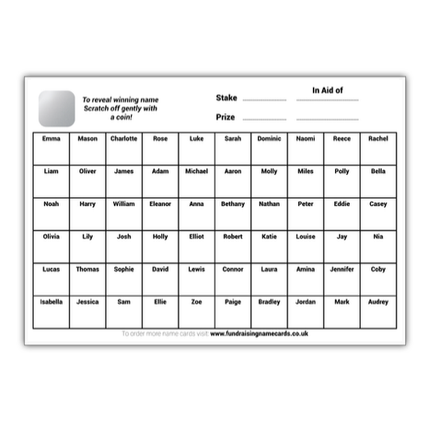
As many of you are aware, Cheryl always has some name cards on the go. There are always great prizes including bottles, candles and chocolate, with boxes costing 20p - £1.

To quote Cheryl, “you have to be in it to win it!”

Email:
fr.adrian.mason@gmail.com

Web:
St-augustine-church-grimsby.org
https://www.achurchnearyou.com/church/14993/

Safeguarding matters please contact:
staugustineofhipposafeguarding@gmail.com



Edition 14

