SUNDAY MORNING READING SHEET 15th March 2026 4th Sunday of Lent

9 am Readings: Ephesians 5: 8 -14 , Gospel: John 9

MOTHERING SUNDAY READING 10.30 am

A Reading from the Book of Exodus

Now a man from the house of Levi went and married a Levite woman. The woman conceived and bore a son; and when she saw that he was a fine baby, she hid him for three months. When she could hide him no longer she got a papyrus basket for him, and plastered it with bitumen and pitch; she put the child in it and placed it among the reeds on the bank of the river. His sister stood at a distance, to see what would happen to him.

The daughter of Pharaoh came down to bathe at the river, while her attendants walked beside the river. She saw the basket among the reeds and sent her maid to bring it. When she opened it, she saw the child. He was crying, and she took pity on him. ‘This must be one of the Hebrews’ children,’ she said. Then his sister said to Pharaoh’s daughter, ‘Shall I go and get you a nurse from the Hebrew women to nurse the child for you?’ Pharaoh’s daughter said to her, ‘Yes.’ So the girl went and called the child’s mother. Pharaoh’s daughter said to her, ‘Take this child and nurse it for me, and I will give you your wages.’ So the woman took the child and nursed it. When the child grew up, she brought him to Pharaoh’s daughter, and she took him as her son. She named him Moses, ‘because’, she said, ‘I drew him out of the water.’ Exodus 2:1-10

LOOKING FORWARD, we will also be looking for donations of Easter eggs for the egg hunt on Easter Sunday, 5th April and chocolate items for a chocolate tombola at the Book Fayre, 2nd and 4th May. We are happy to take these at any time from now on so we can take advantage of any offers. Please leave all items in the kitchen. As always we ask that all food items have good dates on them as we cannot include out of date items! Thank you so much, the Events Committee.

UPCOMING EVENTS :There are a number of events coming up over the next few months to look forward to.
18th April - Cheese and wine evening 2nd & 4th May - Book Fayre 19th June - Hymns and PIMM’ s
20th June - Concert


If you wish to make a donation to the church, then please hold your
phone’s camera over this image then touch the link that appears:

Royston Parish Church
Where all are welcome and God’s love is shared
Sunday 15th March 2026 - 4th Sunday of Lent
Mothering Sunday

If you would like regular copies of the Notice Sheet emailed to you please email the Parish Office at admin@roystonparishchurch.org.uk

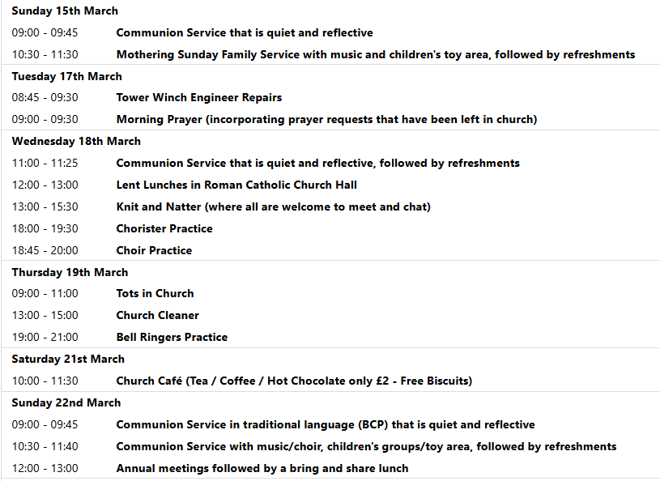

BRING AND SHARE LUNCH - there will be a bring and share lunch in church after the APCM on Sunday 22nd March. All are welcome. Please bring an item of food to share.

We pray for all Christians worldwide:
For all Christians in Denmark, Faroe Islands, Finland, Greenland, Iceland, Norway, Sweden
For all who worship at Royston Methodist Church: Revd. Charity
For the work of our mission partners: Royston Home Start
Pray for the community of Royston:
For our local health centres
For our local Baby and Toddler Groups
We pray for our world and ECO projects:
18th March is Global Recycling Day; 21st March International Day of Forests; 22nd March World Water Day; 23 March World Meteorological Day; also 22nd March is the Earth Hour in which we are encouraged to turn off all non-essential lights for an hour to raise awareness for nature and climate action
We pray for the sick and suffering:
1st March 8th March 15th March 22nd /29th March
Lee Cockerill Ted Rayment Val Brown Peter Coates Pat Pritchard Paul & Pat Tidey Angie & Ken Rushall Margaret Green
Jackson Herbert Mike Brown Paula Walker Peter Foster Marion Keith & Elaine Edwards Gwen Simmons
Laura O’nyamul (On-Ya-Mul) Maria Turi Katie
Colin Fitch Peggy Dawes Janet McElney George N.
Susan Bowles

We pray for those who have died in the faith of Christ:
Deceased | Bereaved
Harry McDonald | Ruth, Family and friends
Chris Christou | Anna, family and friends

We pray for those whose anniversaries fall at this time:
Dudley Walford, Maureen Dunbar
NOTICES

THE FUNERAL FOR THE LATE CHRIS CHRISTOU: The funeral service to take place on Wednesday, March 25th 2026 at 1-30pm at Royston Parish Church followed by cremation at 3-00pm at Cam Valley Crematorium

CHEESE and WINE:SATURDAY 18th APRIL, 7:00PM ROYSTON PARISH CHURCH
Tickets £12 Tickets must be purchased in advance for catering purposes

To book tickets scan the QR code, or visit the website below
https://tickets.myiknowchurch.co.uk/gb/NzcwMi0yNw/t
Ticket price includes cheese, crackers and a glass of wine or sparkling elderflower.
Additional drinks available for a charge. PROCEEDS IN AID OF CHURCH FUNDS
A CALL FOR HELP IN PREPARING MOTHERING SUNDAY POSIES: Our flower arrangers are going to create posies which will be handed out during our services on Mothering Sunday in church on Saturday 14th March at 12.30pm. If you could lend a hand then please contact the Church Office. No previous experience necessary. You don't even need to consider that you have green fingers.

LENT LUNCHES IN AID OF CAFOD AND CHRISTIAN AID: Continues on 18th, 25th March. Venue - Roman Catholic Parish Centre, Melbourn Rd. - Entry for pedestrians and cyclists from School car park only. Lunches are served between 12 noon and 1pm
Donations for lunch: Suggested donation is £5pp. This will be distributed equally between Cafod and Christian Aid

CARBON FAST FOR LENT: Traditionally, Lent is a time when Christians fast and focus on God. You might also be interested in adding a “Carbon Fast” to think about our carbon footprint and ask if there is any excess or unnecessary use in our lives, and if any of that excess is acting as a distraction to our relationship with God. You can sign up at the website climatestewards.org/resources/carbon-fast-for-lent to receive a weekly e-mail with suggested activities. With a different focus each week, you’ll learn more, ask questions, and focus on what God thinks about these areas of our lives:
- Week 1: Delight in and responsibility for nature
- Week 2: Consumerism and shopping
- Week 3: Money and investments
- Week 4: Food waste and meat and dairy consumption
- Week 5: Transport and driving
- Week 6: Energy, electricity, and gas
- Week 7: Social media

CHURCH FLOWERS FOR EASTER: As usual, we will be arranging flowers in church for Easter. If you would like to make a donation towards the cost of the Easter flowers via a bank transfer, please contact Charlotte Wicks on email treasurer@roystonparishchurch.org.uk. Cash and cheque donations are also welcome if preferred. Cheques should be made payable to Royston PCC and can be given to either Clare Rice or Angela Sassoli. Your generous support for festival flowers is very much appreciated. Thank you.

