Holy Week
30th March 11am Chrism Service, Worcester Cathedral
30th March 7pm Compline, St Leonard, Cotheridge
1st April 7pm Compline St Mary Magdalene, Broadwas
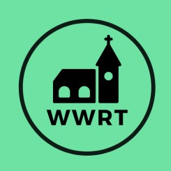

CHURCH SERVICES IN THE LOWER TEME VALLEY
APRIL 2026

4th April 9pm Tenebrae, Knightwick

Sunday 5th April
Easter Sunday
10.30am Easter Holy Communion, St Mary Magdalene, Broadwas

Sunday 12th April
2nd Sunday of Easter
3pm Evening Worship, Knightwick

Sunday 19th April
3rd Sunday of Easter
10.30am CW Holy Communion, St Mary Magdalene, Broadwas

Sunday 26th April
4th Sunday of Easter
10.30am Morning Worship, St Mary Magdalene, Broadwas

29th April 3:30pm Crafty Café in Church, Broadwas

In April there will be Holy Communion at Heaton House, Martley on the 2nd and 4th
Wednesday at 10.15am and on the 1st and 3rd Wednesday via our YouTube channel wwrtlive1.

All services and timings are subject to review and amendment – please check the website for updates: www.achurchnearyou.com

