HOLY WEEK ACTIVITIES AND SERVICES
PALM SUNDAY 10.30 Benefice services as follows
Boyton, St. Michael Lawhitton, Tremaine
HOLY WEEK
Reflections and Compline: 7.00pm St Thomas
Monday, Tuesday, Wednesday
Evening Prayer 6.30 at:
Monday – North Tamerton
Tuesday – Crow’s Nest, Virginstowe
Wednesday – Werrington
Morning Prayer
Wednesday – 10.30 Trewen
Maundy Thursday
Truro Cathedral: 10.30am Chrism Mass
St Giles: 6.30pm Holy Communion with Foot Washing
St Nonna, Altarnun: 7.00pm Last Supper
St Stephen’s: 7.30pm Holy Communion, stripping of altar and Watch
Good Friday

9.00am: Meet outside Central, Churches Together Walk of Witness
10.00 Sevon Words on the Cross – North Tamerton
10.00 Meditation – St Martin, Lewannick
10.30-11.30: St Mary’s - The Cross in Music
12.00: St Thomas Hall - Refreshments
12.30-1.30pm: St Thomas - The Cross in Word
2.00-3.00pm: St Stephen’s - The Cross in Sacrament
3.00pm: An hour at the foot of the Cross – Boyton
7.00pm: St Nonna, Altarnun – Good Friday Service
Holy Saturday
6.30pm: North Petherwin – Sundown Service

EASTER DAY
St Stephen’s: 6.00am Dawn Service
Swan Pool, Trebartha Gardens: 6.30amSunrise Communion
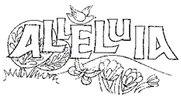
Boyton: 9.00 Holy Communion
Egloskerry: Holy Communion
Virginstowe: 9.15 Holy Communion
St Martin, Lewannick: 9.30 Easter Communion
St Michael, Lawhitton: 9.30 Eucharist
Laneast: 10.30 Morning Prayer
St Mary’s: 10.30am Easter Ceremonies and Holy Communion
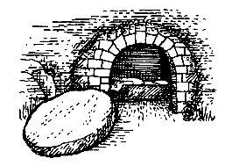
North Petherwin: 10.30 Holy Communion

Tremaine: 10.30 Morning Prayer
Trewin: 10.30 Holy Communion
Tregadillett: 11.00 Holy Communion
St Briochus, Lezant: 11.00 Holy Communion (BCP)
St Thomas: 11.15 Easter Holy Communion
St Nonna, Altarnun: 4.00pm Holy Communion
North Tamerton: 5.00pm Holy Communion
North Hill: 6.00pm Easter Service

