WARM WELCOME AT THE BARN
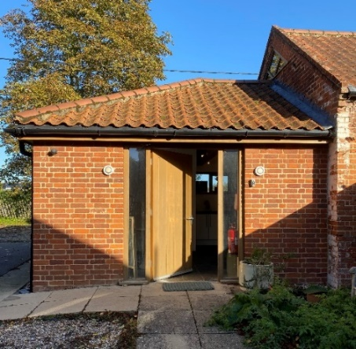

Rectory Lane
Rockland St Mary
NR14 7EY

11.30am-2.30pm
on these MONDAYS
April 27th
June 29th | Sept 28th
July 27th | October 26th
Free refreshments & lunches
Good company
Parking Free WiFi
For more information please contact Nick & Helen
01508 538014

