SUNDAY MORNING READING SHEET 22nd March 2026 5th Sunday of Lent

First Lesson: Ezekiel 37:1-14
Second Lesson: Romans 8:6-11

GOSPEL

When Jesus arrived, he found that Lazarus had already been in the tomb for four days. Now Bethany was near Jerusalem, some two miles away, and many of the Jews had come to Martha and Mary to console them about their brother. When Martha heard that Jesus was coming, she went and met him, while Mary stayed at home. Martha said to Jesus, ‘Lord, if you had been here, my brother would not have died. But even now I know that God will give you whatever you ask of him.’ Jesus said to her, ‘Your brother will rise again.’ Martha said to him, ‘I know that he will rise again in the resurrection on the last day.’ Jesus said to her, ‘I am the resurrection and the life. Those who believe in me, even though they die, will live, and everyone who lives and believes in me will never die.’ John 11:17-26a

CHURCH FLOWERS FOR EASTER: As usual, we will be arranging flowers in church for Easter. If you would like to make a donation towards the cost of the Easter flowers via a bank transfer, please contact Charlotte Wicks on email treasurer@roystonparishchurch.org.uk. Cash and cheque donations are also welcome if preferred. Cheques should be made payable to Royston PCC and can be given to either Clare Rice or Angela Sassoli. Your generous support for festival flowers is very much appreciated. Thank you.

LOOKING FORWARD, we will also be looking for donations of Easter eggs for the egg hunt on Easter Sunday, 5th April and chocolate items for a chocolate tombola at the Book Fayre, 2nd and 4th May. We are happy to take these at any time from now on so we can take advantage of any offers. Please leave all items in the kitchen. As always we ask that all food items have good dates on them as we cannot include out of date items! Thank you so much, the Events Committee.

UPCOMING EVENTS :There are a number of events coming up over the next few months to look forward to.
Julian Prayer meeting Thursday April 16th at 7pm at 11 Middle Drift.

18th April - Cheese and wine
24th April - - Organ Recital by Sean Maxwell
2nd & 4th May - Book Fayre 19th June - Hymns and PIMM’ s
20th June - Concert

Royston Parish Church
Where all are welcome and God’s love is shared
Sunday 22nd March 2026 - 5th Sunday of Lent
PASSIONTIDE

If you would like regular copies of the Notice Sheet emailed to you please email the Parish Office at admin@roystonparishchurch.org.uk

Please note that the clocks go forward one hour on the
29th March (Palm Sunday)

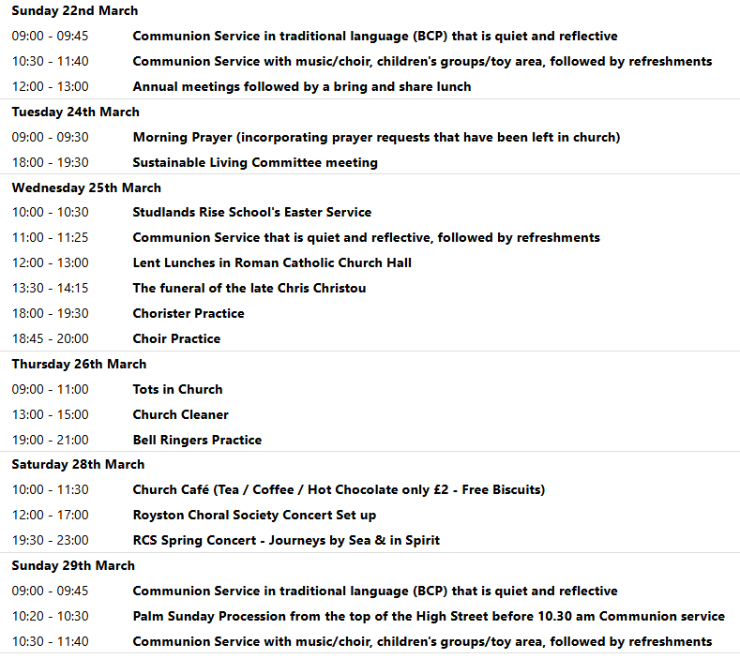

We pray for all Christians worldwide:
For all Christians in Denmark, Faroe Islands, Finland, Greenland, Iceland, Norway, Sweden
For all who worship at Therfield & Kelshall Parish Churches: Revd. Carol Newnham
For the work of our mission partners: Tear Fund
Pray for the community of Royston:
For our local health centres
For our local Roead sweeper and refuse collectors
We pray for our world and ECO projects:
18th March is Global Recycling Day; 21st March International Day of Forests; 22nd March World Water Day; 23 March World Meteorological Day; also 22nd March is the Earth Hour in which we are encouraged to turn off all non-essential lights for an hour to raise awareness for nature and climate action
We pray for the sick and suffering:
1st March 8th March 15th March 22nd /29th March
Lee Cockerill Ted Rayment Val Brown Peter Coates Pat Pritchard Paul & Pat Tidey Angie & Ken Rushall Margaret Green
Jackson Herbert Mike Brown Paula Walker Peter Foster Marion Keith & Elaine Edwards Gwen Simmons
Laura O’nyamul (On-Ya-Mul) Maria Turi Katie
Peggy Dawes Janet McElney George N. Susan Bowles

We pray for those who have died in the faith of Christ:
Deceased | Bereaved
Chris Christou | Anne, family and friends
Colin Fitch | Quentin, family and friends
Richard Moss | Wendy, Mark, family and friends

We pray for those whose anniversaries fall at this time:
Arthur Blair, Graham Brown, Allan Moule, Thomas Krippner, Lilian Bysouth

NOTICES

NEW BISHOP OF ST. ALBANS Downing Street has announced that the Rt Revd Dr Andrew Rumsey, currently Bishop of Ramsbury in the Diocese of Salisbury, is to be the next Bishop of St Albans. Bishop Andrew returns to the Diocese in which he was born and baptised, describing the appointment as "a homecoming" and saying he is thrilled to be joining a "fine team".

THE KNIT AND NATTER GROUP : will be having a craft stall at Church on Saturday 28th March 10-11.30 am, in aid of Church Funds. Please support us if you can.

THE FUNERAL FOR THE LATE CHRIS CHRISTOU: The funeral service to take place on Wednesday, March 25th 2026 at 1-30pm at Royston Parish Church followed by cremation at 3-00pm at Cam Valley Crematorium

THE FUNERAL FOR THE LATE COLIN FITCH: The funeral service to take place on Thursday 9th April 2026 at 2 pm at Royston Parish Church.

CHEESE and WINE:SATURDAY 18th APRIL, 7:00PM ROYSTON PARISH CHURCH
Tickets £12 Tickets must be purchased in advance for catering purposes

To book tickets scan the QR code, or visit the website below
https://tickets.myiknowchurch.co.uk/gb/NzcwMi0yNw/t
Ticket price includes cheese, crackers and a glass of wine or sparkling elderflower.
Additional drinks available for a charge. PROCEEDS IN AID OF CHURCH FUNDS

LENT LUNCHES IN AID OF CAFOD AND CHRISTIAN AID: Continues on 25th March. Venue - Roman Catholic Parish Centre, Melbourn Rd. - Entry for pedestrians and cyclists from School car park only. Lunches are served between 12 noon and 1pm
Donations for lunch: Suggested donation is £5pp. This will be distributed equally between Cafod and Christian Aid

CARBON FAST FOR LENT: Traditionally, Lent is a time when Christians fast and focus on God. You might also be interested in adding a “Carbon Fast” to think about our carbon footprint and ask if there is any excess or unnecessary use in our lives, and if any of that excess is acting as a distraction to our relationship with God. You can sign up at the website climatestewards.org/resources/carbon-fast-for-lent to receive a weekly e-mail with suggested activities. With a different focus each week, you’ll learn more, ask questions, and focus on what God thinks about these areas of our lives:
- Week 1: Delight in and responsibility for nature
- Week 2: Consumerism and shopping
- Week 3: Money and investments
- Week 4: Food waste and meat and dairy consumption
- Week 5: Transport and driving
- Week 6: Energy, electricity, and gas

- Week 7: Social media

If you wish to make a donation to the church, then please hold your
phone’s camera over this image then touch the link that appears:

