Step 6
The last inward section of the labyrinth takes us to the very centre where you can stop to linger. Give yourself some space for new ideas, memories, thoughts or a prayer, or you may just wish to stand and rest and ‘be’.
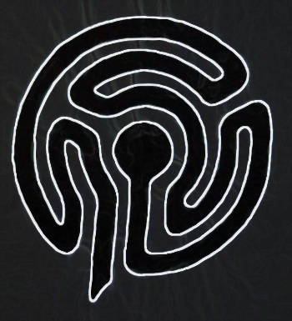
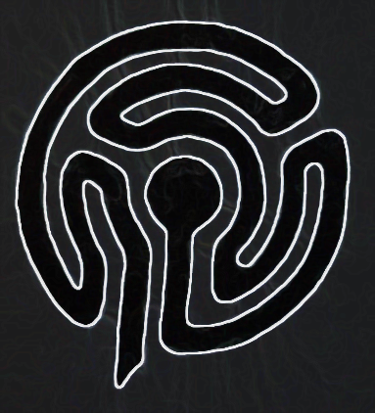
Step 7
When you’re ready, re-trace your steps. We may need to pick up some responsibilities again, but maybe we could leave some burdens behind? Congratulate yourself on having made the space for this mini pilgrimage. You’re very welcome to visit the church or picnic table or admire the view across the valley before you journey onwards.

This finger labyrinth is to take away for your own
prayer/meditation/reflection/keepsake.
For other local labyrinths see labyrinthlocator.org
The Spring Meadow Labyrinth
St Mary’s Church, Marton in the Forest
Stillington Road, YO61 1NH
This seasonal labyrinth is located to the right of the stone path
after you walk through the church gates from the roadside.
The labyrinth is a model of a path that has been used throughout the ages as a tool for pilgrimage, meditation or prayer. This ancient symbol creates a sacred space to allow us time to focus on our inner lives and journeys.
A labyrinth walk is open to everyone, just as they are, bringing people of all faiths or none together.
This labyrinth was created as a gift to visitors and our church and local community. As our churchyard is managed as a wildflower meadow, this is a temporary structure only, created with locally sourced sawdust (from D Wilson, Timber) which will gradually disappear as the grasses grow. The ‘Spring Meadow’ provides a fabulous show of daffodils every year. The labyrinth was designed and constructed by Peter Clark, an enthusiastic ‘labyrinaut’ who has very generously provided step-by-step advice, support and guidance. You can find out more about labyrinths here: labyrinthsinbritain.co.uk

Unlike a maze, a labyrinth has no dead ends.
You can get lost in a maze,
but in a labyrinth you can find yourself.
How to walk a labyrinth
There are no rules, no ‘right’ or ‘wrong’ ways. You are very welcome to do your own thing. These are just some ideas for anyone who wants to explore the labyrinth as a
mini-pilgrimage, prayer/meditation /mindful walk.
Please mind your steps as the ground is quite uneven!
Step 1
As we turn towards the labyrinth from the stone path we are facing east, towards where the sun rises. The church was built to orientate towards the east, as are the graves.
On Easter Sundays we hold a Dawn Vigil here to watch the sun rise and shine through the stained-glass windows.
First, walk all the way around the outside of the labyrinth. You may have tense shoulders or be holding your breath having walked, cycled or driven along these narrow country roads. This is an opportunity to slow down, relax, notice where you are, decompress, quieten racing thoughts and find your feet before you feel ready to begin.
Step 2
At the entrance to the labyrinth, consider if you are carrying any burdens that you could temporarily lay down.
Step 3
The first wave of the pathway leads you through a right turn back towards the entrance. At any time you can stop to look across the stone path to the mature trees and the grass paths to the picnic bench, pond and bird feeding station. You may be lucky enough to hear birdsong, the wind in the trees or insects buzzing. We are sometimes so busy that we forget to celebrate the miracle that we are alive. It’s good to stop and breathe and feel our heartbeat and recognise the life source within us and around us.
Step 4
Now we turn to the left to walk around the outside edge of the labyrinth. This brings us towards the right-hand side of the church, which houses the sanctuary and altar, considered to be holy places. Marton Church is an ancient place of worship that has been steeped in prayer for centuries. Many people find this a place of peace and tranquillity, whether they have a strong faith, or none. This could be an opportunity to breathe in that sense of peace.
Step 5
A left turn, right turn and left turn bring you back to face the church door and a stone angel from Marton Abbey. Marton Church is open every day, offering a welcome and hospitality to visitors and pilgrims. We wonder how many people will have visited this church over the years. This could be a moment to reflect on our own life journeys which have brought us here today, just as we are!

