
Bible Readings and Weekly Notices for the
Parish of St. Peter’s, Great Totham.
Fourth Sunday of Lent
Mothering Sunday
Sunday 15th March 2026

Forthcoming events:
Sat 28 Mar 10:00 Coffee Morning at The Honywood
Sun 26 Apl 10:00 Church Annual Meeting and Report

Diary for Week Commencing Monday 16th March 2026
Mon 16 09:30 Private Function in the Church Extension
Mon 16 17:30 ‘Rainbows’ in the Church Extension
Tue 17 09:30 Private Function in the Church Extension
Tue 17 19:30 P. C. C. Meeting in The Honywood
Wed 18 10:00 Baby Signage Group in the Church Extension
Wed 18 10:30 Bible Studies Group at the Honywood
Wed 18 19:30 Great Totham Community Choir in the Church Extension
Thu 19 10:30 Edward Bear Group in the Church Extension
Fri 20 10:00 ‘Knit and Natter’ Group in the Honywood
Fri 20 10:00 Baby Signage Group in the Church Extension
Fri 20 19:45 Great Totham Bell Ringing Practice
Sun 22 10:00 Morning Service of the Word Sunday Club
Sun 22 18:00 Evensong via ‘Zoom’ Contact Sue Godsmark



DONATIONS
To donate to St Peter’s Church: Scan the QR code;
make a BACS payment to St Peter's Church Great Totham (sort code 20-54-30, account number 20882739),
send a cheque (payable to ‘St Peter’s Church, Great Totham’) to 17 Goat Lodge Road CM9 8BU or use the link on our website: www.achurchnearyou.com/church/6657



Collect. God of compassion, whose Son Jesus Christ, the child of Mary, shared the life of a home in Nazareth, and on the cross drew the whole human family to himself: strengthen us in our daily living that in joy and in sorrow we may know the power of your presence to bind together and to heal; through Jesus Christ your Son our Lord, who is alive and reigns with you, in the unity of the Holy Spirit, one God, now and for ever. Amen.

First Reading Exodus 2. 1-10
Birth and Youth of Moses
¹ Now a man from the house of Levi went and married a Levite woman. ² The woman conceived and bore a son; and when she saw that he was a fine baby, she hid him for three months. ³ When she could hide him no longer she got a papyrus basket for him, and plastered it with bitumen and pitch; she put the child in it and placed it among the reeds on the bank of the river. ⁴ His sister stood at a distance, to see what would happen to him. ⁵ The daughter of Pharaoh came down to bathe at the river, while her attendants walked beside the river. She saw the basket among the reeds and sent her maid to bring it. ⁶ When she opened it, she saw the child. He was crying, and she took pity on him. ‘This must be one of the Hebrews’ children,’ she said. ⁷ Then his sister said to Pharaoh’s daughter, ‘Shall I go and get you a nurse from the Hebrew women to nurse the child for you?’ ⁸ Pharaoh’s daughter said to her, ‘Yes.’ So the girl went and called the child’s mother. ⁹ Pharaoh’s daughter said to her, ‘Take this child and nurse it for me, and I will give you your wages.’ So the woman took the child and nursed it. ¹⁰ When the child grew up, she brought him to Pharaoh’s daughter, and she took him as her son. She named him Moses, ‘because’, she said, ‘I drew him out of the water.’
This is the word of the Lord. - Thanks be to God.
New Revised Standard Version, Anglicised (NRSVA)

Second Reading Colossians 3. 12-17
¹² As God’s chosen ones, holy and beloved, clothe yourselves with compassion, kindness, humility, meekness, and patience. ¹³ Bear with one another and, if anyone has a complaint against another, forgive each other; just as the Lord has forgiven you, so you also must forgive. ¹⁴ Above all, clothe yourselves with love, which binds everything together in perfect harmony. ¹⁵ And let the peace of Christ rule in your hearts, to which indeed you were called in the one body. And be thankful. ¹⁶ Let the word of Christ dwell in you richly; teach and admonish one another in all wisdom; and

with gratitude in your hearts sing psalms, hymns, and spiritual songs to God. ¹⁷ And whatever you do, in word or deed, do everything in the name of the Lord Jesus, giving thanks to God the Father through him.
This is the word of the Lord. - Thanks be to God.
New Revised Standard Version, Anglicised (NRSVA)

Gospel Luke 2. 33-35
Hear the gospel of our Lord Jesus Christ according to N.
Glory to you, Oh Lord.
³³ And the child’s father and mother were amazed at what was being said about him. ³⁴ Then Simeon blessed them and said to his mother Mary, ‘This child is destined for the falling and the rising of many in Israel, and to be a sign that will be opposed ³⁵ so that the inner thoughts of many will be revealed—and a sword will pierce your own soul too.’
This is the Gospel of the Lord - Praise to you, O Christ.
New Revised Standard Version, Anglicised (NRSVA

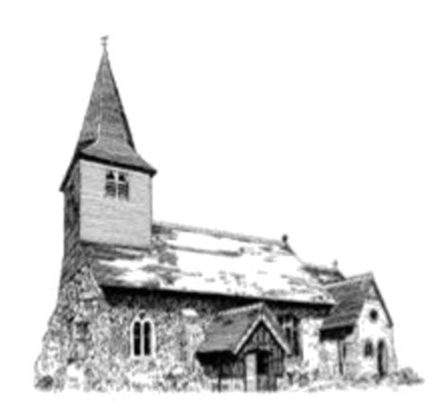

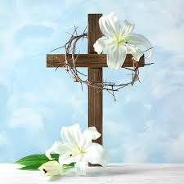
Easter Lilies
If you would like to donate towards the cost of an Easter Lily in memory of a loved one, please contact me on 01621 891220. We are suggesting a minimum donation of £5. We will be decorating the church for Easter from 9am on Saturday, 4th April. If you would like to help, you would be most welcome. Greenery and spring flowers would be much appreciated. Sue Keyes

In your prayer’s this week please include:
Our ‘Friendship Church’ - Bragernes Kirke, Drammen, Norway.
John Gladdish, Nina Pearce, Peter Roast.

Leading your church into growth - a prayer.
God of mission, who alone brings growth to your church, send your Holy Spirit to give vision to our planning, wisdom to our actions, joy to our worship, and power to our witness. Help our church to grow in numbers, in spiritual commitment to you, and in service to our local community, through Jesus Christ our Lord. Amen.


The Prayer for Peace in the World
Almighty God, from whom all thoughts of truth and peace proceed; kindle in the hearts of all people the true love of peace; and guide with your pure and peaceful wisdom those who take counsel for the nations of the earth; that in tranquillity your kingdom may go forward, till the earth is filled with the knowledge of thy love; through Jesus Christ our Lord. Amen.
Parish Magazine
We currently need volunteers to help deliver the Parish Magazine in Maypole Road ten times a year. If you can help (the rounds can be shared or split), please contact Helen on
'01621 891067 or e-mail parishmagazinetotham@yahoo.co.uk
PARISH CONTACTS
Benefice Administrator: (07908 776750
Rosie Pollock: *office.blackwaterbenefice@gmail.com
Diocesan Safeguarding Team: '01245 294444 safeguarding@chelmsford.anglican.org
Parish Safeguarding Representative: Vacancy
Churchwarden: Vacancy
Notices: If you wish to include any item on the weekly ‘Notices’ please contact Chris Munton E-Mail *cmmunton@ukmm.com '01621 891817 who also maintains the consolidated diary for the Church, Church Extension and The Honywood.
Please inform ALL bookings to avoid the possibility of any conflicts.

