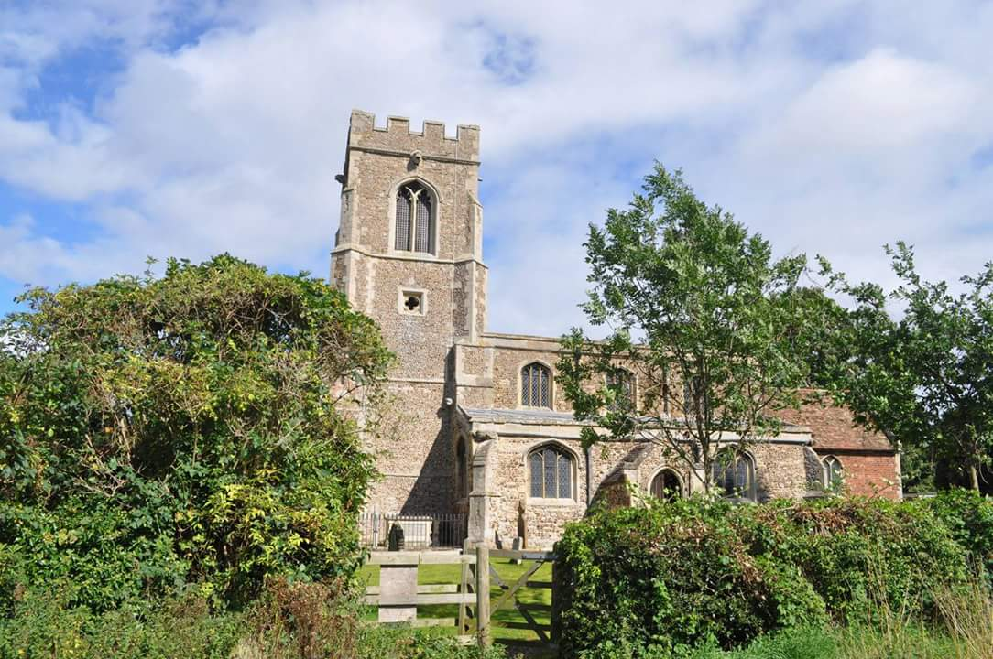

The Parish of All Saints Church,

Offord D’Arcy with Offord Cluny

Address for correspondence:
3 Opeford Close, Offord Cluny
PE19 5QA

Annual Report
and
Financial Statements

of the Parochial Church Council

for the year ended 31st December 2025

Currently in vacancy

Bankers:
Barclays Bank

Independent Examiner:
Mr. Malcolm Reece

Our website:
https://www.achurchnearyou.com/church/13931/

The Parochial Church Council is an Excepted Charity

The Parochial Church Council of All Saints Church
Offord Darcy with Offord Cluny

Annual Report
for the year ended 31st December 2025

Aim and Purpose

The Parochial Church Council (the PCC) has the responsibility of cooperating with the Churchwardens in promoting the ecclesiastical parish, the whole mission of the Church, pastoral, evangelistic, social and ecumenical. As well as the Church itself, which is a Grade II* Listed Building, the PCC is also responsible for the Church Rooms located in Offord Darcy. We are currently in vacancy, and there are also proposed changes to the benefice.

Objectives and Activities

The PCC is committed to enabling as many people as possible to worship at our Church and to become part of our parish family. Our services and worship put faith into practice through prayer and scripture, music and sacrament. We try to enable ordinary people to live out their faith as part of our parish family, through:
- Worship and prayer: learning about the Gospel and developing their knowledge and trust in Jesus.
- Provision of pastoral care for people living in the parish where we can; and
- Mission and outreach work.

To facilitate this work, it is vital that we maintain the fabric of the Church, which is currently in need of extensive repair and restoration.

Achievements and Performance
Worship and Prayer
The PCC have maintained our regular pattern of Sunday Services, since Rev David Sheppard left in June and we give thanks for the Rev Peter Taylor, Rev Miles Falla and Archdeacon Richard Harlow, who have enabled us to continue with two communion services a month and Chris Bylett ALM with Angel Voices and Anne Carter LLM who have done so much to keep our other services going. We have been successful in welcoming some new people into our church, and Songs of Praise on the third Sunday has continued to be very popular.
Attendance at 9.30 am service on Sundays has increased, and there was a huge turnout for the Christingle Service on Christmas Eve.
As well as our regular services, we enable our community to celebrate and thank God at the milestones of the journey through life. There has been one baptism and, sadly, several funerals and internment of ashes during the year. Rev Peter Taylor has also taken baptism and funeral services whilst we have been in vacancy, and we thank him for his support.

Deanery Synod
The first meeting of the year was cancelled as the speaker was unable to attend.
In May, Archdeacon Richard Harlow came and updated us on what was planned for the future with regard to the future ministry. This was important as the meeting also said farewell to David Shepperd, Annette Reed and Nicki Bland, all of whom were leaving in the following months. A presentation on finance was on the agenda, but the Diocesan Treasurer was again unable to attend. Richard, therefore, took questions regarding the parish share.
In September, the discussion focused on finance, as there is still no deanery treasurer. Parish reports were received from the various representatives. A farewell and thanks were given to Nicki Bland, as this was her last meeting as Rural Dean. The November meeting was predominantly a presentation by the Diocesan Environment Officer on trying to reach Net Zero Carbon. There was also another discussion regarding Parish Share, which remains an ongoing problem in the majority of parishes in the deanery.

Church Fabric
During 2025, efforts were made to tackle some of the outstanding building works listed on the 2024 Quinquennial inspection. The only successful repair was the replacement of cracked glass on window CW3 on the South facing Clerestory.
Chancel
Quotations were received for repairing the cracks and open joints on the exterior east-facing wall of the Chancel, as identified in the report. It was decided to pay for the repairs from existing church funds. Unfortunately, the “List B” authorisation was delayed, and the project was postponed until after the winter. An additional rainwater leak from the Chancel roof was identified, and it is proposed that the contractor should carry out all the work. The roof leak is likely to be the cause of the wall plaster failing in the area around the “Lady Chapel”.
There is a recommendation that the Chancel roof should be strengthened by the installation of roof ties. This would overcome the problem of the roof “spreading”. An inspection by a structural engineer has suggested a method of installation. Quotations for the work will be sought once the architectural specification has been received. The work might have to be grant-funded. The structural engineer was concerned that the Chancel floor in the area near the Altar was unsafe, and measures would have to be taken to avoid its use.
Porch
It was suggested that the cracks in the interior walls of the porch may be due to the way the door hinges have been fixed, and a remedy for the problem needs to be sought.
Nave
An additional temporary roof covering to the nave has been installed. The permanent replacement requires an ongoing bat survey, Building Regulations approval, Planning Permission, and a successful application for grant funding.
Bat Survey
An initial free-of-charge bat survey has been carried out, and an overall quotation of £4800 for a full survey has been received. The full survey would be a process covering a full year and needs to commence in May 2026. This would be required to accompany a planning application concerning the replacement nave roof.
Exterior Rainwater pipes
The issues of blocked rainwater downpipes and gullies have been addressed, although leakage from a joint in the cast iron gutter remains to be resolved.
Funding
Consideration needs to be given to the funding of the repair programme, and repair costs will likely have to be taken from the existing church funds to reduce the number of outstanding problems. Applications for grant funding will need to be made to overcome many of the outstanding repair and maintenance issues

Church Rooms
Readers may remember that a decision was taken some years ago that the Church Rooms should be sold, with a view to using the proceeds to improve All Saints' church. Unfortunately, the process has been far from straightforward, mainly because of legal issues and the need to obtain consent from the Charity Commission. However, at long last, these difficulties have been overcome, and by the end of 2025, we were preparing to place the building on the market for sale. In many ways, it will be sad to see it go, but with no funds to refurbish it, it is surely better for it to pass to someone else who can do so.

Mission and Evangelism
Helping those in need is a demonstration of our faith. The church supports the Godmanchester Food Bank with a collection box in the church and the village shop, and the harvest donations from both the school and the church go to this worthy cause.
A small group of volunteers continue to produce the village magazine Out and About (6 editions a year) and they are supported by a larger group of volunteers who deliver a copy of the magazine to every house in the village. It is also available online. We must also thank our advertisers who enable us to continue producing the magazine.
The local school is visited by our retired priest, Rev Taylor, and the school come to the church for services on occasion throughout the year.

Fundraising
Our regular bacon butty mornings continued throughout 2025. They are good fundraisers and also a great opportunity for the folk of the village and elsewhere to meet up for a natter and some good company. Thank you to the ladies who run the kitchen so efficiently for these events.
We held another prosecco and puddings evening in March, which was well supported and enjoyed by all. The array of puddings was amazing as always, and special thanks go to all the ladies who contributed their delicious creations.
The plant sale was a success. It caused a few extra grey hairs with the late delivery of the plants, but it is well worth putting on.
The summer fete was held in conjunction with the school and was a busy day, with the special event of a flyover by a Lancaster bomber as a commemoration of the Pathfinders was also held on that day in the church.
The church barbecue was held in the village hall again this year. It was well attended, and the food, as always, was excellent. Our thanks to Ian for doing the barbecue for us again and to all who contributed salads, etc.
November saw Tuxedo Swing fill the village hall. An amazing night was had by all who attended, and our thanks go to Jenny Murby and her family, who made it all happen.
A very successful Christmas tree festival and fayre was held in November with more trees than ever. The church looked very dull after they were taken down. There were a good number of stalls in the village hall, and our kitchen team kept everyone fed and watered throughout the day.
The year finished again with the Band Concert, which always heralds the beginning of the Christmas season. Our thanks to Carolyn, who organised this. Jenny Murby continued her popular monthly coffee mornings in her home. Thank you, Jenny.
We really appreciate the support of everyone who helps to put on all these events, which raise some of the money we need to keep our church running. It is a team effort and is greatly appreciated by your Churchwardens.

Safeguarding
The PCC has complied with the duty under section 5 of the Safeguarding and Clergy Discipline Measure 2016 (duty to comply with the House of Bishops’ guidance on safeguarding children and vulnerable adults). Thanks to our safeguarding officer, Lynne, for keeping us up to date.

Volunteers
The members of the PCC would like to thank all the volunteers who work so tirelessly to make our Church a happy and welcoming community. Our flower ladies, the cleaning crew, the churchyard and building maintenance team and our tireless fundraisers. We can only keep going with your help. Our special thanks go to our Churchwardens, John Simpkin and Sue Dorrington, for their work, especially whilst we are in vacancy.

Structure, Governance and Management
The method of appointment of PCC members is set out in the Church Representation Rules. The Council comprises the Incumbent, the Churchwardens, those elected to the Deanery Synod, and other members who are elected at the Annual Parochial Church Meeting, by those on the Electoral Roll. Members of the congregation are always encouraged to join the Electoral Roll and to consider standing for election to the PCC.
The PCC members are responsible for making decisions on all matters of general concern and importance in the parish, and for all financial matters. The full PCC met 10 times during the year. We have a buildings sub-committee consisting of Alan Griffiths, Stephen Eayrs, John Simpkin and Sue Dorrington who have been working on the many problems of the church building itself.

Electoral Roll 2025
A new register was compiled as required in 2025.
Following that revision period in April 2025, the number on the Electoral Roll had reduced from 66 to 39.
There were a further 4 applications after the end of the revision period, bringing the total number on role to 43. Sadly, during 2026, 2 more members have died, and their names will be removed during the 2026 revisor period. There were no other applications either to join the register or to have a name removed from it.

Administrative Information
The Church is situated just off the High Street in Offord Cluny and is part of the Deanery of St Neots, in the Diocese of Ely.
The PCC is a body corporate (PCC Powers Measure 1956, and the Church Representation Rules 2022) and a Charity excepted from registration with the Charity Commission.

PCC members who have served from 1st January 2025 until the date this report was approved were:

Ex Officio

The Incumbent The Rev’d David Sheppard (Until June)
Churchwardens Mr John Simpkin Chair
Mrs Susan Dorrington Vice Chair
Deanery Synod Reps Mr John Simpkin
Mrs Susan Dorrington

Elected Members Mrs Elizabeth Simpkin Secretary
Mrs Mandy Eayrs Treasurer
Mrs. Jenny Murby
Mr. Stephen Eayrs
Dr. Cynthia Rowbury
Ms. Helen Northrop
Mr. Alan Griffiths
Mrs. Norma Hollingsworth

Approved by the PCC on March 2026 and signed on its behalf by:

*
……………………………………. ……………………………………
John Simpkin (Chair) Mrs. Mandy Eayrs (Treasurer)

