CHURCH SERVICES IN CLIFTON, THE SHELSLEYS AND LOWER SAPEY (HARPLEY)
April 2026
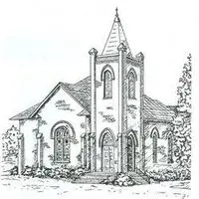

Friday 3rd April Good Friday
1pm: Devotional Hour, St Kenelm’s Clifton

Sunday 5th April Easter Day
6.00am: Dawn Service, Holy Communion, St Mary’s Stanford
9.30am: Family Service and Communion, St Bartholomew, Harpley
10.30am: Family Communion Service, St Kenelm’s, Clifton
11.00am: Family Service and Communion, All Saints,
Shelsley Beauchamp

Wednesday 15th April
10.30am: Holy Communion, St Andrews, Shelsley Walsh

Saturday 18th April
4.00pm: Welly Church, Experience Easter Outdoors,
St Kenelm’s Clifton

Sunday 19th April
10.00am: Praise 4 All, St Kenelm’s Clifton
6.30pm: Evensong, St Kenelm’s, Clifton

Sunday 26th April
10.30am: Circle Service St Bartholomew, Harpley

