Sharing Faith
Welwyn Team Ministry Lent Course 2026
Week One: Why do we share our faith?

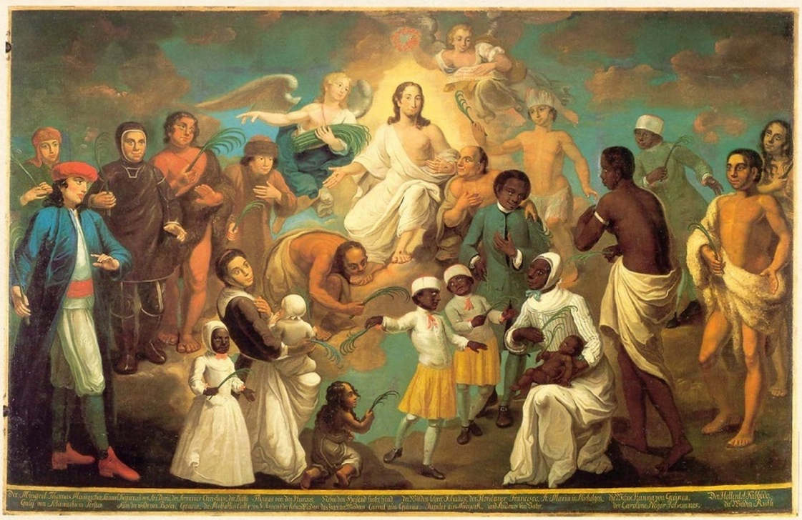
Johann Valentin Haidt, Erstlingbild, 1747, Oil on canvas, Museum Het Hernhutter Huist, Zeist

Introduction
Why should we talk about our faith to other people? Our faith is inherently personal to us, tied up in our own journey with God and our distinctive personalities. Talking about it to other people might make us nervous, or maybe we are just not sure what there is to say to other people. This Lent we are going to think about some of these questions, and more, but first we are going to start by thinking about why it is important for us to share our faith with others.
Read the bible Passage: Luke 24.36-53
Commentary
One of the tutors at Ridley Hall used to have a refrain when it came to sermon preparation: ‘where is the good news’ he would always say. ‘Good news’ is a direct translation of ‘Gospel’ (from Old English gōd “good” + spel “news”) which itself is a translation of the Greek evangelion, from where we get words like ‘Evangelist’, ‘evangelical’ and evangelise’. The language of ‘good news’ is baked into the technical language of the Church.
News is something that is meant to be spread, by definition it is noteworthy and should be of interest to people. But as Christians we have another reason to share this particular ‘Good News’, which is that Jesus has asked us to – this news ‘is to be proclaimed … to all nations, beginning from Jerusalem’ (v.47), or perhaps more directly in the words St Matthew reports: ‘Go therefore and make disciples of all nations’ (Matt 28.19).
Jesus Christ is not simply an historical person, not just a teacher to a group of 1st Century disciples, and St Luke makes clear in his narrating of the life of Jesus (and in his second volume on the life of the early Church) that the story he is telling is bigger than this one man, and these historical events. That there is a bigger meaning that transcends time and space.
The centre of the story is a historical moment: the suffering and death of Jesus on the cross, where he died to set people free from Sin, and rose again so that all might live reconciled with God. But Jesus also says that it is a fulfilment of ‘everything written about me in the law of Moses, the prophets, and the psalms’ (v.44) and explains that to the disciples by opening up the scriptures to them so that they can understand this wider significance.
This story starts before the beginning of all things (see John 1) and goes on to all eternity, which of course means that we are part of it. ‘You are witnesses of these things’ Jesus says to his disciples gathered around him (v. 48), but through the Holy Spirit we are witnesses too, and we are also sent to talk about this Good News of salvation and life.
St Paul in his Letter to the Romans (10.15) quotes the prophet Isaiah: ‘How beautiful are the feet of those who bring good news’ – those feet are beautiful because they carry the message of salvation to people who would not otherwise know about what Jesus has done for them on the cross.
To be able to say that there is Good News in the story of Jesus Christ we must also be able to say that it is good news for everyone. And if it is good news for everyone why should we keep it to ourselves?

Questions for discussion
- How does it make us feel when Jesus says we are to be ‘witnesses’ to the good news of salvation?
- What aspects of our faith and church life do we want other people to know about and experience?
- Talking about our faith to other people can be intimidating! What are the things that we find most challenging? How might we be better prepared?
Time for Reflection
Look at the picture on the front cover, whilst you listen to the music.
Music: How lovely are the messengers (From St Paul) Felix Mendelssohn-Bartholdy (1809-1847)
How lovely are the messengers that preach us the gospel of peace, to all the nations is gone forth the sound of their words.
https://www.youtube.com/watch?v=Ig8mjZjYW-c&list=RDIg8mjZjYW-c&start_radio=1
As we enter this time of reflection you might like to think about these questions:
- Who are the people who introduced you to faith in Jesus, or invited you to (or back) church for the first time? What might you want to say to them?
- How do we feel when we think about being part of a community of faith that spans across all people and nations (and time)?
From today’s session: What can we do to better share our faith?
- Reflect on what it means to say that Jesus death and resurrection is good news for all people?
- Think about what this good news means for us personally. How might we sum this up in one sentence?
Closing Prayers
Spend some time in prayer for the world, particularly those places which need to know the reality of God’s good news of peace. Pray for some of the people we know personally who we would like to know the good news. Perhaps you might want to use a world map, or write names down somewhere (privately or as a group) so that you can continue to pray for them throughout this Lent.

Sharing Faith
Welwyn Team Ministry Lent Course 2026
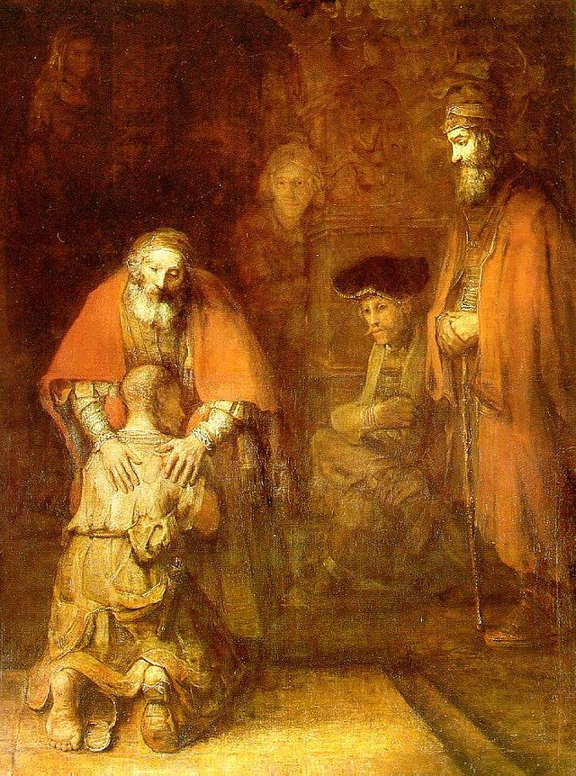
Week Two: What we believe: the story of Salvation
Introduction What is it that Christians believe? The vast numbers of theological books show us that there are endless depths to be plumbed in our Christian faith. The formal creeds of the church attempt to sum up the core tenants yet are still complex when we try and unpick them. So, if someone asked you to describe your faith in a nutshell what would you say? If you find that hard, perhaps remember at its heart the Christian faith is based upon a relationship between God and his people. In this session we will look at two passages from Scripture that give us an insight into what that relationship looks like and its implications for us all. Read the passage through first. Then read again, stopping at the verses mentioned in the commentary for added insights. Take each passage in turn.
Read the bible Passages: John 3:15 – 21 and Luke 15:11 – 24
Commentary
John 3:15 – 21 This passage is given as Jesus’ response to his encounter with Nicodemus, a man who wrestles with Jesus’ teachings. Feel free to do the same! V.14 A reminder to us of the long-standing story of sin and salvation in the history of the Jewish people (see Numbers 21:4-9). The cross does not appear in a vacuum. Our understanding of its meaning is enriched by knowing the Hebrew stories of the Exodus and Exile. V.15 ‘Believes’ in Greek (pisteuien) has a rich range of meaning, including believing truths, trusting in a person and committing one’s life to someone. ‘Life’ is a key theme in John’s gospel. ‘Eternal life’ – a common mistake has been to see this purely as life after death. It does include that, but it doesn’t begin there; those who trust Jesus now experience what it means for him to live in them, and they in him (John 10:10). V.16 This is perhaps one of the most famous verses in the bible; a God-centred summary of the gospel. God’s motive for sending Jesus, is love. Yet how can a father sending his son to a horrific death be loving? The key to this is understanding the intimate connection between the Father and Son (John 10:30). God’s love for the world is so profoundly deep that He comes to us, at cost to Himself, to bring us home. But what about the terrible possibility of ‘may not perish?’, which suggests that perishing is a possibility for some (or for all). Perhaps we have to hold that as a possibility, but also remember these things: i) John 12:32 Christ comes to draw ‘all people’ to himself. Karl Barth, in discussing the fate of Judas, affirms that Christians, in the light of Jesus, are able to hope for the best for all people (that goes back to pisteuien being a relationship of trust) ii) V17 – 20 affirms God’s desire to save not condemn. Condemnation is not through the Son, but rather already in action through human sin and a decision to live in the shadows rather than the light (Genesis 3:8). Could we understand condemnation as self-made? God’s gift in Jesus is eternal life, to receive and welcome that gift is to receive the life he offers. iii) Ultimately there is only one person whose decision we have control over – that is ourselves. Speculation over other people’s salvation is not our business (John 21:22), but we can tell others about the life we have found in Him. V 21 Faith and action are inseparably connected. Our deeds will testify to the light of Jesus.
Luke 15:11 – 24 (25 – 31) Jesus used stories to help people ponder the surprising ways of God. The story of the prodigal son is perhaps one of the best known. The story illustrates that a rebellious human desire for freewill can paradoxically entrap us into a life that is less than free. V12 In desiring his inheritance early, the son severs the relationship with his father dead, as if he were dead. V15 Working for a Gentiles and feeding swine would be horrific to Jesus Jewish listeners (Lev 11:7, Deut 14:8) . V16 ‘No one’ will help him. He is isolated away from relationship and community. V19 ‘hired hand’ a less secure position than a household slave – think zero contract hours! V22 robe and ring signify royal treatment and sonship. V 23 The fatted calf reserved for festive banquets or the day of Atonement. V 24 the proclamation of ‘was dead but alive, lost but is found’ echoes the two parables before of the Lost coin and Lost sheep. (For the sake of space v25 – 31 are not included but feel free to include in your discussion).
Questions for discussion:
John: 1) What stories in the Old Testament help us understand the story of God’s saving work in Jesus? 2) Pisteuian is more than just believing something to be factually true, but also about trust and commitment. Is that helpful? How does your personal Christian belief relate to this? 3) Does this passage inspire you to want to share the gospel story with others? If so, why? What is it that is worth sharing?
Luke: 1) Talk about the characters in the story in turn. Imagine how they would feel in each part 2) How does this story speak to you about God’s love? 3) Are there people we write off and think they are beyond coming home to God? 4) When we want to talk about faith, what is it that can stories offer that may be less easy with straight forward proclamation?
Time for Reflection
Look at the picture of Rembrandt’s Prodigal Son, whilst you listen to the music.
Music Blinded by your grace by English rapper Stormzy, from his 2017 album Gang Signs & Prayer. It was a top ten hit in the UK charts and performed by Stormzy while at Glastonbury in 2019 to an audience of over 150,000 (and TV audience of one million). Stormzy introduced the song saying ‘let’s now take it to church, and we’re going to give God all the glory right now’.
https://www.youtube.com/watch?v=wDlCWuQQ2uo
As we enter this time of reflection you might like to think about these questions:
- If I was kneeling at the Father’s feet, what would I say to him?
- In what situations or times can I see God’s grace in my life?
- Who would I love to see enveloped in the Father’s love?
From today’s session: What can we do to better share our faith?
- What are the stories in your life which speak of God’s grace?
- Think of three people that you know who need to hear about God’s grace. Could you commit to praying for them every day this week, that they might experience his love?
Closing Prayers
O Lord our God, grant us grace to desire you with our whole heart; that so desiring, we may seek and find you; and so finding, may love you; and so loving, may hate those sins from which you have delivered us; through Jesus Christ our Lord. Amen. Anselm (1109)
Sharing Faith
Welwyn Team Ministry Lent Course 2026
Week Three: Sharing Faith – How?
God’s story - Our story.
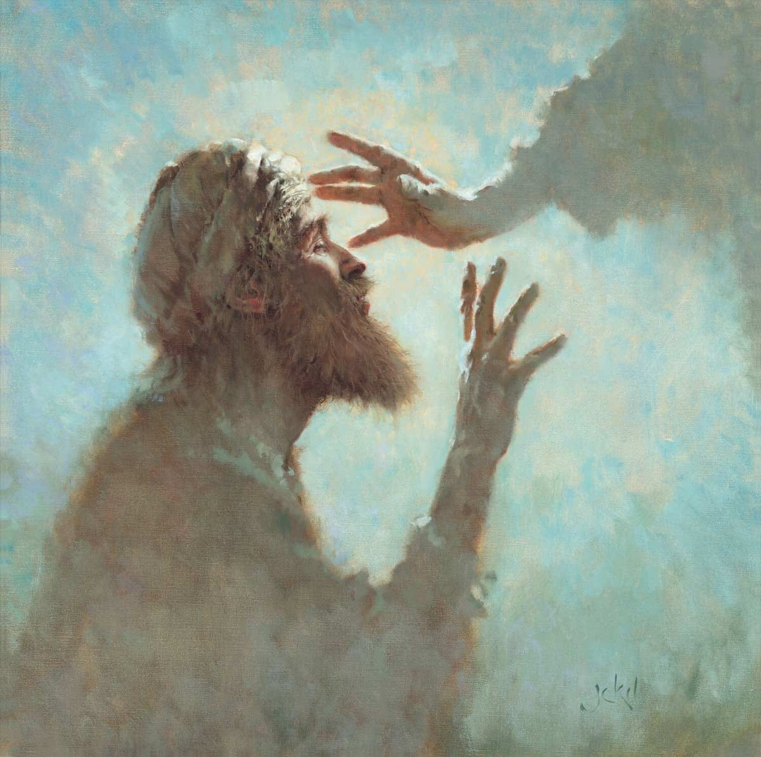

Introduction
If people are interested in our faith, what can we say? We may well feel that we can’t answer theological questions or have a well rehearsed answer. It depends on what we are asked, or the context of the conversation.
The reading from John’s Gospel describes a similar situation. Jesus heals a blind man. Afterwards people question him.
Read the Bible passage(s): John 9: 1-3, 6-16, 18-20, 24-25
Commentary
Jesus comes across a blind man and heals him. This causes anger from the local Jewish leaders and they ask the healed man lots of questions. He can’t answer them. The Jewish leaders then ask his parents who also can’t answer them.
Jews believed that illness is a result of sin, which is behind the disciples’ first questions (vv2,3).
The background to the story is that the Jews believe that only God can heal. Jesus is human yet is claiming to be God, which is blasphemy. He is known to have broken the Sabbath laws so can’t be from God. The healed man is out of his depth on theological matters.
The man’s parents are too scared to answer questions because anyone who openly said that Jesus was the Messiah would be expelled from the synagogue.
The man answers truthfully that he doesn’t know the answer to most questions.

Questions for discussion
Look at the questions people ask the healed man. What type of questions were they? How did he answer them?
What type of questions do people ask Christians today? Have you ever been asked about creation? (How can anyone make a universe in seven days? What about evolution?) or why people die (My son was very il and I prayed to God but my son still died) or the church (no one goes to church any more)
What kind of answers do we think that they want?
What was the healed man’s final answer. How effective was it?
How might we use a similar approach?
Can you think of a similar situation that you have been involved in?
What can you truthfully say about your faith? ‘All I know is…’ Share with another if you feel you can.

Time for Reflection
The picture is Jesus healing the Blind Man, an oil painting by Brian Jekel (born1951) Brian is a prolific painter using his talent to share God’s Story. This is a very intimate moment just before the blind man will be able to look into Jesus’ face.

What do we see in people when we look at them? Do we see the face of God in everyone we meet? Do people see God in us by the way we talk and behave? How does God see me?
The music, Amazing Grace by John Newton, is an autobiographical personal testimony charting his life journey from rebellious sailor and slave trader to a clergyman and abolitionist who felt saved by God’s mercy. Amazing Grace
Think in the next few weeks how you can share your faith story with others.
Closing Prayers
Gracious and loving God, as unique as we all are, so are our stories. In every detail, every memory, every element of our story, you are present. As we share our faith, we witness to your ever-present, ever-faithful, ever-loving accompaniment on our journey.

Help us, Lord, to share our faith stories in ways and with people who might come to know you more.
Show us those with whom you would like us to connect.
Thank you for those you have sent to share their stories with us.
Together, all our stories are a part of your story, for which we are grateful. Amen.
from “Faith reflections: Sharing our faith stories” by Tiffany C. Chaney
Sharing Faith
Welwyn Team Ministry Lent Course 2026
Week Four: Who?
The Holy Spirit

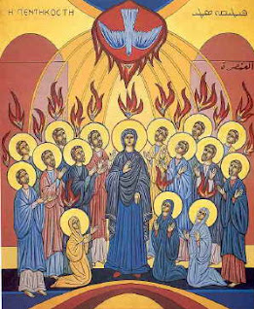

Introduction
Who does the Evangelism?
When given the task to spreading our faith in Christ to others it may well be that we say “ I can’t. I don’t know enough”. But we need also to realise it’s not just our mission that we do, it is always the ministry of Christ with the Holy Spirit. It was the Holy Spirit that turned Simon Peter afraid to own up to being a follower of Jesus in the courtyard of the High Priest into the great preacher and leader that he became on the Day of Pentecost and after. We are taught and led by the Spirit in many situations of our lives in which moments may occur when we can find the confidence to share what we know and what we gave received from others.

Read the bible Passage
“When the Advocate comes, whom I will send to you from the Father—the Spirit of truth who goes out from the Father—he will testify about me.²⁷ And you also must testify, for you have been with me from the beginning.
I have much more to say to you, more than you can now bear. ¹³ But when he, the Spirit of truth, comes, he will guide you into all the truth.
John 15.26-27 and 16:12-13

Commentary
The passage from John combines the two roles of the Holy Spirit as teacher to us about Christ, reminding us of things about Him that we can then convey to others with confidence and power to do so.

Questions for discussion
What do you see in the icon of Pentecost?
Why is the Spirit associated with fire?
In the passage from John why does Jesus call the Holy Spirit the Spirit of truth?
The passage speaks of the Spirit guiding us into truth rather than giving it all at once. How have you experienced faith as something that unfolds over time?
How have you experienced the Spirit as leader or teacher?
Can you think of everyday situations where the Spirit might prompt gentle, natural opportunities to share something of Christ?

Time for Reflection
Look at the picture on the front cover, whilst you listen to the music.
Music Hymn. Sing to him in whom creation
https://www.youtube.com/watch?v=7fIYNE0FTFg

From today’s session: What can we do to better share our faith?

Closing Prayers
You might like to imagine yourself in the Upper Room at Pentecost – think for a few minutes of how you might feel, what you might think, what you might want to do next.

The Collect for Pentecost Sunday:
God, who as at this time
taught the hearts of your faithful people
by sending to them the light of your Holy Spirit:
grant us by the same Spirit
to have a right judgement in all things
and evermore to rejoice in his holy comfort;
through the merits of Christ Jesus our Saviour,
who is alive and reigns with you,
in the unity of the Holy Spirit,
one God, now and for ever. Amen.

Sharing Faith
Welwyn Team Ministry Lent Course 2026
Week Five: When
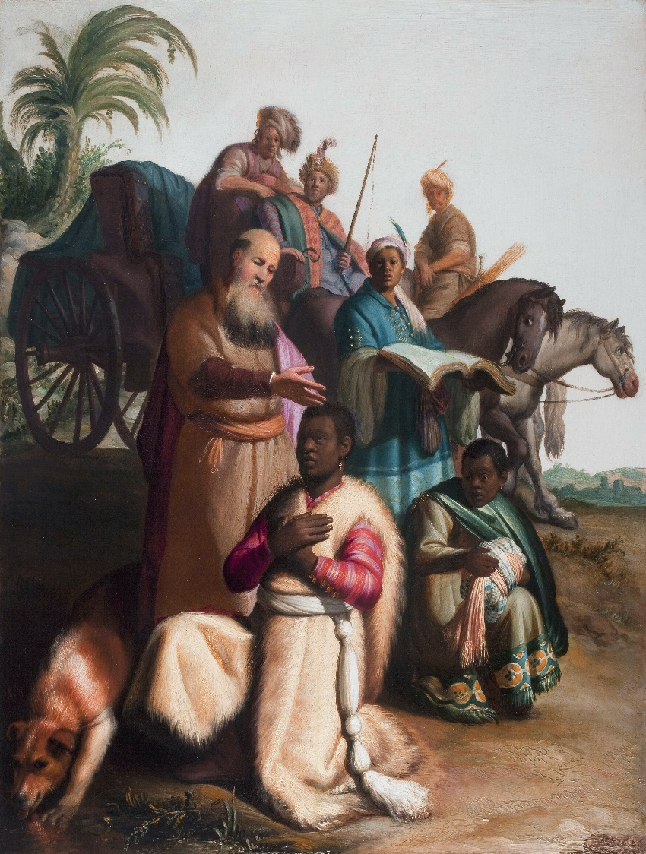

Introduction
Today we are thinking about the times WHEN we might share our faith with others. We will look at a couple of biblical examples.
In both of them what is perhaps surprising is how much is left to God, and our communication of the story of Jesus. In both cases there is little sign of strategy or programme.
Read the bible Passage(s): See sheet for text of Philip and the Ethiopian Eunuch (Acts 8:26-40), and Paul preaching Christ crucified (1 Corinthians 2:1-5)
Commentary
The story of the baptism of the Ethiopian eunuch is intriguing. Perhaps it is most intriguing to start at the end: What became of the Ethiopian eunuch? We are told nothing more of him following this story, though it is notable that Ethiopia was one of the first nations to embrace Christianity as its state religion. Just as the unnamed Ethiopian disappears, so in a sense does Philip. He is transported to Azotus and will not appear again for a dozen chapters.
The incident occurs at a cross-roads as the paths of the Ethiopian and Philip meet – at a place called Eleutheropolis. We can assume that the Ethiopian was a Gentile, particularly as he was a eunuch. Eunuchs were often kept as slaves in royal courts as they were not likely to become involved in sexual intrigue. However, it is highly unlikely he was Jewish, because eunuchs were not considered ‘whole’ men, and were not permitted to practice as Jewish men. So, the question is why was he travelling from Jerusalem and reading Isaiah? There was (and is) a very ancient Jewish community in Ethiopia, so he may well have been influenced by them. The book of Acts often refers to ‘God-fearers’ (or similar phrases). Scholars debate how formal a title that was, but it is generally accepted that there were substantial numbers of people who were impressed by Judaism and its writings, but were reluctant or in this case unable, to become full converts. Perhaps the most striking part of this story – and we might like to think about how we prepare for baptism today – is how quick it is. We can’t be sure how long Philips spoke to him for – we presume it was perhaps for several hours, but at the end of it, it is the eunuch himself who requests baptism, and in the nearest water he can find. As soon as he emerges from the water, Philip is no longer with him, so there can be no baptismal follow up. Also striking is the absence of any mention of the gift of the Spirit to the eunuch – this seems purely to have been ‘baptism in water.‘

Paul is writing to a troubled church in Corinth, riddled with splits and scandal (is there anything new under the sun?). In a sense Paul is playing a rhetorical game here. Paul is a very highly educated man, who displays learning, complex argument and rhetorical flourishes when he needs to in his letters. However here he is at pains to let the Corinthians know that these are mere decoration (it may have been that his rivals in Corinth, were glorifying in their own equal and perhaps greater learning and sophistication). What is powerful and converting for Paul is simply the story of Jesus – crucified and risen. For Paul, whilst he will give plenty of advice to the trouble church in Corinth, it is not the details of human argument which will provide the solution to their troubles. Rather in all things, Paul simply asks ‘what does it mean to say that Jesus is Lord?’

Questions for discussion
Many of those we baptise may not become regular members of our congregation – does that mean baptism is a waste of time?
Who are today’s ‘God fearers?’ Those who are intrigued but not ready to commit. How can we encourage them?
What does it mean to say that ‘Jesus is Lord’ today?
Time for Reflection
Look at the picture by Rembrandt on the front cover, whilst you listen to the music.
Music: Two contrasting pieces –
‘Down in the water’ A Bluegrass song based on the story of the Ethiopian Eunuch https://www.youtube.com/watch?v=1o0a1_fWirA
‘When I survey the wondrous cross’ words by Isaac Watts is a reflection 1 Cor 2:1-5. You might like to sing it together, or listen to it: https://www.youtube.com/watch?v=4_fvFfPqjO4&list=RD4_fvFfPqjO4&start_radio=1
From today’s session: What can we do to better share our faith?
As you go away today:
Think about our churches and those who come to baptism. Does our baptism policy and practice need to change?
The world is full of information. Some of it is helpful, some of it is unhelpful, some of it is ‘fake news.’ In such a world, how can we ‘know nothing except Jesus Christ and him crucified’?
Closing Prayers
The story of Philip and the Ethiopian eunuch is a good one to imagine yourself in. Put yourself in the place of Philip or the Eunuch, and take a few minutes to read the story again. Think about how you feel as the story unfolds.
End by saying this prayer together:
Dear Jesus, you came to us in humility and weakness, so that we might know the power of God’s love for us. Help us to forsake worldly wisdom and acclaim, and know that the only thing we have to offer the world is the power and wisdom of your cross. Amen.

