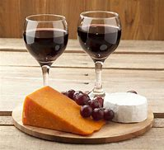

CHEESE and WINE

SATURDAY 18th APRIL, 7:00PM

ROYSTON PARISH CHURCH

Tickets £12

Tickets must be purchased in advance for catering purposes  To book tickets scan the QR code, or visit the website below | 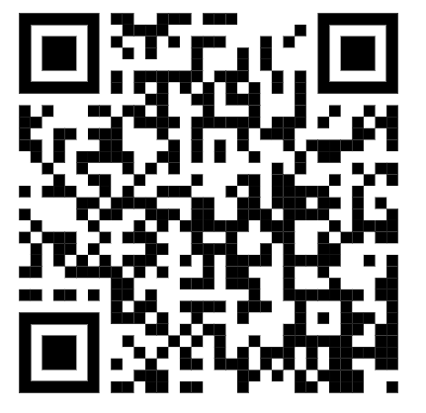
https://tickets.myiknowchurch.co.uk/gb/NzcwMi0yNw/t

Ticket price includes cheese, crackers and a glass of wine or sparkling elderflower.
Additional drinks available for a charge.

PROCEEDS IN AID OF CHURCH FUNDS

