Benefice Newsletter
with Thought for Thursday
for the parishes of Etton, Glinton, Maxey, Northborough and Peakirk
Thursday February 19th

Click for Website
https://9bridges.church/
Thought for Thursday

Thursday, when this is issued will be the 2nd day of Lent 2026.

Tuesday was ‘Shrove Tuesday’ historically when Christians confessed their sins and sought forgiveness, being “shriven” (absolved from their sins) presumably so they could enter lent with a clean slate. Today, more commonly we call it Pancake Day, historically again the day to use up all the nice things in the house before the austerity of Lent, but now more a bit of fun with pancake races and an excuse to eat pancakes with ever more exotic fillings.

Most people know of and celebrate Pancake Day, the media cover various activities on the day, celebrity chefs give guidance on the perfect pancake mix, and everyone debates their perfect filling and the best way to eat them. However much lest coverage and awareness surrounds Ash Wednesday. the day following, the day without which there would be no Shrove Tuesday.

Ash Wednesday marks the commencement of the period of Lent, a period of forty days culminating in Holy Week and Easter Day. The date on which Lent commences is calculated back from Easter Day which is linked to an archaic formula around particular lunar cycles, fixed by the Council of Nicaea in 325 AD.

Lent, for Christians. Is a period of reflection, deprivation, prayer, study, community service, and for very few fasting

Those of Muslim faith commemorate the period of Ramadan, a period of fasting, communal prayer, reflection and community. It is the ninth month of the Islamic calendar which is linked to the cycles of the moon so also moves every year.

This year by amazing coincidence the cycles of the Islamic calendar and the Christian Easter calendar have combined with both Ramadan and Lent both commencing on the same day a most unusual alignment of cosmic and spiritual events.
Muslims take their commitment to Ramadan (my generalisation) with fasting dawn to dusk, prayer regimes and community service, mutual supporting and sustaining each other.

As Christian we are called to examine our faith, our dedication and commitment to love and serve God and our neighbours.

This Lent we can think of and share our experiences with and be aware of those of other faiths who are following a similar regime of devotion and service to their God (actually the same God) and what it means to love our God and our neighbours.
In the love of Christ.

Reader Mark

Benefice Prayers

🙏 For Our Community
We lift up in prayer all who live in Rectory Lane, Peakirk, Firdale Close, Peakirk, Tuckers Nook, Maxey & School Lane, Glinton. May they be surrounded by love, peace, and the presence of God in their daily lives.
💙 For Those in Need of Healing
We pray for all who are suffering in mind, body, or spirit, especially those dear to us: Ann Rata, David Cupit and Bill Dean. May they find strength, comfort, and restoration.
🕊 For Those We Hold in Our Hearts
We remember with love those who have gone before us: especially, David Tapscott and Robert Layen. Eternal rest grant unto them, O Lord, and let perpetual light shine upon them.


How can we help? 💬

Life can be a lot sometimes — you don’t have to figure it out on your own.
Our Benefice Community Help drop-in runs every Friday, 2–4pm at St Benedict’s Church.
No pressure, no forms, no cost — just people who want to listen and help where they can.

You can:
☕ Pop in for a coffee and a chat
📍 Ask about local services or issues
💭 Share worries (big or small)
📱 Get help with phones, tablets, or online stuff
🤝 Or just sit and be for a while
You don’t need to be religious.
You don’t need to be in crisis.

It’s completely free.
Just come as you are — we’ll start with one simple question:
How can we help?
Feel free to share or tag someone who might find this useful 💛

SERVICES NEXT WEEK
SUNDAY 1st March
09:00 Morning Worship – Glinton
10:30 Sung Communion – Peakirk
15:00 Messy Church – Peakirk Village Hall
18:00 Celtic Evening Prayer – Northborough
(Special sung service with benefice choir)

DATES for your DIARY
Friday 20th February  6.00pm to 8.00pm  Messy Church Family and Friends Bottle Bingo  Peakirk Village Hall  Bingo games for all the family. (Please bring a wrapped bottle, maximum value £5.00, towards the prizes)  Half time pizza  £5.00 a table for a family/friends group  To book : communications@9bridges.church or text 07731669264 |  | 
Sunday 22nd February  9.30am - 11.30am  St. Pega’s Cafe Brunch  Peakirk Village Hall  Full English Breakfast  Continental Breakfast  Bacon Roll  To book : sheila.lever@btinternet.com or  01733 252416 | 
St Andrew’s Church, Northborough  Annual Quiz with Peter Kemp  6th March 2026 at 7.30pm  Northborough Village Hall  £10 per person, light supper included  BYO drinks  Tables of up to 4  Please book with Polly – 01778 380849  Or Jane – 01778 345101 | 
Mothering Sunday  15th March 2026  Services across the Benefice | 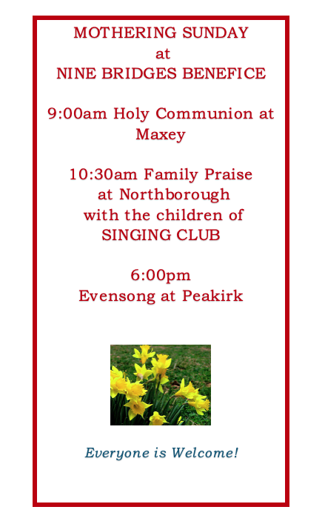
St. Benedict’s Church, Glinton  Lent Lunch  Wednesday 18th March 2026  12:00 - 13:30  Glinton Village Hall  Homemade soup, crusty bread, cake and drink  Tickets £10 from  Julie 01733 252712  Helena 07802 279756 | 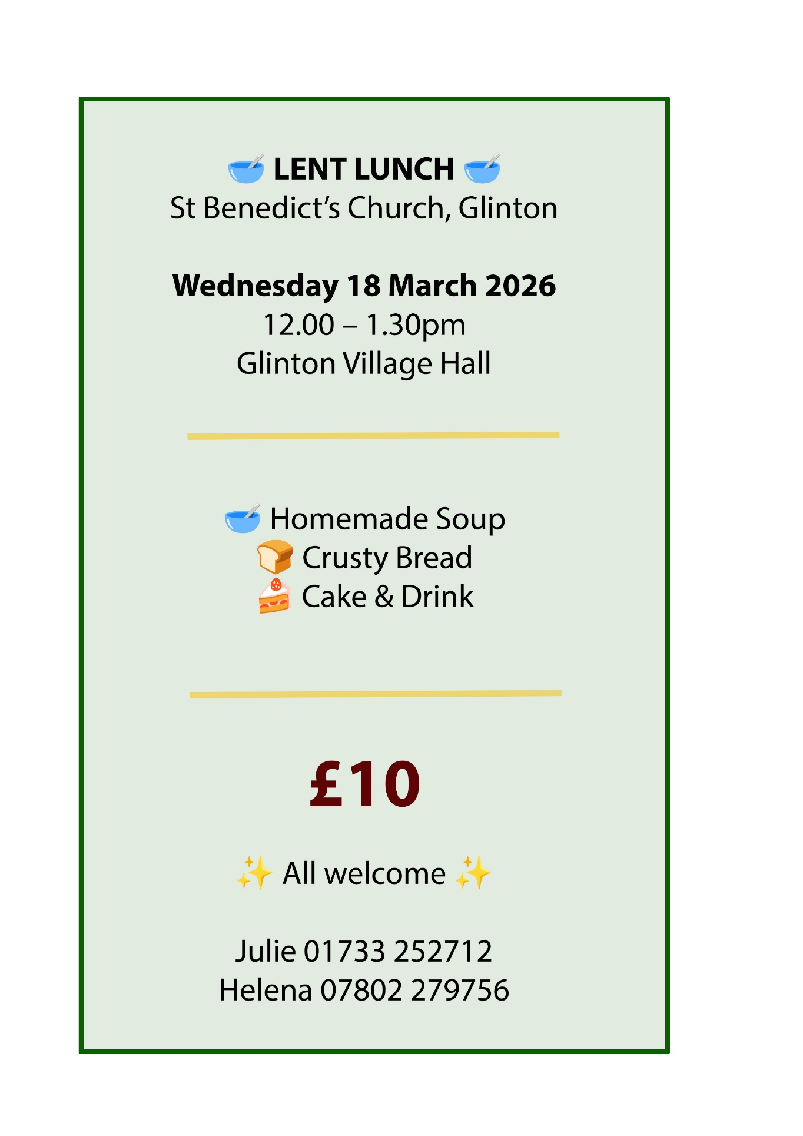
The Nine Bridges Benefice Choir is delighted to be singing Sir John Stainer’s  much-loved Passiontide work The Crucifixion during Holy Week, on Tuesday 31st March at 7.00pm, at St Peter’s, Maxey.  First performed in 1887, The Crucifixion is a deeply moving meditation on the events of Good Friday. Written to be accessible yet profoundly expressive, it weaves together scripture, reflective choruses, and well-known congregational hymns that invite listeners to contemplate the meaning of Christ’s suffering and love. For many, its music has become inseparable from the spiritual journey of Holy Week.  The Nine Bridges Benefice Choir draws together singers from across our churches, united by a shared love of worship, music, and community. Regularly leading services and special events around the benefice, the choir brings warmth, commitment, and joy to everything it sings.  We are especially pleased to be joined by our soloists Bradley Smith (Tenor) and Simon Richards (Bass), whose roles as the Evangelist and Christus bring clarity, drama, and depth to this powerful work.  All are very welcome to come and listen, reflect, and prepare their hearts for Easter through this beautiful and prayerful music. | 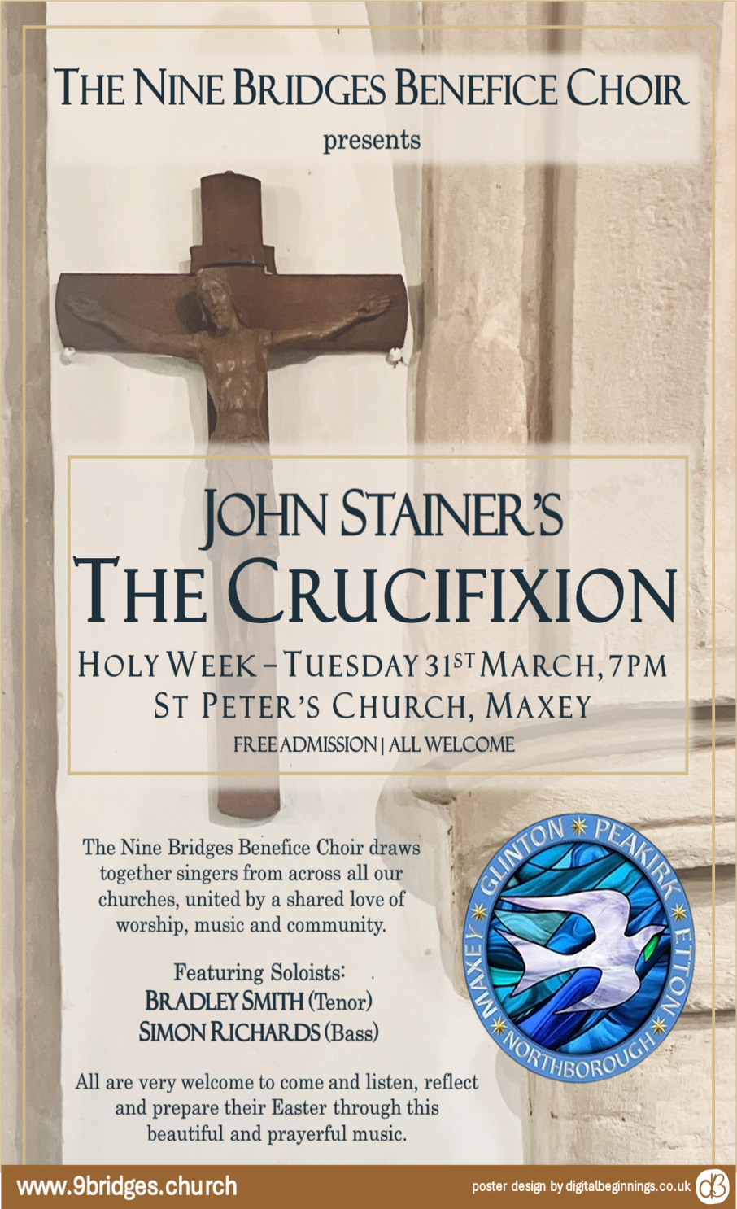

REGULAR DATES for your DIARY
Every Wednesday  St Benedict’s Glinton  Singing Club for Children  https://9bridges.church/singing-club/ | 

NEWS

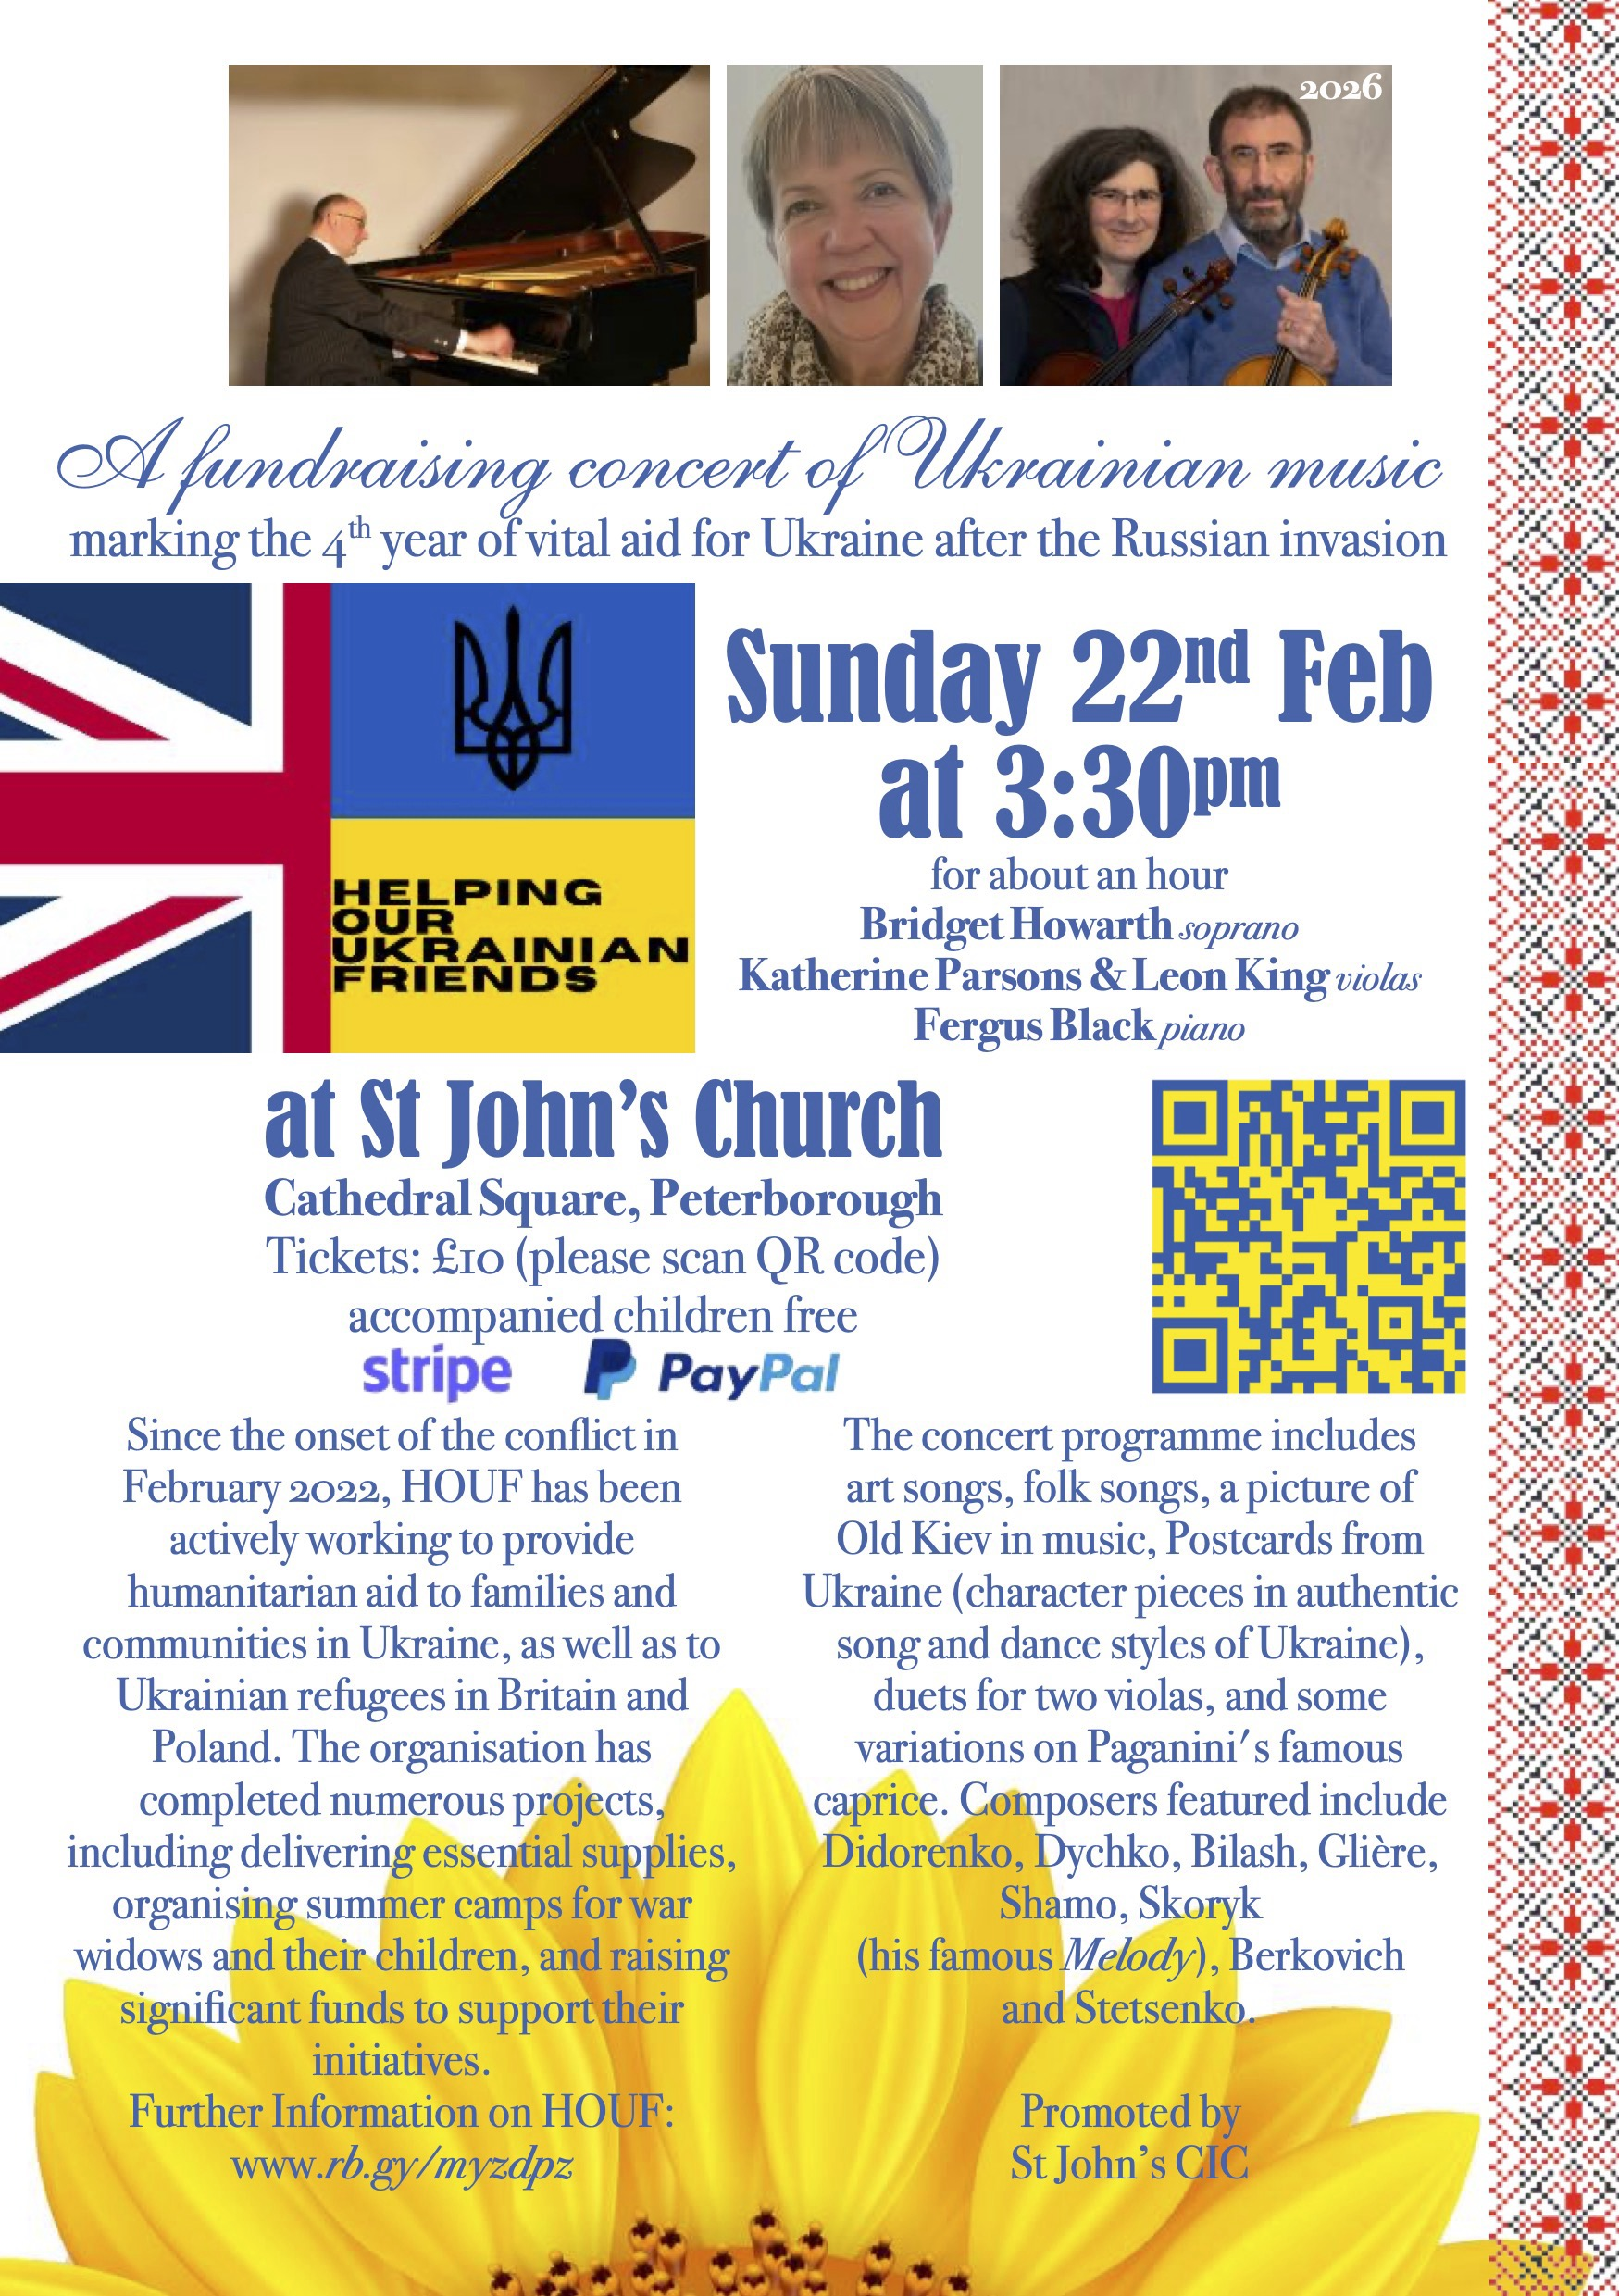 |  | 



Across Peterborough is a communication tool with a website, social media and newsletter.
It is managed by Light Project Peterborough
https://www.lightprojectpeterborough.org.uk
whose aim is to enable and
equip the church and community to heal the broken hearted,
set free the oppressed and bring good news to the poor.

Wherever you are on your life journey we hope you will find something useful there.
Their aim is to showcase some of the amazing work done in our city and provide
resources that will help improve the Peterborough community.

We will be sharing more content from across the city in the future.
https://www.acrosspeterborough.org.uk

This Week’s Collect and Readings

Collect
Heavenly Father, your Son battled with the powers of darkness, and grew closer to you in the desert: help us to use these days to grow in wisdom and prayer that we may witness to your saving love in Jesus Christ our Lord. Amen

Genesis 2.15–17; 3.1–7
The Lord God took the man and put him in the garden of Eden to till it and keep it. And the Lord God commanded the man, ‘You may freely eat of every tree of the garden; but of the tree of the knowledge of good and evil you shall not eat, for in the day that you eat of it you shall die.’ Now the serpent was craftier than any other wild animal that the Lord God had made. He said to the woman, ‘Did God say, “You shall not eat from any tree in the garden”?’ The woman said to the serpent, ‘We may eat of the fruit of the trees in the garden; but God said, “You shall not eat of the fruit of the tree that is in the middle of the garden, nor shall you touch it, or you shall die.” ’ But the serpent said to the woman, ‘You will not die; for God knows that when you eat of it your eyes will be opened, and you will be like God, knowing good and evil.’ So, when the woman saw that the tree was good for food, and that it was a delight to the eyes, and that the tree was to be desired to make one wise, she took of its fruit and ate; and she also gave some to her husband, who was with her, and he ate. Then the eyes of both were opened, and they knew that they were naked; and they sewed fig leaves together and made loincloths for themselves.

This is the word of the Lord. Thanks be to God

Romans 5.12–19
Therefore, just as sin came into the world through one man, and death came through sin, and so death spread to all because all have sinned— sin was indeed in the world before the law, but sin is not reckoned when there is no law. Yet death exercised dominion from Adam to Moses, even over those whose sins were not like the transgression of Adam, who is a type of the one who was to come. But the free gift is not like the trespass. For if the many died through the one man’s trespass, much more surely have the grace of God and the free gift in the grace of the one man, Jesus Christ, abounded for the many. And the free gift is not like the effect of the one man’s sin. For the judgement following one trespass brought condemnation, but the free gift following many trespasses brings justification. If, because of the one man’s trespass, death exercised dominion through that one, much more surely will those who receive the abundance of grace and the free gift of righteousness exercise dominion in life through the one man, Jesus Christ. Therefore, just as one man’s trespass led to condemnation for all, so one man’s act of righteousness leads to justification and life for all. For just as by the one man’s disobedience the many were made sinners, so by the one man’s obedience the many will be made righteous.

This is the word of the Lord. Thanks be to God

Matthew 4.1-11
Hear the Gospel of our Lord Jesus Christ according to Matthew.
All Glory to you, O Lord.

Jesus was led up by the Spirit into the wilderness to be tempted by the devil. He fasted for forty days and forty nights, and afterwards he was famished. The tempter came and said to him, ‘If you are the Son of God, command these stones to become loaves of bread.’ But he answered, ‘It is written, “One does not live by bread alone, but by every word that comes from the mouth of God.” Then the devil took him to the holy city and placed him on the pinnacle of the temple, saying to him, ‘If you are the Son of God, throw yourself down; for it is written, “He will command his angels concerning you”, and “On their hands they will bear you up, so that you will not dash your foot against a stone.” ’Jesus said to him, ‘Again it is written, “Do not put the Lord your God to the test.” ’ Again, the devil took him to a very high mountain and showed him all the kingdoms of the world and their splendour; and he said to him, ‘All these I will give you, if you will fall down and worship me.’ Jesus said to him, ‘Away with you, Satan! for it is written, “Worship the Lord your God, and serve only him.” ’Then the devil left him, and suddenly angels came and waited on him.

This is the Gospel of our Lord; Praise to you, O Christ

And Finally

Thank you for your continued support, providing me with all your news and events. Your feedback on the format of this email would be very much appreciated.
Simon
admin@9bridges.church
You can use the email address above to UNSUBSCRIBE
You are also free to share this with friends and relatives, who can in turn SUBSCRIBE by emailing the same address

