
St Augustine of Hippo
Grimsby

A Forward in Faith Parish

Parish Magazine



February 2026

Our Giving

Bank details for standing orders or donations are:
TSB Bank
St Augustine of Hippo PCC
Sort Code: 30-93-72 Account Number: 00159954

You may have seen that many charity bank accounts have started
charging fees for every day transactions. It costs us money to bank cheques and cash, which devalues the amount of the donation/payment. We are therefore asking that, wherever possible, people donate money using online banking, even for small amounts. This doesn't cost us a penny. Please indicate in the reference field who it's from, and what for, then we can Gift Aid your donation wherever possible. Gift aid forms should be completed for regular giving by standing order if applicable. Thank you.


Donating by card or phone

We have a card machine positioned at the back of church near the south door as an alternative way of giving. Please bear in mind that a percentage of all giving using this method (between 1% and 2%) is taken by the provider.

Regular Sunday giving by oﬀertory collection plate


It is no longer necessary to use gift aid envelopes for cash donations of £30 or less. This again keeps administration down. However, should you wish to make a higher donation, please use gift aid envelopes as usual.
Anniversary of Deaths / Year’s Mind Parish Records for February
Date Year Forename Surname Age

3 2019 Marie Lilian Whitworth 99
12 2010 Annie Howarth 83
22 2014 Lilian May Laceby 90

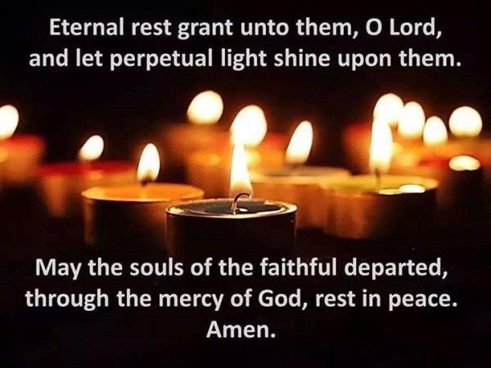

If you have any additional information to complete any gaps for those
listed, or information relating to anyone you know of who should be
included please let me know on: mrs.maria.mason@gmail.com

Thank you

Maria
February Worship Times

Fourth Week in Ordinary Time
Sunday 1 February 10am Sung Parish Mass
Monday 2 February 10am Said Mass
Tuesday 3 February 6.30pm Sung Mass for the Epiphany
Wednesday 4 February 10am Said Mass followed by Coffee Morning

Fifth Week in Ordinary Time
Sunday 8 February 10am Sung Parish Mass
Monday 9 February 10am Said Mass
Tuesday 10 February 6.30pm Said Mass
Wednesday 11 February 10am Said Mass followed by Coffee Morning

Sixth Week in Ordinary Time
Sunday 15 February 10am Sung Parish Mass
3.30pm Evensong and Benediction
Monday 16 February 10am Said Mass
Tuesday 17 February 6.30pm Said Mass
Wednesday 18 February 7pm Sung Mass with the imposition of ashes

First Week of Lent
Sunday 22 February 10am Sung Parish Mass
Monday 23 February 10am Said Mass
Tuesday 25 February 6.30pm Said Mass
Wednesday 26 February 10am Said Mass followed by Coffee Morning



February 2026 Calendar
Dates, Observances and Prayer Intentions
Month of Devotion to the Holy Family
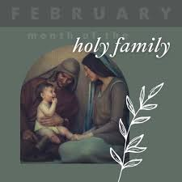
Date Feast Intentions
1 The Presentation of the Lord The Parish
2 Feria New Monasticism
3 Feria Bishop Luke
4 St Gilbert Sempringham Parish
5 St Agatha Those who are abused
6 St Paul Miki and Companions Persecuted Christians
7 Feria The Bishop of Oswestry
8 5th Sunday in Ordinary Time The Parish
9 Feria The Diocese of Llandaff
10 St Scolastica Benedictines
11 Feria The Shrine of Lourdes
12 Feria Dominicans
13 Feria Bishop Stephen
14 Ss Cyril and Methodius Bible Translators
15 6th Sunday in Ordinary Time The Parish
16 Feria Archdeacon Eleanor
17 Feria Bishop Elect Jean
18 Ash Wednesday The Parish
19 Lenten Feria The Bishop of Beverley
20 Lenten Feria Lisle Marsden Academy
21 Lenten Feria Lawyers
22 1st Sunday of Lent The Parish
23 Lenten Feria Spiritual Directors
24 Lenten Feria St Andrew’s Hospice
25 Lenten Feria The Diocese of Canterbury
26 Lenten Feria Our PCC
27 Lenten Feria Our Organist and Choir
28 Lenten Feria Our Servers

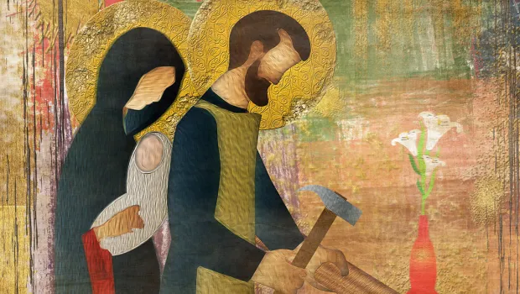

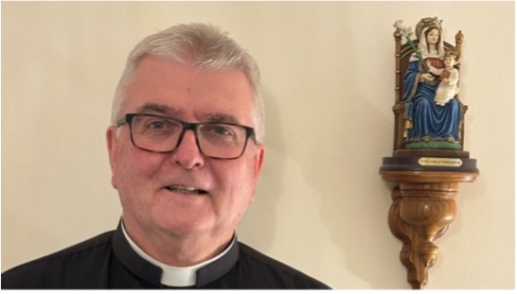

Fr Adrain Writes


I have a recollection of doing some form of exercise where the leader/tutor would end a part of the session by saying;

And breath……and relax. The “and” especially was drawn out.

Candlemass, which we are celebrating on February 1st (Sunday, rather than it’s usual February 2nd) is supposed to give us that chance to breathe and relax. We finish the extended period of Christmas and begin a time of looking forward to Easter.

However, this year Easter comes early. The method of calculating the date for Easter is rather complex. If anyone is interested, I would be quite happy to show you the method. You need a bit of logic!!

Of course, because Easter is early, Lent comes early, starting with Ash Wednesday on 18th February. This means there is little time for us to relax and breathe easily. We go straight into Lent. Lent is called the Penitential season, which is a period of time when we have a chance to prepare for the great festival of Easter; we look forward and get our heads, hearts, bodies and souls in the right place to rejoice as much as we can when the great day arrives.

As such, and because we live in the Northern Hemisphere, Lent can seem very dull, miserable and even depressing. Let’s try and give those feelings a miss.
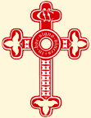
As most of you know I am a member of the Clery Brotherhood, The Society of the Holy Cross. Part of our Rule of Life suggests to us “The Brethren shall regard the Lenten fast as a joyful season of sacrifice and through self-discipline and denial to prepare fully to greet the Risen Lord.”

I recommend it to all!

Self-discipline and denial sound anything but joyful and indeed if we are not careful it is this that turns the joyful season to misery. In order that we don’t set ourselves up to fail, which would definitely turn the joyful season of Lent into a misery, let’s not undertake too much. It’s a bit like New Year Resolutions; if we make too many we quickly lapse.

I plan some extras to happen in church which may help some of us with and through Lent. I hope that we can have some sort of Lenten discussion group after our Mass on Wednesdays. I hope that on Tuesday evenings, in place of our usual mass, we can pray the Stations of the Cross and end the liturgy receiving the Holy Communion, as we did last year. Whilst this is very solemn, hopefully it will be joyful for us as we remember all that Jesus did for us and receive Him risen in the Blessed Sacrament.

Personally, I plan to eat a vegetarian diet though the season, for various reasons; I care about animal welfare; I care about the Father’s creation and our husbandry of it.

Let’s be sure that we don’t do nothing for the joyful season. However, let’s try to ensure we don’t set ourselves up to fail.


Fr Adrian

February Month of Devotion to the Holy Family

The month of February is traditionally dedicated to the Holy Family. Between the events which marked Christmas and the beginning of Christ's public life the Church has seen fit to recall the example of the Holy Family for emulation by the Christian family.
The Solemnity of the Holy Family is celebrated on the Sunday in the Octave of Christmas, or December 30 when Christmas falls on a Sunday.
Outside of the feast, the faithful have frequent recourse to the Holy Family of Nazareth in many of life's circumstances: joining the Association of the Holy Family so as to model their own families on the Holy Family of Nazareth; frequent prayers to entrust themselves to the patronage of the Holy Family and to obtain assistance at the hour of death. -- Directory on Popular Piety and the Liturgy
The feast of the Holy Family, granted to certain dioceses by Leo XIII in 1893, was inserted in the general Calendar of the Roman rite by Benedict XV in 1921.
The liturgy of the Feast takes us back to Nazareth, that we may catch a glimpse of the life of the Holy Family. We are begotten in the bosom of our family; in the midst of our family we grow to maturity. We are all called to live a family life, whether it be the life of a human family in this world, or the life of the supernatural family, which is the Church (through baptism), or the life of a religious family (through religious profession). Thus we may all go to Nazareth and with profit observe the model that is offered to us, so that we may shape our lives after that example.
The life of the Holy Family at Nazareth is sketched for us in the Gospel of the feast. The entire family goes up to Jerusalem to offer the prescribed sacrifice. There Joseph and Mary lose the child and return to Jerusalem in deep sorrow searching for Him. Eventually they find Him in the Temple, and Jesus becomes subject to them. The life of the Holy Family is characterized by zeal for religion and prayer, and by the love that binds it together. Moreover, Jesus, the Son of God, shows a respectful obedience to Joseph and Mary. "And He was subject to them." Come and observe, and learn to imitate this divine model.

The spirit of the Holy Family and its characteristic virtues are pictured for us in St. Paul's words to the Colossians (3:12-17), "Brethren, put ye on, therefore, as the elect of God [through holy baptism], holy and beloved, the bowels of mercy, benignity, humility, modesty, patience; bearing with one another and forgiving one another if any have a complaint against another; even 'as the Lord hath forgiven you, so do you also. But above all these things, have charity, which is the bond of perfection; and let the peace of Christ rejoice in your hearts, wherein also you are called in one body; and be ye thankful. Let the word of Christ dwell in you abundantly, in all wisdom; teaching and admonishing one another in psalms, hymns, and spiritual canticles, singing in grace in your hearts to God".
An inspiring model, a precious instruction! The sacred liturgy, however, is not satisfied with this. She opens to us the sources of strength which are needed for a good, Christian family life. She opens these to us through the Holy Sacrifice of the Mass, Holy Communion, and prayer.
A devoted family spirit and these family virtues are a precious possession both for the human family and for the supernatural family. Among these virtues we may call attention especially to:
- the will and effort to be of one heart and one soul in chaste love;
- to the disposition of devotion to one another, bearing each other's faults and forgiving each other's mistakes;
- to the disposition to serve one another and to subject one's own interests to the common good of the family;
- to the disposition to do whatever is necessary for mutual understanding and mutual appreciation.
To live a good, Christian family life requires sacrifice, the renunciation of one's own wishes, and a reasonable mortification of self. If it is to be perfect, it requires complete victory over self-love. It requires a high degree of virtue, deep piety and living faith, much prayer, and a close union with God.

In our day the very foundations of family life have been shaken by the failure of so many marriages. For this reason, the devotion to the Holy Family of Nazareth takes on a new meaning and a new importance. The modern family must again be rejuvenated and filled with the spirit of the Holy Family of Nazareth. It must recapture the spirit of faith, the spirit of subjection to the will of God. It is for this intention that we should offer our prayers and sacrifices during the month.
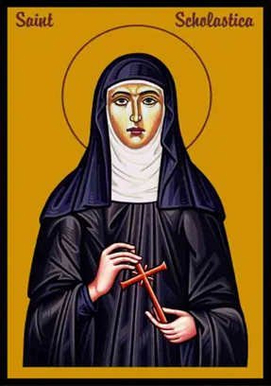
Feast of St Scholastica
On 10 February, the Catholic Church remembers St. Scholastica, a nun who was the twin sister of St. Benedict, the “father of monasticism” in Western Europe.
The siblings were born around 480 to a Roman noble family in Nursia, Italy. Scholastica seems to have devoted herself to God from her earliest youth, as the account of Benedict’s life by Pope Gregory the Great mentions that his sister was “dedicated from her infancy to Our Lord.”
The twins’ mother died at their birth. When Benedict was old enough he left home to study in Rome leaving Scholastica with her father to tend the Nursian estate. In time, Benedict left his studies to live first as a hermit, and then as the head of a community of monks in Italy.
When Scholastica learned of her brother’s total dedication to the Lord, she was determined to follow his example. It is not certain that she became a nun immediately, but it is generally supposed that she lived for some time in a community of pious virgins. Some biographers believe she eventually founded a monastery of nuns there.
The brother and sister communities were about five miles apart. St. Benedict seems to have directed his sister and her nuns, most likely in the practice of the same rule by which his own monks lived.
Unlike her brother, St. Scholastica was never the subject of a formal biography. As such, little is known of her life apart from her commitment to religious life which paralleled that of her brother. Pope Gregory wrote that Scholastica used to come once a year to visit Benedict, at a house situated halfway between the two communities.
St. Benedict’s biographer recounted a story which is frequently told about the last such visit between the siblings. They passed the time as usual in prayer and pious conversation — after which Scholastica begged her brother to remain for the night, but he refused.
She then joined her hands together, laid them on the table and bowed her head upon them in supplication to God. When she lifted her head from the table, immediately there arose such a storm that neither Benedict nor his fellow monks could leave.
“Seeing that he could not return to his abbey because of such thunder and lightning and great abundance of rain,” Pope Gregory wrote, “the man of God became sad and began to complain to his sister, saying, ‘God forgive you, what have you done?'”
“‘I wanted you to stay, and you wouldn’t listen,’ she answered. ‘I have asked our good Lord, and He graciously granted my request, so if you can still depart, in God’s name return to your monastery, and leave me here alone.'” St. Benedict had no choice but to stay and speak to his sister all night long about spiritual matters — including the kingdom of heaven for which she would soon depart.
Three days later in the year 543, in a vision Benedict saw the soul of his sister, departed from her body and in the likeness of a dove, ascend into heaven. He rejoiced with hymns and praise, giving thanks to God. His monks brought her body to his monastery and buried it in the grave that he had provided for himself. St. Benedict followed her soon after and was buried in the same grave with his sister.
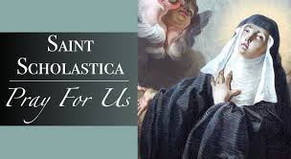

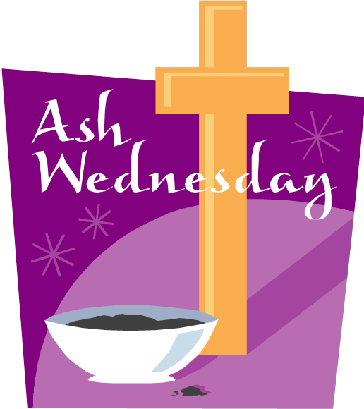
A Guide to Ash Wednesday

What is Ash Wednesday?
Ash Wednesday is the first day of Lent—and a wonderful opportunity to make yourself 100% available to God!
How available to God are you? 50%? 75%? 96.4%? No matter what your answer, Ash Wednesday is the perfect time to decide that you will spend this Lent increasing that number.
On Ash Wednesday, you can get your forehead blessed with ashes at Mass or a prayer service. These ashes are a reminder that we need to repent.
Repentance is a powerful invitation. When John the Baptist first appeared in the desert of Judea, this was his message: “Repent, prepare the way of the Lord” (Matthew 3:2). Later, when Jesus began his ministry, he led with this message: “Repent, for the kingdom of heaven is at hand” (Matthew 4:17).
But what does it mean for us to repent, here and now, more than two thousand years later? It means the same as it did to the people walking around the dusty pathways in their sandals, trying to inch closer to Jesus as he passed through their town or village. Repent means “to turn back to God.”
We all find ourselves needing to turn back to God many times a day, in ways small and large. It is not a matter of guilt and it is not a shameful thing. It is simply that we are a better version of ourselves when we return to his side!

When is Ash Wednesday 2026?
This year Ash Wednesday is on February 18, 2026.

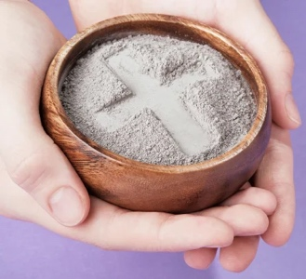
The History of Ashes on Ash Wednesday
You might be wondering why we get ashes on our foreheads for Ash Wednesday. Throughout history, ashes have been a powerful outward symbol of interior repentance and spiritual awareness. Here are some examples of ashes in the Bible:
- "Therefore I disown what I have said, and repent in dust and ashes." (Job 42:6)
- "Daughter of my people, dress in sackcloth, roll in the ashes." (Jeremiah 6:26)
- "I turned to the Lord God, to seek help, in prayer and petition, with fasting, sackcloth, and ashes." (Daniel 9:3)
- "When the news reached the king of Nineveh, he rose from his throne, laid aside his robe, covered himself with sackcloth, and sat in ashes. Then he had this proclaimed throughout Nineveh: “By decree of the king and his nobles, no man or beast, no cattle or sheep, shall taste anything; they shall not eat, nor shall they drink water. Man and beast alike must be covered with sackcloth and call loudly to God; they all must turn from their evil way and from the violence of their hands." (Jonah 3: 6-8)
The Early Christians used ashes to show repentance as well, but not just on Ash Wednesday! After going to confession, it was common for the priest to give the person ashes on their forehead. Catholics have been receiving ashes on Ash Wednesday since the time of St. Gregory the Great. In 1091, Pope Urban II encouraged the entire Church to use ashes on Ash Wednesday.
If you want to get blessed with ashes this Ash Wednesday, be sure to check with your local parish. Most churches celebrate Mass or have a prayer service on Ash Wednesday, and all are welcome to attend and be blessed with ashes.
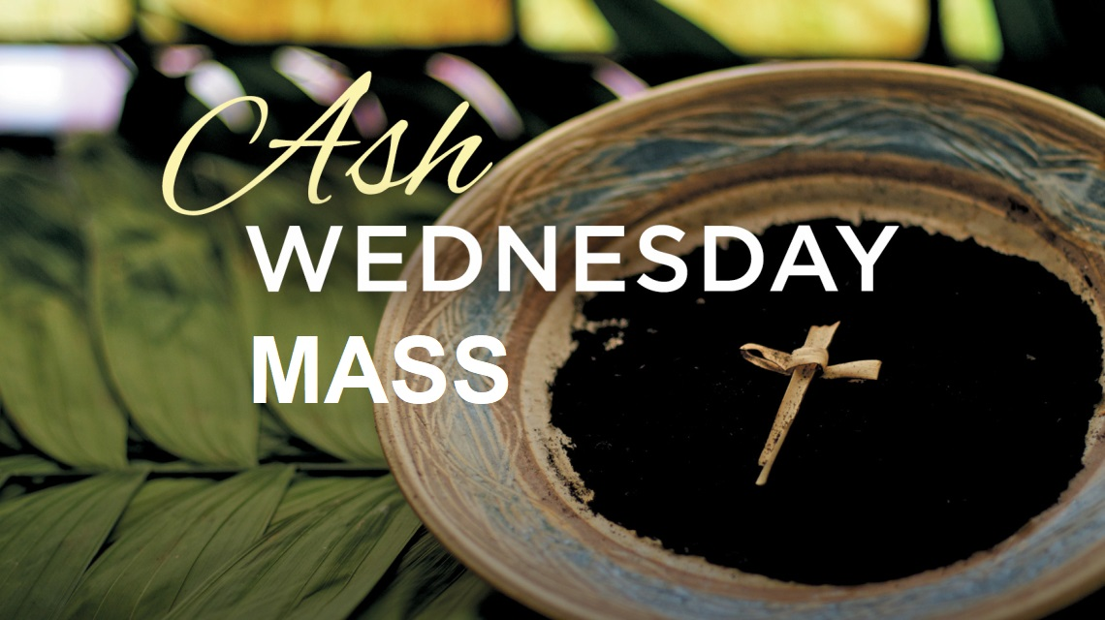Bottom of Form

Is Ash Wednesday a Holy Day of Obligation?
Contrary to popular belief, Ash Wednesday is not a Holy Day of Obligation. Even though you’re not required to attend Mass, Ash Wednesday is a wonderful opportunity to rearrange your priorities and feed your soul before one of the most important seasons of the entire year! Mass, with the imposition of ashes, will take place in St Augustine’s at 7pm.

Can you eat meat on Ash Wednesday?
No. Unless you have a medical exemption, Ash Wednesday is a day of Abstinence for Catholics.
Avoiding meat can be difficult, but it’s a powerful way to be disciplined about your priorities. When you make little sacrifices a part of your everyday spirituality, amazing things happen!
For example, suppose you have a craving for a Coke, but you have a glass of water instead. It is the smallest thing. Nobody notices. And yet, by this simple action you strengthen your willpower and become an even better-version-of-yourself.
Or, say your soup tastes a little dull. You could add salt and pepper, but you don’t. It’s a little thing. It’s nothing. But by saying no to yourself in small ways, it makes you even freer to say yes to the things that truly matter.
If you want to grow in strength this Lent, there’s one simple thing you can do: Try to never leave a meal table without practicing some form of sacrifice. It is these tiny acts that will strengthen your will for the great moments of decision that are a part of each of our lives!

What are the fasting rules for Ash Wednesday?
The Church requires all Catholics from ages 14-59 to fast on Ash Wednesday. As long as you are in good health, this means that you should only eat one full meal, plus two smaller meals that do not equal a full meal. Ash Wednesday is also a day where Catholics avoid eating meat.
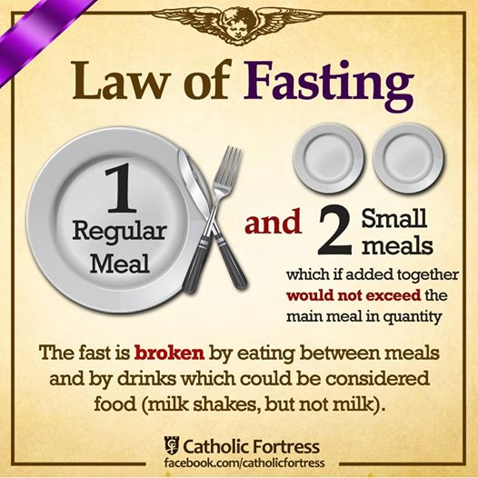
There is great wisdom in the Christian practice of fasting—even though its benefits are largely forgotten! Fasting is a spiritual exercise, and as such is primarily an action of the inner life. Authentic fasting draws us nearer to God and opens our hearts to receive his many gifts.
Fasting is also a sharp reminder that there are more important things in life than food. Authentic Christian fasting helps to release us from our attachments to the things of this world. It is often these worldly attachments that prevent us from becoming the-best-version-of-ourselves. Fasting also serves as a reminder that everything in this world is passing and thus encourages us to consider life beyond death.
Go without food for several hours and you quickly realize how truly weak, fragile, and dependent we are. This knowledge of self strips away arrogance and fosters a loving acknowledgment of our utter dependence on God. Ash Wednesday is a powerful day to rediscover the power of fasting in your life!

Make It Personal
Ash Wednesday is the perfect time to decide if you want to have the kind of Lent that’s easy to forget…or the kind that changes your life. Do you want a renewed commitment to prayer? More discipline in a specific area of your life? A stronger marriage? More peace? This Ash Wednesday, set aside 15 minutes to set your intentions for the season of Lent!
Magazine Sponsorship for February

Eileen Wringe

Eileen was born in 1933 on October 2nd. She died in 2025 on February 26th. Her daughter Jane Whitfield is sponsoring this month’s magazine in her memory, on her anniversary.

Her daughter Jane writes the following:

A life Well Lived

Meeting my mum Eileen was someone you'd never forget. She came from humble beginnings but loved life and travelled extensively.

She spent many years in Luxor in Egypt and learnt and spoke the Arabic language fluently and was able to write it as well; all this during her 60s.

You would see her on a camel around the pyramids at Giza and she worked as guest relations of the Winter Palace Hotel in Luxor.

My mother was on Egyptian television in 1997 speaking to people in Arabic after the killing of 58 tourists and 4 Egyptians outside Queen Hapshetput’s temple on the West Bank in Luxor. She also knew the pilot on Egypt Air and travelled in the cockpit from Luxor to Cairo (you wouldn't get away with that these days)!!!

I spent many years with my mum. We had some wonderful times, one being a professional cast from the USA performing Aida, the opera, with the backdrop of Queen Hapshetput’s temple, all about an Egyptian slave girl.

Mum was the ultimate “silver surfer”. She booked holidays and cruises to New Zealand, Australia, and the USA. She was the “Apple Queen": Phones, laptops, watches, you name it she had them, I lost count of how many!!!

Unfortunately, she never had the best of health all her life, but it never fazed her, off she would go on her adventures.

Sadly, her adventures had to stop, although sharp as a pin, she knew she was facing her final journey.

She left grandchildren and great grandchildren. My mum, my confidante and best friend, she made the most of her life and lived it to the full until she couldn't and at 91 years left all her family.

I miss that connection and her love like I'm sure many of you reading this will understand.

Until...

Jane

This sponsorship enables us to offer our monthly magazine free of charge. Thank you!

Moving forward as a way of covering some of the ongoing costs of the
the church and wider ministry I would like to trial the introduction of
sponsorship.


The easiest example of what I am thinking is the sponsorship of the
printing costs of our new magazine. Another example is covering the cost of the sanctuary light which is always alight (except following the
Good Friday Liturgy until it is lit again to celebrate the risen Lord at the Easter Vigil) and the candles in the Lady Chapel and St Monica’s Chapel.

Sponsorship would be on a weekly or monthly basis, although monthly sponsorship would make administering the process an easier task, and could be in memory of a loved one who has died or something else such as a birthday that is close to your heart. Sponsors and their special intention will be published in this magazine each month.

Sponsorship money should be paid at the beginning of the month
preferably by bank transfer using the reference box to indicate that it is
sponsorship money or you could give your sponsorship money in cash
to our treasurer, Tracy Poole.

If you would like to participate in this, please email Maria
the month, what you are sponsoring and your intention to:

mrs.maria.mason@gmail.com

It is of course possible to have more than one sponsor for any category in
any month and all sponsors with their intention will be published.

Item | Duration | Suggested Donation
Parish Magazine | Monthly | £50
Sanctury Lamp | Monthly | £15
St Monica’s Chapel Lamp | Monthly | £10

Could you sponsor the magazine, or any of the above items, for a month moving forward?


It would be helpful moving forward into 2026 to have the year’s sponsorships laid down. Payment wouldn’t be asked for until the beginning of the month sponsored. Please email Maria to let her know which month you would like to sponsor and she will then be in contact with you nearer the time to ask you why you are sponsoring that particular month’s magazine or sanctuary lamp etc . . . . . .

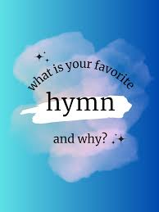
Your Favourite Hymn

Would you like to share with us details of your favourite Hymn? We have introduced this new feature and are encouraging you all to share your favourite hymn and why it is so special to you. We will feature one each month beginning in the January 2026 magazine.

Please email details of your favourite hymn to the usual email address:
mrs.maria.mason@gmail.com .

If you would rather just talk about your favourite hymn with Maria, she will do her best to do it justice when writing it up. If this is your preferred way of sharing details about your favourite hymn, please arrange a time to sit down with Maria. A quick conversation after Mass on a Sunday won’t work.
You can contact Maria on 07463 303112.

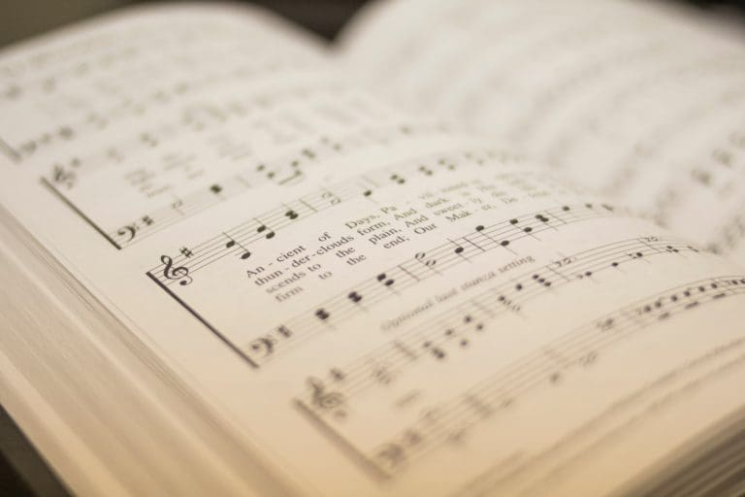

My Favourite Hymn – Fr Adrian

I suspect it is hard for most priests to actually choose one favourite hymn. Having been singing hymns for over 65 years, many have become dear to my heart. Here is one of my favourites.
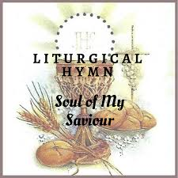

Soul of my Saviour sanctify my breast,
Body of Christ, be thou my saving guest,
Blood of my Saviour, bathe me in thy tide,
wash me with waters gushing from thy side.
Strength and protection may thy passion be,
O blessed Jesus, hear and answer me;
deep in thy wounds, Lord, hide and shelter me,
so shall I never, never part from thee.
Guard and defend me from the foe malign,
in death's dread moments make me only thine;
call me and bid me come to thee on high
where I may praise thee with thy saints for ay.
It is a hymn (or metrical) version of the ancient prayer Anima Christi, which originates from the beginning of the Ignatian Spiritual Exercises.
Soul of Christ, sanctify me.
Body of Christ, save me.
Blood of Christ, inebriate me.
Water from the side of Christ, wash me.
Passion of Christ, strengthen me.
O Good Jesus, hear me.
Within your wounds hide me.
Permit me not to be separated from you.
From the wicked foe, defend me.
At the hour of my death, call me
and bid me come to you
That with your saints I may praise you
For ever and ever. Amen.

It is full of sound theology, as indeed are many of our well-known traditional hymns, here especially sacramental theology. It speaks of Our Lord Jesus present in the bread and wine of the altar and all that is within the sacrament of the Holy Communion and of the Mass as a whole. It is a prayer said effectively before receiving Holy Communion, or as a hymn sung during the reception of Holy Communion. It prays that we may be strengthened by the redeeming work of Jesus, renewed in us by the receiving of the sacrament. It prays that we may never be separated from Our Lord, even in death, and that ultimately we may be received and joined into the heavenly host.

What more could we ask from a prayerful hymn?

In my opinion, we sing it to a wonderful, moving, stirring, evocative tune.


So often, music speaks to the soul and stirs the Spirit of God within us.
Holy Eucharist a Poem by Mark Fletcher

What does it mean, this oft-repeated rite?
I've done it more times than I can remember,
But still the Mystery eludes me.
It's bigger than I am; a truth of God.

Sometimes I want to stay in the choir stalls,
Conscious of sin; some unkind thought or act;
The good not done.
But I know, all too well; that's just the voice
Of the ancient Enemy,
Sowing tares in my mind.

Then it hits me: He died so that I could be here.
He gave his body and his life's blood, for me.
I am His guest; unworthy to be here,
But most welcome.

The people move forward, slowly and quietly;
The priest murmurs a blessing;
In the near-silence something momentous is happening.
You won't see it in the world's news.

I step forward to receive the Lord,
And the miracle happens again.
I have His Peace, His Presence;
The fulness of His blessing.

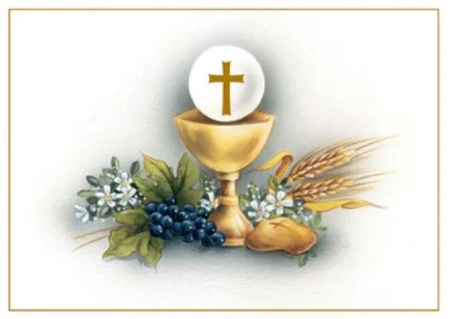

Pope Leo XIV declares Year of St Francis
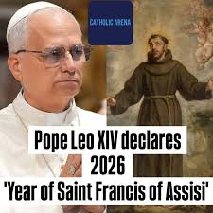
Pope Leo has proclaimed a Franciscan Jubilee Year for the 800th anniversary of the death of St Francis of Assisi.

The Holy Father has arranged that, from the 10th January, 2026 to the 10th January, 2027, this Year of St Francis will be celebrated, during which all the Christian faithful are invited to follow the example of the Saint of Assisi, becoming models of holiness of life and constant witnesses of peace. The Apostolic Penitentiary grants the plenary indulgence under the usual conditions to those who participate devoutly in this extraordinary jubilee, which represents an ideal continuation of the Ordinary Jubilee of 2025.

This Jubilee Year is addressed especially to members of the Franciscan Families of the First, Second and Third Regular and Secular Orders, as well as to Institutes of Consecrated Life, Societies of Apostolic Life and Associations that observe the Rule of St Francis or are inspired by its spirituality. However, the grace of this special year is also extended to all the faithful without distinction who, with their spirits removed from sin, visit in the form of a pilgrimage any Franciscan conventual church or place of worship dedicated to St. Francis in any part of the world. The elderly, the sick and those who for serious reasons cannot leave home will also be able to obtain the plenary indulgence by spiritually joining the Jubilee celebrations and offering their prayers, pains or sufferings to God.

In this time of celebration that draws together eight hundred years of Franciscan memory, we cordially invite all the faithful to take an active part in this exceptional Jubilee. May the shining example of St Francis, who knew how to make himself poor and humble in order to be true, alter Christus on earth, inspire our hearts to live with authentic Christian charity towards our neighbour and with sincere longings for concord and peace among peoples. Following in the footsteps of the Poverello of Assisi, let us transform the hope that made us pilgrims during the Holy Year into fervour and zeal of effective charity. May this Year of St Francis be for each one of us a providential occasion for sanctification and evangelical witness in the contemporary world, for the glory of God and the good of the whole Church.

Prayer of St Francis of Assisi

Key lines from the prayer:

"Lord, make me an instrument of your peace."
"Where there is hatred, let me sow love; where there is injury, pardon; where there is error, truth; where there is doubt, faith; where there is despair, hope; where there is darkness, light; and where there is sadness, joy."

"O Divine Master, grant that I may not so much seek to be consoled, as to console; to be understood, as to understand; to be loved, as to love."

"For it is in giving that we receive; it is in pardoning that we are pardoned; and it is in dying that we are born to eternal life."
This prayer emphasizes selflessness, forgiveness, and finding spiritual fulfilment through serving others, aligning with the Franciscan tradition.




Have you thought about becoming a Friend of St Augustine’s Church for 2026?

First of all, a big thank you for your support in 2025. We had a record season for audience, which is very encouraging. We have listened to those of you who have completed feedback forms and based this year’s season on those comments.

Once again, we have a tremendous line up of artists and do hope that you will continue to enjoy the concerts that we have on offer. There is a small increase to ticket prices as follows:

Adults: £14 Friends: £12
Students under 22: £5 Children under 12: Free


All tickets include a complimentary glass of wine or fresh fruit juice.

Please note that single membership costs just £15 per year, joint membership is £25, so to those of you who are not Friends at the moment, you may wish to consider joining!

A concert brochure is being prepared and will be distributed in early February, however see the following page for advance notice.

Dates for Concert Season 2026

Friday, 20th March By Request with Barry Whitfield
Please submit requests as soon as possible either in person or email staugustinesfriends@gmail.com

Friday, 24th April Alex Wilson (cello), Karen Beer (oboe) and David Beer (piano)

Friday, 15th May DC Quartet – Easy listening jazz

Friday, 5th June Josh Hughes - classical guitar

Friday, 17th July Bradley Creswick (violin) & David Murray (Piano)
Saturday, 18th July Violin/piano masterclass for young artists led by Bradley & David

Summer Lunchtime organ recitals:
Every Wednesday from 22nd July to 19th August

Malcolm Pentelow 22nd July, Michael Baron 19th August
Graham Burrell, Steven Maxson, Barry Whitfield to perform on the other dates.

Friday, 25th September Adele Dixon & Barry Whitfield
Friday, 16th October DC Quartet – Easy listening jazz
Friday, 13th November Louth Male Voice Choir
Friday, 27th November Music for Advent – St Augustine’s Consort
Friday, 18th December Adele Dixon & Barry Whitfield & Friends
A light-hearted Christmas evening with carols for all!

Book early to avoid disappointment! Tel: 07398 566677 or email staugustinesfriends@gmail.com

Building Repair Restoration and Maintenance News

Many thanks to all of you who responded to our mini appeal for financial support to enable us to get urgent works carried out in order that we have prevented further decay.

Many thanks also to Paul Nixon for coordinating these works so efficiently and effectively.

I have culled some extracts from emails between Paul, other church members and contractors to create this update.

Drains

It is a perpetual joke amongst clergy that whenever we have contact, private or public, with archdeacons they always ask about the state of the church drains.

At St. Agustine’s, our drains had begun to give us problems as you know. The outcome of this is that we have significant damp in the building and this has caused a number of areas of decorative discolouration inside. After seeking a variety of inspections and pricing for remedial works a company of specialists carried out work at the beginning of the year with some degree of success. Gutterwork has been cleared and hoppers cleaned; downpipes and drains have been cleared. The majority are now running freely, efficiently taking the rainwater away from the building.

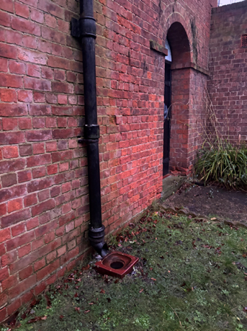
One ground drain continues to give a problem (see the photograph) and further inspection reveals that either the pipework is blocked or damaged by tree roots, or that the soakaway has collapsed probably also due to tree root damage. This is a common occurrence in churches.
Watch this space for further updates.

This picture shows the ground drain overflowing in recent wet weather.

Trees

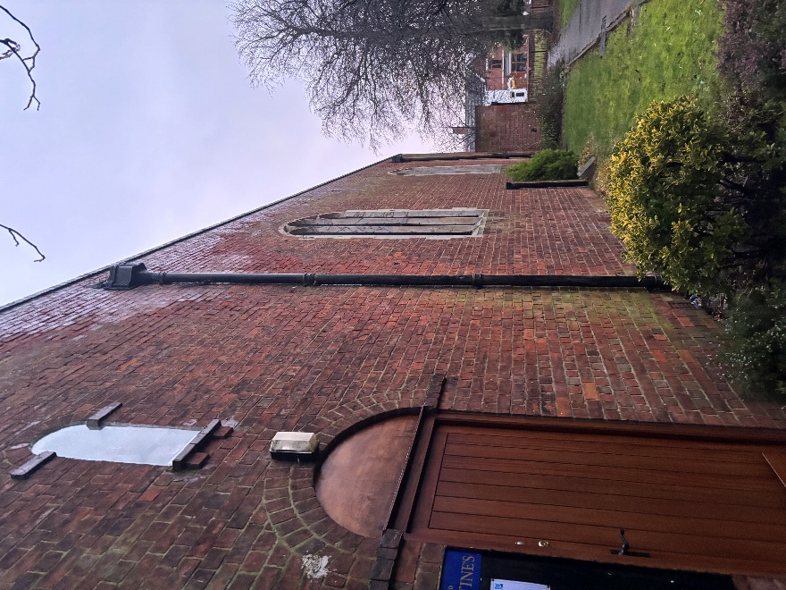
As many of you will know, our church sits in a conservation area. Some of the trees within the Churchyard and by the Church Hall have TPOs (tree preservation orders). This means that we have to let the relevant authorities know when we plan to work on them, follow any consultations they require of us and await permission before we carry out the work. We are in the process of doing this and the tree specialists are “pencilled in” to carry out necessary works as soon as possible, hopefully later in February, or early March. This will prevent the trees doing damage to the buildings.


As a little teaser, can anyone see what is missing from this picture?

The Life and Times of Thomas Augustus,
The Vicarage Cat

Gosh it has been a chilly January. I am grateful that my people keep the vicarage nice and warm, especially when they are at home. They went away to catch up with family that had been unable to come up and see us over the Christmas period. That is all well and good apart from two major points. One, they turn the heating down when when they are not in residence and two, I miss out on all the fuss that the family give me because they all love me. It isn’t so bad in this vicarage when my people are away because Adele comes in to see me, feed me and give me some fuss every day. My little girlfriend Kitty is a funny little thing. She still hides from Adele and I don’t think she realises what she is missing out on.
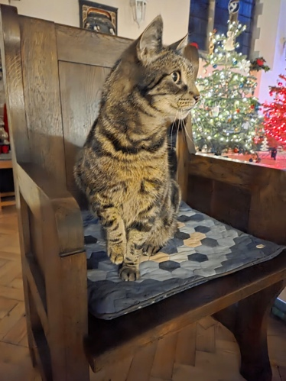
Although it has been petty cold in church, especially during the week, I go in when I can. I have recently been trying out this servers’ chair for size. I understand that either John or Michal usually sits here each Sunday. I will need to have a word with them about what goes on in church each Sunday as I am not allowed in between 9.30am and 12noon. However, I love the smell of the incense that lingers in church when I go in later in the day. I usually go into church each Sunday around 8am to check that the heating has come on. I have heard mention that a dog called Barney who occasionally comes with Fr Terry and I am not sure how we would get along. However, the way my people talk about how well-behaved Barney is, I am sure we would get along just fine.
I have been doing a little bit of research to see if I can find a cassock that fits my shape and size. This is proving rather tricky. I may have to go back to one of my other favourite seats in the nave.
Historic February
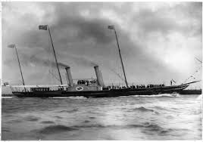
1 Feb 1901 The royal yacht Alberta brings the body of Queen Victoria into Portsmouth harbour en route to her funeral in London tomorrow. The Queen, aged 82, died on January 22, at Osborne on the Isle of Wight.
2 Feb 1665 British forces capture New Amsterdam, the centre of the Dutch colony in North America. The trading settlement on the island of Manhattan is to be renamed New York in honour of the Duke of York, its new governor.
3 Feb 1730 The London Daily Advertiser newspaper publishes the first stock exchange quotations.

4 Feb 1926 Malcolm Campbell sets a new world land speed record of 174 mph (278 kmph) in Wales.
5 Feb 1958 Parking meters first appear on the streets of London’s exclusive Mayfair district. The meters were first used in America in 1935.

6 Feb 1783 Death of Lancelot ‘Capability’ Brown the greatest English landscape gardener. His work lives on today throughout the great estates of England.
7 Feb 1301 The son of King Edward I of England becomes the first English Prince of Wales.

8 Feb 1587 Mary Queen of Scots is beheaded on the orders of her cousin England’s Queen Elizabeth I.


9 Feb 1964 73 million Americans tune in to the Ed Sullivan Show to watch four lads from Liverpool appear for the first time – The Beatles.
10 Feb 1354 Students at Oxford University fight a street battle with local townspeople resulting in several deaths and many people injured.
11 Feb 1975 Iron Lady Margaret Thatcher becomes the first woman leader of the British Conservative Party.
12 Feb 1554 At the tender age of 16, the “nine days queen”, Lady Jane Grey is beheaded at the tower of London.
13 Feb 1688 A “Glorious Revolution” brings the Protestant William of Orange and his wife Mary (daughter of James II) to the throne of England after the Catholic King James II flees to France.
14 Feb 1933 Students at Oxford University, obviously bored with fighting the local townspeople, declare that they would not fight for “King and Country”.
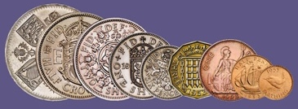
15 Feb 1971 Pennies, bobs and half-crowns all disappear as Britain goes decimal.

16 Feb 1659 A cheque is used for the first time in Britain as Mr Nicholas Vanacker settles a debt.
17 Feb 1461 Lancastrian forces defeated the Yorkists at the Second Battle of St. Albans.
18 Feb 1478 George Plantagenet, Duke of Clarence died in the Tower of London said to have been drowned in a butt of his favourite malmsey wine.
19 Feb 1897 The Women’s Institute is founded in Ontario, Canada, by Mrs Adelaide Hoodless.
20 Feb 1938 Anthony Eden resigned as British foreign secretary after Prime Minister Neville Chamberlain decided to negotiate with Italian Fascist leader Benito Mussolini.
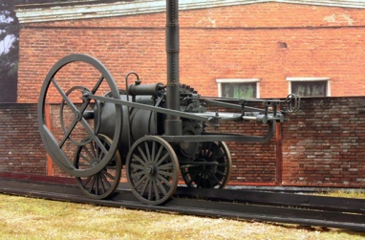
21 Feb 1804 British engineer Richard Trevithick demonstrated the first steam engine to run on rails.
22 Feb 1797 Over 1,000 French troops attempted to invade Britain, landing on the Welsh coast. The brave ladies of Fishguard saved the day!
23 Feb 1863 Lake Victoria, in Africa, was declared to be the source of the River Nile by British explorers John Speke and J A Grant.
24 Feb 1917 President Woodrow Wilson informs the US nation of the contents of an intercepted message from the German foreign minister offering Mexico an alliance against the US.

25 Feb 1570 England’s Queen Elizabeth I is excommunicated by Pope Pius V.
26 Feb 1797 The Bank of England issues the first ever one pound note, in part a result of the panic in London caused by the French invasion of Fishguard.
27 Feb 1782 The British Parliament votes to abandon the American War of Independence. Perhaps they were more concerned about the potential threat to Fishguard!
28 Feb 1900 The four-month siege of the British garrison at Ladysmith in Natal, South Africa, ended as a relief force broke through the Boers at Spion Kop.
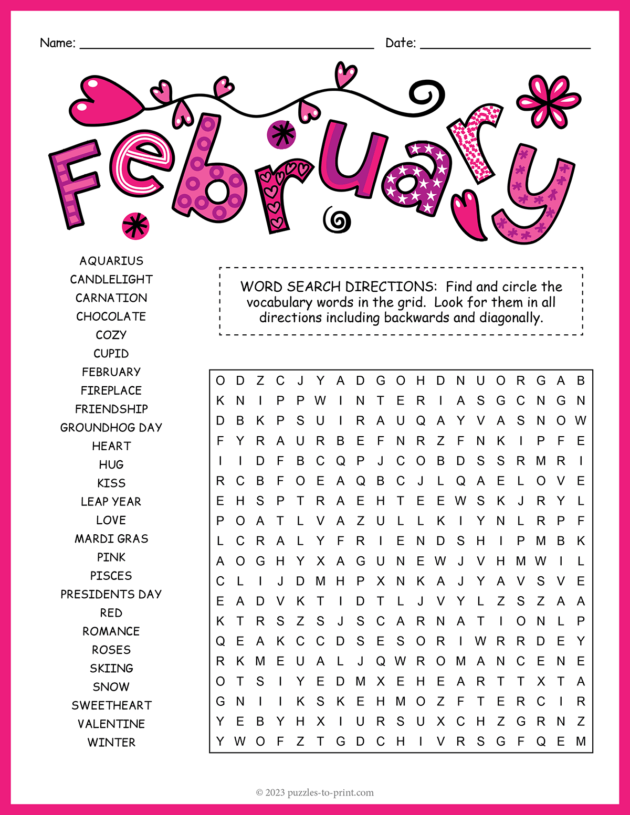


Priest-in-Charge | Fr Adrian Mason | fr.adrian.mason@gmail.com 07824 467333
Church Wardens | Adele Dixon Janet Nixon | adele.dixon90@gmail.com  janet.nixon59@gmail.com
Lay Chair of PCC | Adele Dixon | adele.dixon90@gmail.com
PCC Secretary | Barry Whitfield | barrywwhitfield@gmail.com
PCC Treasurer | Tracy Poole
Safeguarding Officer | Adele Dixon | staugustineofhippo safeguarding@gmail.com
Electoral Roll Officer | Cheryl James | cheryljames1@live.co.uk
Director of Music | Barry Whitfield | barrywwhitfield@gmail.com
Magazine Editor | Maria Mason | mrs.maria.mason@gmail.com


Items for inclusion in the February 2026 edition of this magazine should be sent to the editor via email by Sunday 15 February. There is no guarantee of inclusion after this date.

(mrs.maria.mason@gmail.com).

Could you write an article for our Parish Magazine? The editor would be pleased to receive articles of a religious nature or otherwise that would be of interest to our readers.
Again, the email address to send articles to is: mrs.maria.mason@gmail.com

Cheryl’s Name Cards
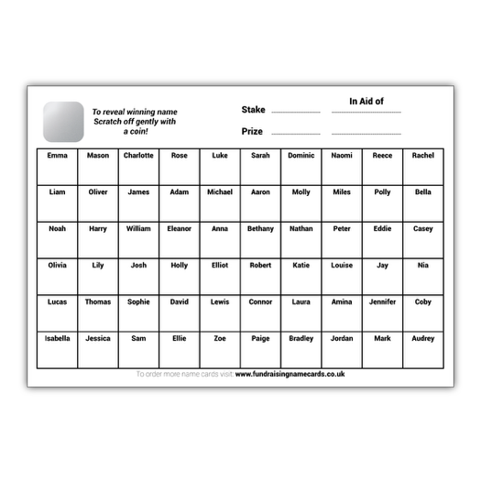
As many of you are aware, Cheryl always has some name cards on the go. There are always great prizes including bottles, candles and chocolate, with boxes costing 20p - £1.

To quote Cheryl, “you have to be in it to win it!”

Email:
fr.adrian.mason@gmail.com

Web:
St-augustine-church-grimsby.org
https://www.achurchnearyou.com/church/14993/

Safeguarding matters please contact:
staugustineofhipposafeguarding@gmail.com



Edition 12

