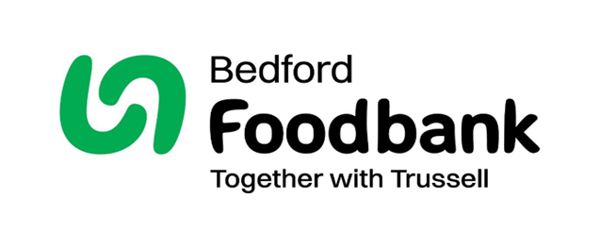



Will you take part in our 40 for 40 challenge this Lent?
By giving up 40 pence a day for the 40 days of Lent you
can support local individuals and families facing hardship this Easter.
All you have to do is find an old jam jar or similar container and start collecting!
Registered Charity Number: 1179538| Registered in England & Wales
40 pence
for 40 days
v
01234 268569
bedford.foodbank.org.uk

