SUNDAY MORNING READING SHEET 22nd February 1st Sunday of Lent
A Reading from Psalm 32
Happy are those whose transgression is forgiven, whose sin is covered. Happy are those to whom the Lord imputes no iniquity, and in whose spirit there is no deceit. While I kept silence, my body wasted away through my groaning all day long. For day and night your hand was heavy upon me; my strength was dried up as by the heat of summer. Then I acknowledged my sin to you, and I did not hide my iniquity;
I said, ‘I will confess my transgressions to the Lord’, and you forgave the guilt of my sin. Therefore let all who are faithful offer prayer to you; at a time of distress, the rush of mighty waters shall not reach them.
You are a hiding-place for me; you preserve me from trouble; you surround me with glad cries of deliverance. I will instruct you and teach you the way you should go; I will counsel you with my eye upon you. Do not be like a horse or a mule, without understanding, whose temper must be curbed with bit and bridle, else it will not stay near you. Many are the torments of the wicked, but steadfast love surrounds those who trust in the Lord. Be glad in the Lord and rejoice, O righteous, and shout for joy, all you upright in heart. Psalm 32
GOSPEL
Jesus was led up by the Spirit into the wilderness to be tempted by the devil. He fasted for forty days and forty nights, and afterwards he was famished. The tempter came and said to him, ‘If you are the Son of God, command these stones to become loaves of bread.’ But he answered, ‘It is written, “One does not live by bread alone, but by every word that comes from the mouth of God.”’ Then the devil took him to the holy city and placed him on the pinnacle of the temple, saying to him, ‘If you are the Son of God, throw yourself down; for it is written, “He will command his angels concerning you”, and “On their hands they will bear you up ,so that you will not dash your foot against a stone.”’ Jesus said to him, ‘Again it is written, “Do not put the Lord your God to the test.”’Again, the devil took him to a very high mountain and showed him all the kingdoms of the world and their splendour; and he said to him, ‘All these I will give you, if you will fall down and worship me.’ Jesus said to him, ‘Away with you, Satan! for it is written, “Worship the Lord your God, and serve only him.”’ Then the devil left him, and suddenly angels came and waited on him. Matthew 4:1-11

UPCOMING EVENTS :There are a number of events coming up over the next few months to look forward to.
18th April - Cheese and wine evening 2nd & 4th May - Book Fayre 19th June - Hymns and PIMM’ s
20th June - Concert



If you wish to make a donation to the church, then please hold your
phone’s camera over this image then touch the link that appears:

Royston Parish Church
Where all are welcome and God’s love is shared
Sunday 22nd February 2026 - 1st Sunday of Lent

If you would like regular copies of the Notice Sheet emailed to you please email the Parish Office at admin@roystonparishchurch.org.uk

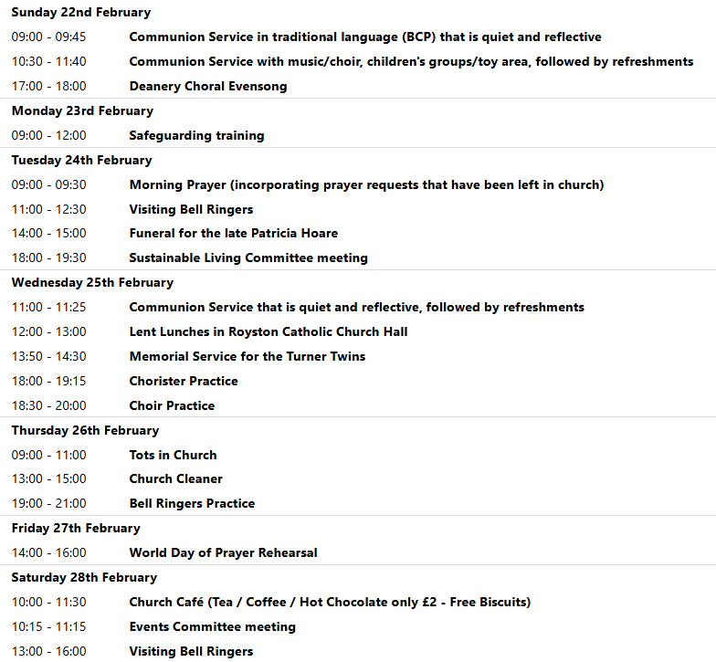
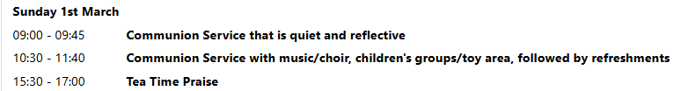
We pray for all Christians worldwide:
For all Christians in France, Germany, Monaco
For all who are worship at Barley, Barkway and Reed: Revd. Mark Bridgen
For the work of our mission partners: Orchid Project: Anne-Marie Wilson
Pray for the community of Royston:
For our local health centres
For our employed at our local farmers and land workers
We pray for our world and ECO projects:
We give thanks as Spring bulbs start to appear, and crops for summer harvest grow in local fields
We pray for the sick and suffering:
1st February 8th February 15th February 22nd February
Lee Cockerill Chris Christou Val Brown Peter Coates Pat Pritchard Paul & Pat Tidey Angie & Ken Rushall Margaret Green
Jackson Herbert Mike Brown Paula Walker Peter Foster Marion Keith & Elaine Edwards Gwen Simmons
Laura O’nyamul (On-Ya-Mul) Maria Turi Katie
Peggy Dawes Janet McElney
We pray for those who have died in the faith of Christ:
Deceased | Bereaved
Harry McDonald | Ruth, Family and friends
Ann Coburn | Kay Blayney, Matt, family and friends
The Turner twins | Heather, Ross family and friends
Morris Mordet | Family and Friends
Jennifer Jones | Family and friends
Patricia Hoare | Family and friends

We pray for those whose anniversaries fall at this time:
Arthur Blair, Graham Brown, Allan Moule, Thomas Krippner, Lilian Bysouth
NOTICES
LENT LUNCHES IN AID OF CAFOD AND CHRISTIAN AID: Starts Wednesday 25th February and continues on4th, 11th, 18th, 25th March
Venue - Roman Catholic Parish Centre, Melbourn Rd. - Entry for pedestrians and cyclists from School car park only. Lunches are served between 12 noon and 1pm
Donations for lunch: Suggested donation is £5pp. This will be distributed equally between Cafod and Christian Aid
ELECTORAL ROLL: If you would like to join the Electoral Roll this year, which enables you to vote at our annual meeting, please apply on this link:
https://roystonparishchurch.org.uk/electoral-roll

CHRISTMAS TREE: The Christmas tree is finally down, and a BIG thank you to all who made it possible this year. We have counted 1056 this year, which is a record. The cards will be prayed over before being cleared away.

CARBON FAST FOR LENT: Traditionally, Lent is a time when Christians fast and focus on God. You might also be interested in adding a “Carbon Fast” to think about our carbon footprint and ask if there is any excess or unnecessary use in our lives, and if any of that excess is acting as a distraction to our relationship with God. You can sign up at the website climatestewards.org/resources/carbon-fast-for-lent to receive a weekly e-mail with suggested activities. With a different focus each week, you’ll learn more, ask questions, and focus on what God thinks about these areas of our lives:
- Week 1: Delight in and responsibility for nature
- Week 2: Consumerism and shopping
- Week 3: Money and investments
- Week 4: Food waste and meat and dairy consumption
- Week 5: Transport and driving
- Week 6: Energy, electricity, and gas
- Week 7: Social media

CHURCH FLOWERS FOR EASTER: As usual, we will be arranging flowers in church for Easter. If you would like to make a donation towards the cost of the Easter flowers via a bank transfer, please contact Angela Sasoli or Clare Rice. Cash and cheque donations are also welcome if preferred. Cheques should be made payable to Royston PCC and can be given to either Clare Rice or Angela Sassoli. Your generous support for festival flowers is very much appreciated. Thank you.

BASIC AWARENESS SAFEGUARDING COURSE Three years ago, after the church re-opened, we ran a Basic Awareness Safeguarding Course for anyone who was unable to access the training online and would find it easier to come along to the church to do the training as a group. For some people it is now time to renew their training after three years, for others it will be the first time. This is a relaxed, non threatening way for everyone to join together and learn how we can, as a church, keep everyone safe whether it is children or vulnerable adults. If you would like to take advantage of this opportunity we will be running the course on Monday 23rd February 2026 at 9.30 am in church. Please let me know if you would like to join us.
Alison Bailey, Parish Safeguarding Officer, 01763 250637, safeguarding@roystonparishchurch.org.uk

LOOKING FORWARD, we will also be looking for donations of Easter eggs for the egg hunt on Easter Sunday, 5th April and chocolate items for a chocolate tombola at the Book Fayre, 2nd and 4th May. We are happy to take these at any time from now on so we can take advantage of any offers. Please leave all items in the kitchen. As always we ask that all food items have good dates on them as we cannot include out of date items! Thank you so much, the Events Committee.

