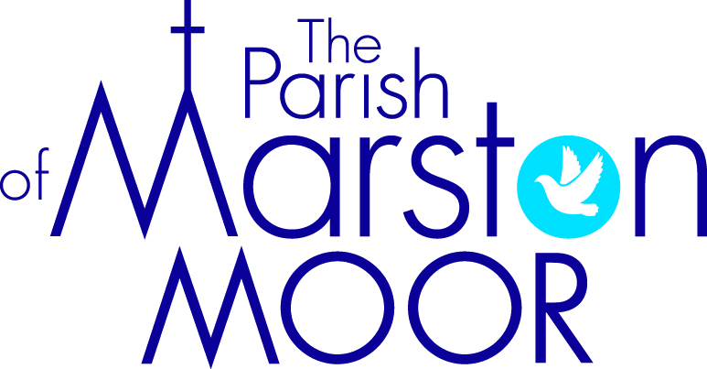 | Askham Richard | Bilbrough | Long  Marston | Rufforth | Tockwith
1st  2nd Sunday of Lent |  | 9.00am  Holy Communion | 8.30am  Breakfast Praise | 11.00am  Holy Communion | 11.00am  Refresh Service
8th  3rd Sunday of Lent | 9.00am  Holy Communion | 10.00am  Parish Praise | 5.00pm Holy Communion | 11.00am  Worship Together | 11.00am  Holy Communion
15th  Mothering Sunday | 10.00am  All Age Worship | 10.00am  All Age Worship | 11.00am  Creative Church | 11.00am  All Age Worship | 6.00pm  BCP Evensong
22nd  5th Sunday of Lent | 9.00am  Holy Communion | 10.00am  Family Praise | 11.00am  All Age Worship | 11.00am  Holy Communion | 11.00am  Informal Parish Praise
29th  Palm Sunday | Parish Holy Communion  Long Marston 10.00am

