SUNDAY MORNING READING SHEET 1st March 2026 2nd Sunday of Lent
A Reading from Paul’s Letter to the Romans
What then are we to say was gained by Abraham, our ancestor according to the flesh? For if Abraham was justified by works, he has something to boast about, but not before God. For what does the scripture say? ‘Abraham believed God, and it was reckoned to him as righteousness.’ Now to one who works, wages are not reckoned as a gift but as something due. But to one who without works trusts him who justifies the ungodly, such faith is reckoned as righteousness. For the promise that he would inherit the world did not come to Abraham or to his descendants through the law but through the righteousness of faith. If it is the adherents of the law who are to be the heirs, faith is null and the promise is void. For the law brings wrath; but where there is no law, neither is there violation. For this reason it depends on faith, in order that the promise may rest on grace and be guaranteed to all his descendants, not only to the adherents of the law but also to those who share the faith of Abraham (for he is the father of all of us, as it is written, ‘I have made you the father of many nations’)—in the presence of the God in whom he believed, who gives life to the dead and calls into existence the things that do not exist. Romans 4:1-5, 13 - 17

GOSPEL
Now there was a Pharisee named Nicodemus, a leader of the Jews. He came to Jesus by night and said to him, ‘Rabbi, we know that you are a teacher who has come from God; for no one can do these signs that you do apart from the presence of God.’ Jesus answered him, ‘Very truly, I tell you, no one can see the kingdom of God without being born from above.’ Nicodemus said to him, ‘How can anyone be born after having grown old? Can one enter a second time into the mother’s womb and be born?’ Jesus answered, ‘Very truly, I tell you, no one can enter the kingdom of God without being born of water and Spirit. What is born of the flesh is flesh, and what is born of the Spirit is spirit. Do not be astonished that I said to you, “You must be born from above.” The wind blows where it chooses, and you hear the sound of it, but you do not know where it comes from or where it goes. So it is with everyone who is born of the Spirit.’ Nicodemus said to him, ‘How can these things be?’ Jesus answered him, ‘Are you a teacher of Israel, and yet you do not understand these things? ‘Very truly, I tell you, we speak of what we know and testify to what we have seen; yet you do not receive our testimony. If I have told you about earthly things and you do not believe, how can you believe if I tell you about heavenly things? No one has ascended into heaven except the one who descended from heaven, the Son of Man. And just as Moses lifted up the serpent in the wilderness, so must the Son of Man be lifted up, that whoever believes in him may have eternal life. ‘For God so loved the world that he gave his only Son, so that everyone who believes in him may not perish but may have eternal life. ‘Indeed, God did not send the Son into the world to condemn the world, but in order that the world might be saved through him. John 3:1-17

UPCOMING EVENTS :There are a number of events coming up over the next few months to look forward to.
18th April - Cheese and wine evening 2nd & 4th May - Book Fayre 19th June - Hymns and PIMM’ s
20th June - Concert


If you wish to make a donation to the church, then please hold your
phone’s camera over this image then touch the link that appears:
Royston Parish Church
Where all are welcome and God’s love is shared
Sunday 1st March 2026 - 2nd Sunday of Lent

If you would like regular copies of the Notice Sheet emailed to you please email the Parish Office at admin@roystonparishchurch.org.uk
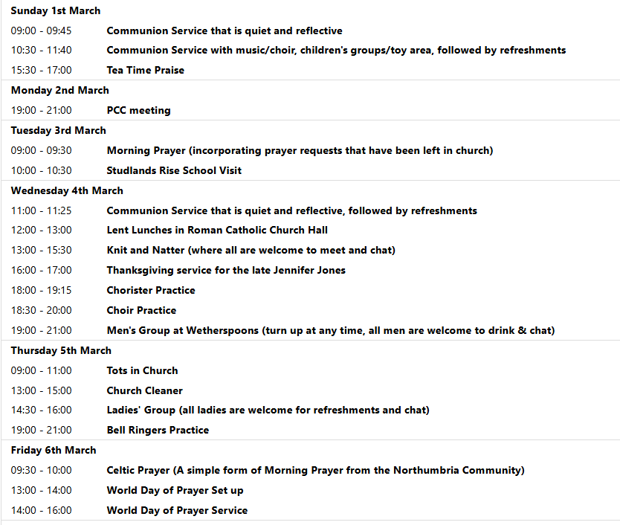
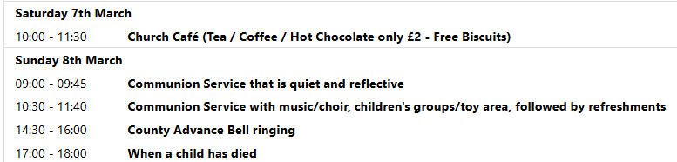
We pray for all Christians worldwide:
For all Christians in Belgium, Luxembourg, Netherlands
For all who are worship at Kneesworth House Hospital: Ged McHale
For the work of our mission partners: GenR8
Pray for the community of Royston:
For our local health centres
For our uniformed organisations: Guides, Scouts etc.
We pray for our world and ECO projects:
As "Food Waste Action Week" takes place 9th-13th March 2026, we pray that we may use our food resources more responsibly
We pray for the sick and suffering:
1st March 8th March 15th March 22nd /29th March
Lee Cockerill Chris Christou Val Brown Peter Coates Pat Pritchard Paul & Pat Tidey Angie & Ken Rushall Margaret Green
Jackson Herbert Mike Brown Paula Walker Peter Foster Marion Keith & Elaine Edwards Gwen Simmons
Laura O’nyamul (On-Ya-Mul) Maria Turi Katie
Peggy Dawes Janet McElney
We pray for those who have died in the faith of Christ:
Deceased | Bereaved
Harry McDonald | Ruth, Family and friends
The Turner twins | Heather, Ross family and friends
Jennifer Jones | Family and friends

We pray for those whose anniversaries fall at this time:
Edith Barrett
NOTICES
FOR ALL THOSE WHO HAVE BEEN AFFECTED BY THE DEATH OF A CHILD- A SERVICE OF REMEMBRANCE AND THANKSGIVING
We are having a Service of Remembrance and Thanksgiving for those who have lost a child or who have been affected by the loss of a child of whatever age, however long ago, and no matter under what circumstances. The service will take place on Sunday 8th March 2026 at 5.00pm and will be followed by light refreshments in the church.
There is a special poignancy over the loss of a child, and finding support is crucial to a healing process. Coming together, in a place of peace and quiet such as the space we find in St John the Baptist Church can be especially helpful whatever our faith and whoever we are. Please feel free to invite families with whom you have had contact who have experienced the death of their child to come to this service. (It does not need to be a bereavement from just this past year, nor as a young child or baby but at any stage of life.) I also have some letters of invitation that you might like to pass onto anyone who might appreciate such a service. Also, if you or someone you know might wish for their own child to be remembered but is unable to come along, I have some small cards to fill in with the name of the child, and we will ensure that they are remembered during the service. Reg Bailey
LENT LUNCHES IN AID OF CAFOD AND CHRISTIAN AID: Starts Wednesday 25th February and continues on4th, 11th, 18th, 25th March
Venue - Roman Catholic Parish Centre, Melbourn Rd. - Entry for pedestrians and cyclists from School car park only. Lunches are served between 12 noon and 1pm
Donations for lunch: Suggested donation is £5pp. This will be distributed equally between Cafod and Christian Aid

ELECTORAL ROLL: If you would like to join the Electoral Roll this year, which enables you to vote at our annual meeting, please apply on this link:
https://roystonparishchurch.org.uk/electoral-roll

CARBON FAST FOR LENT: Traditionally, Lent is a time when Christians fast and focus on God. You might also be interested in adding a “Carbon Fast” to think about our carbon footprint and ask if there is any excess or unnecessary use in our lives, and if any of that excess is acting as a distraction to our relationship with God. You can sign up at the website climatestewards.org/resources/carbon-fast-for-lent to receive a weekly e-mail with suggested activities. With a different focus each week, you’ll learn more, ask questions, and focus on what God thinks about these areas of our lives:
- Week 1: Delight in and responsibility for nature
- Week 2: Consumerism and shopping
- Week 3: Money and investments
- Week 4: Food waste and meat and dairy consumption
- Week 5: Transport and driving
- Week 6: Energy, electricity, and gas
- Week 7: Social media

CHURCH FLOWERS FOR EASTER: As usual, we will be arranging flowers in church for Easter. If you would like to make a donation towards the cost of the Easter flowers via a bank transfer, please contact Charlotte Wicks on email treasurer@roystonparishchurch.org.uk. Cash and cheque donations are also welcome if preferred. Cheques should be made payable to Royston PCC and can be given to either Clare Rice or Angela Sassoli. Your generous support for festival flowers is very much appreciated. Thank you.

LOOKING FORWARD, we will also be looking for donations of Easter eggs for the egg hunt on Easter Sunday, 5th April and chocolate items for a chocolate tombola at the Book Fayre, 2nd and 4th May. We are happy to take these at any time from now on so we can take advantage of any offers. Please leave all items in the kitchen. As always we ask that all food items have good dates on them as we cannot include out of date items! Thank you so much, the Events Committee.

