SUNDAY MORNING READING SHEET 8th February 2nd Sunday before Lent
A Reading from Paul’s Letter to the Romans

I consider that the sufferings of this present time are not worth comparing with the glory about to be revealed to us. For the creation waits with eager longing for the revealing of the children of God; for the creation was subjected to futility, not of its own will but by the will of the one who subjected it, in hope that the creation itself will be set free from its bondage to decay and will obtain the freedom of the glory of the children of God. We know that the whole creation has been groaning in labour pains until now; and not only the creation, but we ourselves, who have the first fruits of the Spirit, groan inwardly while we wait for adoption, the redemption of our bodies. For in hope we were saved. Now hope that is seen is not hope. For who hopes for what is seen? But if we hope for what we do not see, we wait for it with patience.
Romans 8:18-25

GOSPEL
‘Therefore I tell you, do not worry about your life, what you will eat or what you will drink, or about your body, what you will wear. Is not life more than food, and the body more than clothing? Look at the birds of the air; they neither sow nor reap nor gather into barns, and yet your heavenly Father feeds them. Are you not of more value than they? And can any of you by worrying add a single hour to your span of life? And why do you worry about clothing? Consider the lilies of the field, how they grow; they neither toil nor spin, yet I tell you, even Solomon in all his glory was not clothed like one of these. But if God so clothes the grass of the field, which is alive today and tomorrow is thrown into the oven, will he not much more clothe you—you of little faith? Therefore do not worry, saying, “What will we eat?” or “What will we drink?” or “What will we wear?” For it is the Gentiles who strive for all these things; and indeed your heavenly Father knows that you need all these things. But strive first for the kingdom of God and his righteousness, and all these things will be given to you as well. ‘So do not worry about tomorrow, for tomorrow will bring worries of its own. Today’s trouble is enough for today. Matthew 6:25-34

LENT COURSE: As we approach Lent, everyone is invited to take part in our parish Lent course, Draw Near: Life-Giving Habits for Lent, based on the Church of England resource offering short daily reflections to help deepen our relationship with God. Sunday preaching and home groups will follow shared weekly themes, creating a common rhythm of worship, reflection, and conversation across the church. Home groups will meet weekly where possible, with most able to welcome newcomers as well as three newly formed groups for Lent only. Further details about booklets and groups will be shared soon.

UPCOMING EVENTS :There are a number of events coming up over the next few months to look forward to.
18th April - Cheese and wine evening 2nd & 4th May - Book Fayre 19th June - Hymns and PIMM’ s
20th June - Concert



If you wish to make a donation to the church, then please hold your phone’s
camera over this image then touch the link that appears:

Royston Parish Church
Where all are welcome and God’s love is shared
Sunday 8th February 2026 - 2nd Sunday before Lent

If you would like regular copies of the Notice Sheet emailed to you please email the Parish Office at admin@roystonparishchurch.org.uk

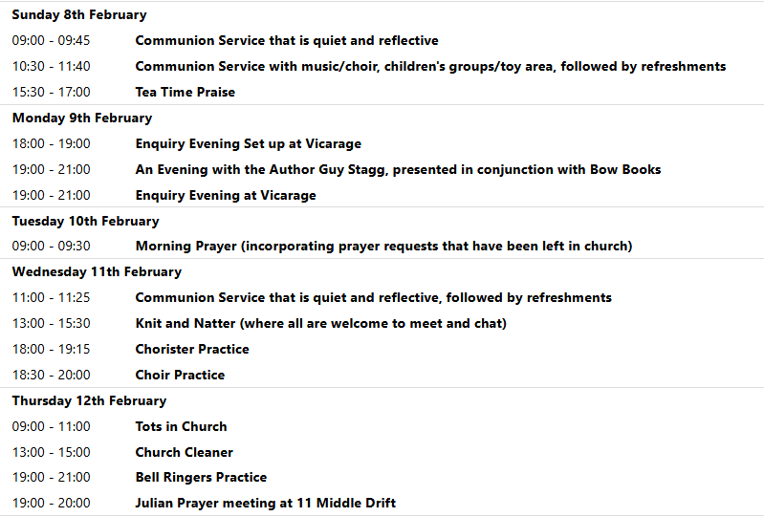
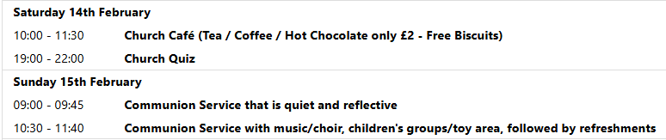

ASH WEDNESDAY 18TH FEBRUARY 11 AM AND 8 PM: In preparation for the imposition of ashes on Ash Wednesday, we shall need your Palm Crosses from last year. A basket will be at the back of Church for this Sunday (8th) until Sunday 15th. Thank you.

We pray for all Christians worldwide:
For all Christians in Andorra, Italy, Malta, Portugal, San Marino, Spain, Vatican City
For all who are worship at Royston Evangelical Church: Jonathan Scott
For the work of our mission partners: Church Mission Society (CMS)

Pray for the community of Royston:
For our local health centres
For our local Markaet Stall holders and shop keepers
We pray for our world and ECO projects:
We pray that as Lent approaches (starting on 18th Feb) that we may take the time to think about how to reduce our individual Carbon Footprints, perhaps participating in the "Carbon Fast" - more information can be found on the website climatestewards.org.
We pray for the sick and suffering:
1st February 8th February 15th February 22nd February
Lee Cockerill Chris Christou Val Brown Peter Coates Pat Pritchard Paul & Pat Tidey Angie & Ken Rushall Margaret Green
Jackson Herbert Mike Brown Paula Walker Peter Foster Marion Keith & Elaine Edwards Gwen Simmons
Laura O’nyamul (On-Ya-Mul) Maria Turi Katie
Peggy Dawes Janet McElney

We pray for those who have died in the faith of Christ:
Deceased | Bereaved
Harry McDonald | Ruth, Family and friends
Ann Coburn | Kay Blayney, Matt, family and friends
The Turner twins | Heather, Ross family and friends

We pray for those whose anniversaries fall at this time:
No anniversaires this week
NOTICES

BASIC AWARENESS SAFEGUARDING COURSE Three years ago, after the church re-opened, we ran a Basic Awareness Safeguarding Course for anyone who was unable to access the training online and would find it easier to come along to the church to do the training as a group. For some people it is now time to renew their training after three years, for others it will be the first time. This is a relaxed, non threatening way for everyone to join together and learn how we can, as a church, keep everyone safe whether it is children or vulnerable adults. If you would like to take advantage of this opportunity we will be running the course on Monday 23rd February 2026 at 9.30 am in church. Please let me know if you would like to join us.
Alison Bailey, Parish Safeguarding Officer, 01763 250637, safeguarding@roystonparishchurch.org.uk

DEANERY CHORAL EVENSONG on February 22nd at 5pm, our choir will be joined by choirs and singers from across the Deanery to sing Choral Evensong together. No other churches in the Deanery are having evening services as all the church leaders are taking part in the service, and we are also coming together with congregations across the Deanery to worship together in this service, which will be followed by wine and refreshments. If you would like to sing then please speak to Steven, otherwise, please do come along and worship together with our sisters and brothers from across the Deanery.

QUIZ NIGHT:Saturday 14th February, 7 for 7.30 pm, Venue: Royston Parish Church, teams of up to 8, £8 per person. If you wish to register a team or interest in joining a team, please contact Duncan Rodgers email: duncanrodgers66@gmail.com
Licensed bar, bring your own nibbles, opportunity to enter a raffle on the night. All proceeds in aid of church funds.

NEW SUNG SETTING In our 10.30 services from the 8th February (with the choir singing it at the Candlemas service on the 1st February) we shall be singing a new setting of the communion setting (where we sing Lord, have mercy, Glory to God, Holy, Holy, Holy Lord and Lamb of God). The setting is written by David Thorne and is called the Mass of St Thomas. If you would like to get to know it before we start singing it then you can hear it at this link: https://www.youtube.com/watch?v=vVMJxiIXQMs

QUIZ RAFFLE: We are having a small raffle at the quiz on Saturday 14th February and are looking for contributions for this. At the back of the Church is a list of items that we need, if you feel able to contribute please cross off an item.
The hampers will be made up on the morning of the quiz so please bring items before then, thank you.
Looking forward, we will also be looking for donations of Easter eggs for the egg hunt on Easter Sunday, 5th April and chocolate items for a chocolate tombola at the Book Fayre, 2nd and 4th May. We are happy to take these at any time from now on so we can take advantage of any offers.
Please leave all items in the kitchen. As always we ask that all food items have good dates on them as we cannot include out of date items!
Thank you so much, the Events Committee.

HELP NEEDED PLEASE: We are helping with Lent Lunch on Wednesday 11th March which is held at the Roman Catholic Church Hall. Lunches usually run from 12 until 1.30pm, consist of a selection of soups, bread, butter, cheese and fruit. Help is also needed to put out/put back chairs and tables (men please). There is a suggested donation of £5 per person. Profits after costs go to Christian Aid and CAFOD.
If you are able to help in anyway, there is a sign up sheet up at the back of Church, or please speak to Kay for any more information. Thank you.

