Sunday 1st February 2026 St Paul’s, Woodhouse Eaves
WE WELCOME YOU, for we are all one in Christ Jesus

MISSION  Our Mission Statement  Our Mission is to make known the Gospel and love of Jesus Christ. We hope that you experience us as a safe, sacramental, welcoming, loving and inclusive Kingdom people who seek to make Christ present in the hearts of all.  Safeguarding  The parishes of St Paul’s, Woodhouse Eaves & St Mary’s, Woodhouse, are committed to the safeguarding of children, young people and adults. We follow the House of Bishops’ guidance and policies, and have our own Parish Safeguarding Officers. If you are concerned that a child or adult has been harmed or may be at risk of harm please contact –  ST PAUL’S - Safeguarding  Co-ordinator: Tony Lane  07977 924 677  ST MARY’S - Safeguarding  Co-ordinator: Andrea Farnsworth 07958 376 963  As a Benefice, we affirm that it is about not just a set of policies and procedures, but about all of us as the body of Christ sharing the responsibility for making God’s Church as safe as we can  Please take this pew sheet  home and recycle it when you’ve read it. Thank you |  | PRAYER  Let us use our time  before the service  to talk to God,  during the service  may God talk to us, and  after the service  let us talk to one another  If you would like someone to listen or to pray with you, please contact your Parish Priest:  Rev’d Lisa Temperley-Barnes - 01509 890 972  If you would like us to pray for someone by name in our Sunday services and through the week, please email Rev’d Lisa or Stephen  A Prayer for Archbishop Sarah  Almighty God, you call your Church in every age to proclaim the Gospel of Christ: look with mercy upon your servant Sarah, and grant that, as deacon, she may care for those in need, as priest, sustain us with the ministry of word and sacrament, and as bishop, guard the faith and  build up the body of Christ in holiness. Amen.  Save the dates!  Lent Bible  Studies  St Paul’s  Church  1.45pm each    week on -  Monday 9th  Monday 16th  Monday 23rd  March  Do join us over a cuppa,  as we share thoughts and reflections on the meaning  of Lent in the Bible,  supporting each other on our Lenten journeys.  Photo by Jamie Ginsberg on Unsplash |  | We pray for all who are ill  for Dennis, Gill Kelly,  Marlene Nash, June Shilton,  Sue and John Thorne  We remember before God  the faithful departed  Judy Riley, Michelle Lee  and from St Mary’s  Book of Remembrance  Harry Ernest Gorham Gee  and from St Paul’s  Book of Remembrance  Margaret ‘Margo’ Davies-Jones, Dorothy Catherine Wesley, Beryl Ann Bagley, George Anthony Johnson  Rest eternal grant unto them, O Lord, and let light perpetual shine upon them. May the souls of the faithful departed through the mercy of God, rest in peace and rise in glory. Amen  
Candlemas Sung Eucharist
COLLECT  Almighty and ever-living God,  clothed in majesty, whose beloved Son was this day presented in the Temple, in substance of our flesh: grant that we may be presented to you with pure and clean hearts, by your Son Jesus Christ our Lord, who is alive and reigns with you, in the unity of the Holy Spirit, one God, now and for ever. Amen  FIRST READING A reading from the prophet Malachi  The Lord Almighty answers, “I will send my messenger to prepare the way for me. Then the Lord you are looking for will suddenly come to his Temple. The messenger you long to see will come and proclaim my covenant.”  But who will be able to endure the day when he comes? Who will be able to survive when he appears? He will be like strong soap, like a fire that refines metal. He will come to judge like one who refines and purifies silver. As a metalworker refines silver and gold, so the Lord's messenger will purify the priests, so that they will bring to the Lord the right kind of offerings. Then the offerings which the people of Judah and Jerusalem bring to the Lord will be pleasing to him, as they used to be in the past.  The Lord Almighty says, “I will appear among you to judge, and I will testify at once against those who practice magic, against adulterers, against those who give false testimony, those who cheat employees out of their wages, and those who take advantage of widows, orphans, and foreigners—against all who do not respect me.  Malachi 3:1-5  This is the word of the Lord  Thanks be to God  PSALM 24:7-end Refrain: The Lord of hosts: he is the King of glory  - Lift up your heads, O gates;  be lifted up, you everlasting doors; ♦ |  | and the King of glory shall come in.  - ‘Who is the King of glory?’ ♦  ‘The Lord, strong and mighty,  the Lord who is mighty in battle.’ R  - Lift up your heads, O gates;  be lifted up, you everlasting doors; ♦  and the King of glory shall come in.  - ‘Who is this King of glory?’ ♦  ‘The Lord of hosts,  he is the King of glory.’ R  Glory be to the Father, and to the Son, and to the Holy Spirit: as it was in the beginning, is now, and ever shall be, world without end. Amen  GOSPEL  Alleluia, alleluia  “Speak, Lord, your servant is listening. You have the words to eternal life.” Alleluia  Hear the holy Gospel of our Lord Jesus Christ according to St Luke  -  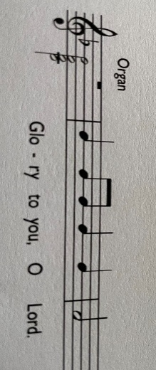  When the time came for their purification according to the law of Moses, Mary and Joseph brought Jesus up to Jerusalem to present him to the Lord (as it is written in the law of the Lord, ‘Every firstborn male shall be designated as holy to the Lord’), and they offered a sacrifice according to what is stated in the law of the Lord, ‘a pair of turtle-doves or two young pigeons.’ Now there was a man in Jerusalem whose name was Simeon; this man was righteous and devout, looking forward to the consolation of Israel, and the Holy Spirit rested on him. It had been revealed to him by the Holy Spirit that he would not see death before he had seen the Lord’s Messiah. Guided by the Spirit, Simeon came into the temple; and when the parents brought in the child Jesus, to do  for him what was customary under |  | the law, Simeon took him in his arms and praised God, saying, ‘Master, now you are dismissing your servant in peace, according to your word; for my eyes have seen your salvation, which you have prepared in the presence of all peoples, a light for revelation to the Gentiles and for glory to your people Israel.’ And the child’s father and mother were amazed at what was being said about him. Then Simeon blessed them and said to his mother Mary, ‘This child is destined for the falling and the rising of many in Israel, and to be a sign that will be opposed so that the inner thoughts of many will be revealed—and a sword will pierce your own soul too.’ There was also a prophet, Anna the daughter of Phanuel, of the tribe of Asher. She was of a great age, having lived with her husband for seven years after her marriage, then as a widow to the age of eighty-four. She never left the temple but worshipped there with fasting and prayer night and day. At that moment she came, and began to praise God and to speak about the child to all who were looking for the redemption of Jerusalem. When they had finished everything required by the law of the Lord, they returned to Galilee, to their own town of Nazareth. The child grew and became strong, filled with wisdom; and the favour of God was upon him.  Luke 2:22-40  This is the Gospel of the Lord  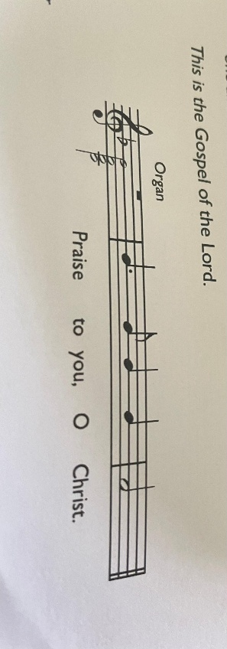  POST COMMUNION Lord, you fulfilled the hope of Simeon and Anna, who lived to welcome the Messiah: may we, who have received these gifts beyond words, prepare to meet Christ Jesus when he comes to bring us to eternal life; for he is alive and reigns, now and for ever. Amen

