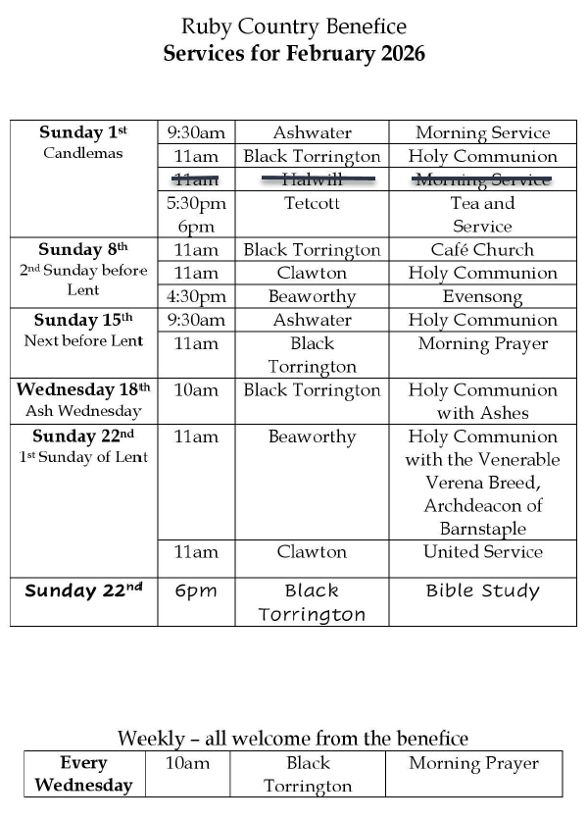

Please note:
On Sunday 15th February – there will also be Holy Communion at Halwill at 11.00am

