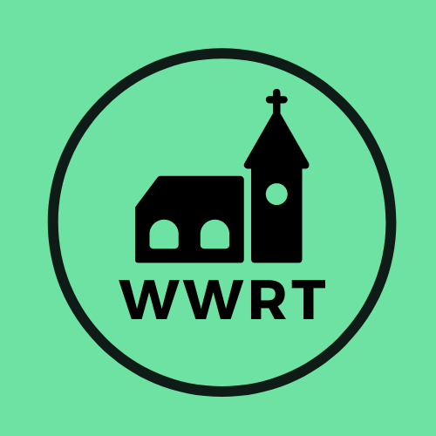

CHURCH SERVICES IN THE LOWER TEME VALLEY MARCH 2026

Sunday 1st March
Lent 2
9.00am BCP Holy Communion, St Leonard, Cotheridge
10.30am Worship for all, St Mary Magdalene, Broadwas

Sunday 8th March
Lent 3
3.00pm Evening Worship, Knightwick Chapel

Sunday 15th March
Mothering Sunday/Lent 4
10.30am CW Holy Communion, St Mary Magdalene, Broadwas

Sunday 22nd March
Lent 5
10.30am Morning Worship , St Mary Magdalene, Broadwas

Sunday 29th March
Palm Sunday
10.30am All Age Family Service, Cob House

In March there will be Holy Communion at Heaton House, Martley on the 2nd and 4th Wednesday at 10.15am and on the 1st and 3rd Wednesday via our YouTube channel -wwrtlive1.
All services and timings are subject to review and amendment – please check the website for updates: www.achurchnearyou.com

All services and timings are subject to review and amendment in accordance with Covid lockdown easing – please contact the Rectory or check the website for updates.
01886 888664
www.achurchnearyou.com

