What is a heart attack?
A heart attack happens when the supply of blood to part of the heart is suddenly blocked, usually by a blood clot. You can make a full recovery following a heart attack, but this may depend on how much of the heart is affected.
Signs and symptoms
Someone having a heart attack may:
- have crushing pain in the centre of their chest, that may spread to their jaw, and down one or both arms
- be breathless or gasping for breath
- be sweating profusely
- experience pain similar to indigestion
- collapse without warning
- complain of dizziness
- have pale skin and their lips may have a blue tinge
- have a rapid, weak, or irregular pulse
- have a feeling of impending doom.
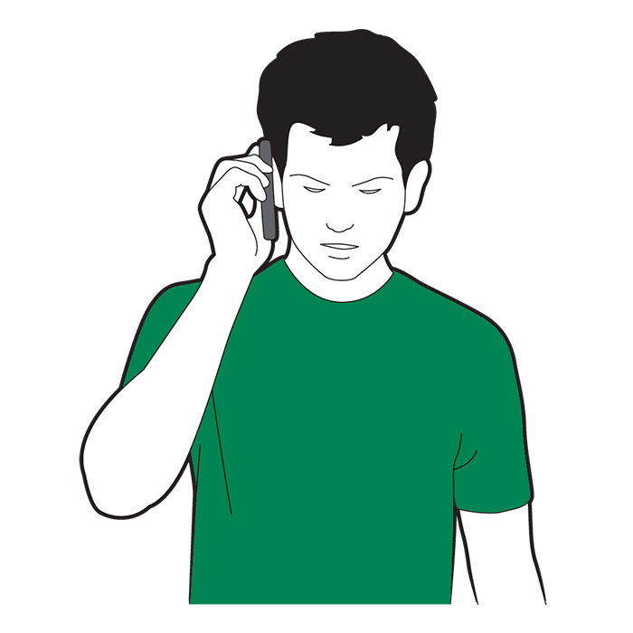
What to do

Call 999 or 112 for emergency help straight away and tell them you think someone is having a heart attack.

Help move the casualty into a comfortable position. The best position is on the floor, with their knees bent and their head and shoulders supported.
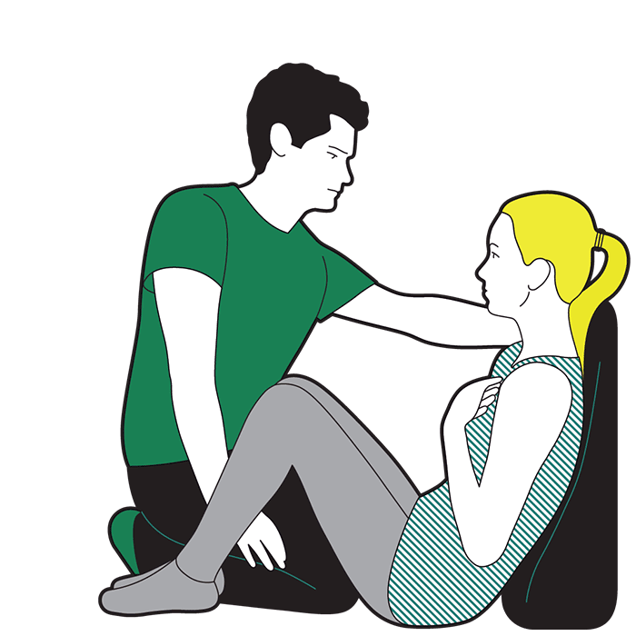
  - You could place cushions behind them or under their knees.
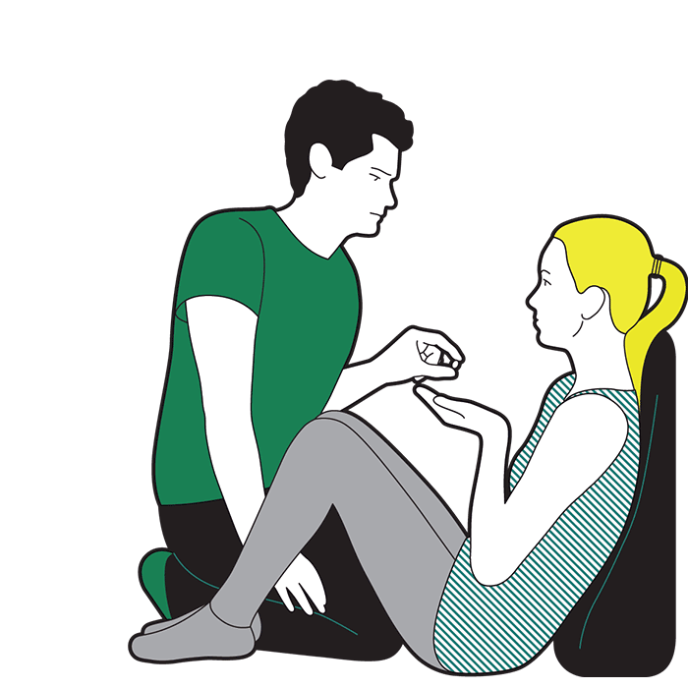
Give them one aspirin tablet (300mg) and ask them to chew it slowly.
  - Do not give aspirin to the casualty if they are under 16 or if they are allergic to it.

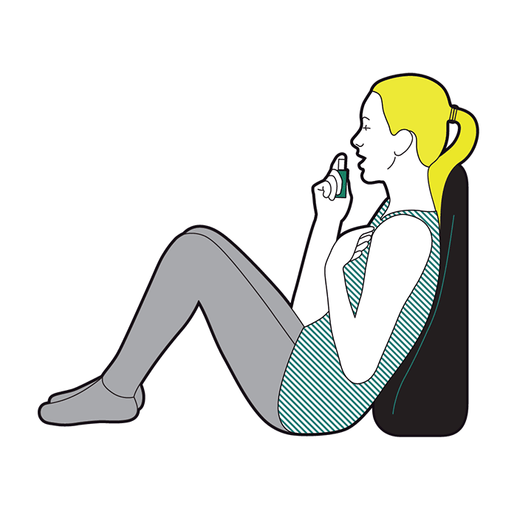
Ask the casualty to take their own angina medication, if they have some.

Keep monitoring the casualty’s level of response until emergency help arrives.

