CHURCH SERVICES IN CLIFTON, THE SHELSLEYS AND LOWER SAPEY (HARPLEY)
March 2026
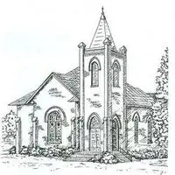

Sunday 1st March
10.30am: Holy Communion, St Kenelm’s Clifton
10.30am: Morning Praise, St Bartholomew, Harpley

Friday 6th March
6.30pm: Skies at Night St Bartholomew, Harpley

Sunday 8th March
10.30am: Family Holy Communion, All Saints,
Shelsley Beauchamp
3pm: Lambing Café Church, Parsonage Farm, Rochford

Sunday 15th March: Mothering Sunday
10.00am: Praise 4 All, Mothering Sunday, St Kenelm’s Clifton
6.30pm: Evensong, St Kenelm’s, Clifton

Wednesday 18th March
10.30am: Holy Communion. St Andrews, Shelsley Walsh

Sunday 22nd March
10am: All Age & Holy Communion, Rochford Church

Sunday 29th March: Palm Sunday
10am: Hanley Rectory to Village Hall Walk for
Palm Sunday Celebration

