CANALSIDE NEWS
for DECEMBER 2025




Thought from the Rectory

New Year’s celebrations. Think about Lent. What are you giving up? Before you know it, it’s Easter. Big celebration! Too much chocolate. Into the summer. Hot. Holidays. Sun and seasides. Back to school. Autumn, falling leaves, frown at the Halloween decorations in Sainsbury’s. Suddenly it’s Advent and we’re getting ready for Christmas, the end of another year.

I don’t know how 2025 has been for you, but it certainly seems to have been a blur to me. As we gear up for Advent 2025, and even for what’s to come in the New Year, it’s hard not to look back on another year that has flown by.

During Advent, the Church of England follows a sequence of four Sundays to remember the patriarchs and matriarchs, the prophets, John the Baptist and Mary, Jesus’ mother. This year, we’re also using an alternate sequence that is used by other church traditions: as we light the four Advent candles, we remember Hope, Peace, Joy and Love. In our preparations for Christmas, and at a time when we look forward to Jesus coming again some day, we tell a story of those four things.

Reflecting on this year, it definitely feels good to remember Hope, Peace, Joy and Love. They are all there, if I look back. It’s just that I didn’t always take the time to notice them. In the busy-ness of the year, in the frenetic pace of life and when trying to balance all the different things we do (church, family, schools, trying to do some exercise, remembering to answer Michael’s emails about the newsletter), we sometimes overlook basic things.

This all counts as we look forward to 2026, as well. What do you hope for? What gives you peace? Where will you encounter joy? When might you receive, or need to offer, love?

A final thought. I don’t know what Christmas films you reach for each December, but my three I watch every single year are Die Hard (yes, it’s a Christmas film and I am absolutely willing to fight over this), Nativity and Home Alone. Maybe it’s just because we’re searching for those feel-good vibes, but (perhaps leaving Die Hard to the side), so many Christmas films are all about people searching for those four things: Hope, Peace, Joy and Love. Whether it’s George Bailey, consumed by despair but given new hope by the end of the film or Ebenezer Scrooge, setting aside selfish miserliness for shared joy and love with others (I do err towards the muppets’ version of A Christmas Carol), these films embody things that, in church, we are finding in the story of Jesus.

Enjoy your Christmas films this year. And I pray that you each find Hope, Peace, Joy and Love, spotting where it showed itself in 2025 and receiving it in present-loads for 2026. Rev. Chris

Thankyou for your Support


We are so grateful to everyone who supported, in whatever way, the recent Christmas Festive Fayre at St Mary Magdalen’s. It was a wonderful turnout and the event raised an amazing £997 (incl donations) for parish funds. Last year’s Fayre raised £632. We also raised a further £435 at the Quiz Night - £1,432 in less than a week – that’s pretty good going. That’s the good news – sadly despite all our best efforts we are still forecasting an end of year deficit of around £15,000. This hasn’t been helped by a couple of unforeseen problems at St Mary’s recently – the heater in the chancel has had to be replaced and the kitchen roof has had to be repaired after rain water leaked in. The total cost of the heater and roof repairs is about £3,000. Many thanks to everyone who has responded to Chris’ letter last week, setting out the financial situation that we now face. Already we have received some very kind one off donations and I know that some of you are reviewing your giving to church. THANKYOU ALL. Michael
Special Visitors

On the afternoon of Sunday November 9th at St Katharine’s Church in Holt it was such a privilege to meet in person Archbishop Ezekiel of Sudan and Bishop Hassan of the Kadugli Diocese (South Kordofan) – here in the UK to highlight the plight of their war ravaged country.

Following welcomes by the Rev. Andrew Evans, singing and prayer, first the Archbishop and then Bishop Hassan spoke in words very wide-ranging. So many factions – local, national, international – at war in their land. A very complex picture. Some factions supported by weapons from other nations. So much destruction. 12 million people displaced, many thousands killed. Unspeakable, brutal atrocities.

Questions were then invited. One question: “What are your two main needs ?” The Archbishop replied : “Food and Advocacy”. (for “Food” read all humanitarian needs). Advocacy – the World has been slow to recognise, to respond to, what many call this “Forgotten War”.

The Archbishop and Bishop Hassan were off to Westminster early in the week. On Monday I rang my MP’s office asking him to do what he can in Parliament to “raise” the plight and needs of Sudan.

Despite all this darkness what is abundantly clear is the Faith and Hope of these two priests – and of their “flock” – and of how important to them is the link between the Episcopal Church o f Sudan and Salisbury Diocese. The Deanery of Bradford on Avon they call Bradford on Heaven. A sentence from the Archbishop which will stay with me : “Our children are your children; your children are our children.”

To quote the Archbishop again : “Please do not grow tired of praying for Sudan”. Jo Davis
Used Postage Stamps

No doubt we will all be seeing more post in your letterboxes in the next few
weeks. It would be great if you could save the stamps and pass them on to Bill
and Marilyn Stubbs who in turn pass them on to the Bible Society. Please keep
them coming and use the Storehouse church porch containers for dropping
them off.
100 Club News

Congratulations to the winner of the November 100 Club Draw: Dawn Charman

Bill Stubbs

Unfortunately Bill is currently unable to drive as he awaits some treatment
needed to his eyes. We wish you well Bill and hope that you are back on the
road very soon. In the meantime enjoy a well deserved rest. Whilst Bill is
confined to barracks we are looking for a volunteer to take any donations from
the Foodbank box at St Mary Magdalen’s in Horse Road to Storehouse in Union
Street, Trowbridge. If you would like to take this on for a while please let
me know. Many thanks to Keith and Janet Waring who emptied the box
for us last week.

Christmas Services Flier

On the back of this newsletter you will see this year’s poster of our Christmas
Services. Sadly we don’t have the resources to deliver a flier to every
home in the Benefice but if you could deliver some to neighbours, homes in
your own road or neighbourhood please let me know how many fliers you
would like and I will get them copied for you and in church for Sunday 7th. I
will also need to know in which roads you will be delivering to avoid any
duplication. The fliers need to be distributed before the Christingle and Carols
event at St Mary Magdalen’s on Sunday 14th. Many thanks. Michael
Christingle and Carols


On Sunday 14th December our Christingle and Carols event
will be held at St Mary Magdalen’s at 3pm. At 9.30am on
the Saturday (13th) the Christingles will be prepared at St
Mary Magdalen’s. If anyone could help with the
preparation please let me know as soon as possible. Joy

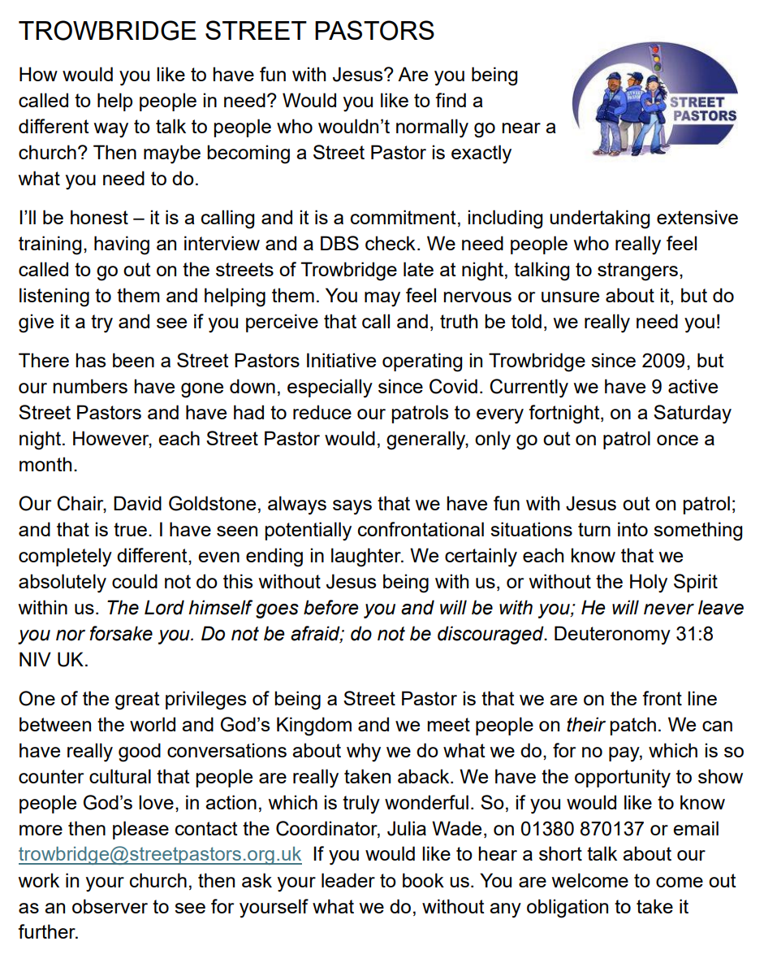




Prayer Requests

It is important that we pray for all who seek our support.
Please let Michael know of anyone who particularly needs our prayers. Do ensure that you have their permission.
This month we pray for..  + Alison Meader  + Amelia-Lily and  family  + Andrew Margetts  + Audrey Sheppard  + Barbara Tucker  + Bob Cradock  + Catherine  + Cathy and Ian  + Chloe Stevens  + Colin Jackson  + Collette Miyagawa  + Colston Carpenter | + Dave, Rosemary,  Matthew & Family  + Eve and Jim Banks  + Hannah, Ash, Oliver & baby Leo  + Heather  + Helen Thomas  + Hilary & Mark Heaton  + Irene Hicks  + Isabelle & Family  + Jeannette  + Joanna Martin  + Laurence & Family  + Maggie & Family | + Maureen Mitchell  + Michelle  + Mike Aldridge  + Mitchel and Divine  + Richard Marshman  + Roger Emes  + Rosa Light  + Tanya  + Val, Phil and family  + Viv and Jan  

- We pray for all those who are mourning the loss of a loved one at this time especially the friends and family of Pat Butler.

- We pray for the people of Sudan at this time of conflict, including Archbishop Ezekiel as he leads the Anglican Church there.


Foodbanks Update


Together with many other Foodbanks across the country both Melksham and Trowbridge are desperate for more donations, as the demand is very high at present, so please give as generously as you are able.


HELP!
If you can donate any food or hygiene items PLEASE, pop them in our trolleys or come on down and bring them to us. If you are a little flush; you can do online shopping with ASDA as they will deliver to us on your behalf. Please drop into the building as we now do a breakfast for the homeless so eggs are always needed plus cheese, butter bacon etc as we have a fridge freezer, and fridge. Fruit and vegetables are always welcome but do not put in a trolley.
Please continue to donate to us so we can keep blessing the people of Trowbridge. Thank you all.
Please use the collection boxes in the porches of St Mary Magdalen’s and St Michael’s to drop off food donations etc.
If you prefer you can make a one off financial donation or support Trowbridge Storehouse regularly, please follow the link below and select storehouse. https://westwiltsvineyard.churchsuite.co.uk/donate/fund/zk54op3a Storehouse is always in need of carrier bags

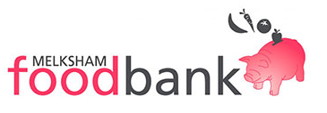
Melksham Foodbank continue to need all items but in particular at the moment
require : biscuits, tinned meat, sugar, and in addition to all the usual stuff are collecting some ’treat’ items for Christmas, including 100g bars of Chocolate, and Christmas foods with dates well into January.. The demand for support is very high (please ensure all items are well within the best before date). They can also take large bags of rice, tea bags, sugar & pasta as these can be decanted into smaller bags for distribution. Please take your donations to the porch at St George’s, Semington before 6pm on Wednesday.


Our continued support of Melksham FoodBank and Trowbridge StoreHouse is vital, and a part of our response to God’s generosity to us.



CANALSIDE DIARY
Please pray for all events taking place in the next few weeks

Day | Date | Time | Event details | Location
D E C E M B E R 2 0 2 5
Tu | 2nd | 0930 | Hilperton/Staverton Morning Prayer https://us06web.zoom.us/j/89678887943?pwd=IKy2vBYNviwibNcoWUpqTtf4hpwQTA.1 | Online
Tu | 2nd | 1450 | Collective Worship | St George’s School
W | 3rd | 1000 | Midweek Morning Worship | St Michael’s
W | 3rd | 1430 | Collective Worship | Hilperton School
Th | 4th | 0900 | Semington Morning Prayer  https://us06web.zoom.us/j/88553953942?pwd=1EHGGg18bBqqYKytMMRbYvZ5JZFZNm.1 | Online
F | 5th | 0930 | Toddlers@theTin | St Mary Magdalen’s
Su | 7th | 1030 | Service of Holy Communion | St Michael’s
Su | 7th | 1500 | Service of BCP Holy Communion | St Mary the Virgin
Su | 7th | 1800 | Semington Christmas Lights | High Street
Tu | 9th | 0930 | Hilperton/Staverton Morning Prayer  Use link above | Online
W | 10th | 1000 | Midweek Communion | St Michael’s
W | 10th | 1430 | Open the Book | Hilperton School
Th | 11th | 0900 | Semington Morning Prayer  Use link above | Online
Th | 11th | 1045 | Open the Book | St George’s School
Th | 11th | 1430 | Friendship Group | St Mary Magdalen’s
Th | 11th | 1445 | Open the Book | Staverton School
F | 12th | 0930 | Toddlers@theTin | St Mary Magdalen’s
Sa | 13th | 0930 | Preparation of Christingles | St Mary Magdalen’s
Su | 14th | 0930 | Breakfast Church | St George’s Church
Su | 14th | 1030 | Service of Holy Communion | St Mary Magdalen’s
Su | 14th | 1500 | Christingle and Carols | St Mary Magdalen’s
Tu | 16th | 0930 | Hilperton/Staverton Morning Prayer  Use link above | Online
W | 17th | 1000 | Midweek Morning Worship | St Michael’s
W | 17th | 1730 | Carols by Candlelight | St George’s School
Th | 18th | 0900 | Semington Morning Prayer  Use link above | Online
Th | 18th | 0930 | Hilperton School Christmas Service | St Michael’s
Th | 18th | 0930 | St George’s Sch Christmas Service | St George’s Church
Th | 18th | 1530 | Staverton Sch Christmas Service | Staverton School
F | 19th | 0930 | Toddlers@theTin | St Mary Magdalen’s
F | 19th | 1030 | Carols at Staverton House | Staverton House
F | 19th | 1800 | Whaddon Carol Service | St Mary the Virgin
Sa | 20th | 1100 | Trowbridge Living Nativity | Civic Centre
Su | 21st | 1030 | Service of Holy Communion / Crib | St Mary Magdalen’s
Su | 21st | 1500 | Semington Carol Service | St George’s Church
Su | 21st | 1800 | Hilperton Carol Service | St Michael’s
Tu | 23rd | 0930 | Hilperton/Staverton Morning Prayer  (NOT online – IN PERSON) | St Michael’s
W | 24th | CHRISTMAS EVE
W | 24th | 1000 | Midweek Communion | St Michael’s
W | 24th | 1400 | Christmas Celebration | St George’s
W | 24th | 1700 | Crib Service | St Michael’s
W | 24th | 2330 | Christmas Midnight Communion | St George’s
W | 24th | 2330 | Christmas Midnight Communion | St Michael’s
Th | 25th | CHRISTMAS DAY
Th | 25th | 0930 | Christmas Morning Communion | St George’s
Th | 25th | 1030 | Christmas Morning Communion | St Michael’s
F | 26th | BOXING DAY
Su | 28th | 1030 | Service of Holy Communion | St Michael’s
W | 31st | NEW YEAR’S EVE
W | 31st | 1000 | Midweek Communion | Online
J A N U A R Y 2 0 2 6
Th | 1st | NEW YEAR’S DAY
Tu | 6th | EPIPHANY
Tu | 6th | 0930 | Hilperton/Staverton Morning Prayer  Use link above | Online
W | 7th | 1000 | Midweek Morning Worship | St Michael’s
Th | 8th | 0900 | Semington Morning Prayer  Use link above | Online

CANALSIDE CONTACTS
Rector | Rev. Chris Hunter | 07396875236  01225 975510 | rector.canalside@gmail.com
Associate Priest | Rev. Joy Albone | 07931638524 | revjoyalbone@gmail.com
Office | Michael Gamble | 07795400262 | canalsideoffice@gmail.com
Churchwardens
Semington | David Wildsmith | c/o 01380 870784 | c/o jackbev.woodward@gmail.com
Hilperton and Staverton | James Newton | 07803904947 | jpnewton@churchmouse.org.uk
Hilperton and Staverton | Martyn Carpenter | 07831309377 | martyncarpenter55@gmail.com
Website | canalsidebenefice.org.uk
Facebook | https://www.facebook.com/canalsideparishes



Almighty God, from whom all thoughts of truth and peace proceed: kindle, we pray, in the hearts of all, the true love of peace and guide with your pure and peaceable wisdom those who take counsel for the nations of the earth that in tranquillity your kingdom may go forward, till the earth is filled with the knowledge of your love; through Jesus Christ your Son our Lord, who is alive and reigns with you, in the unity of the Holy Spirit, one God, now and for ever. Amen.
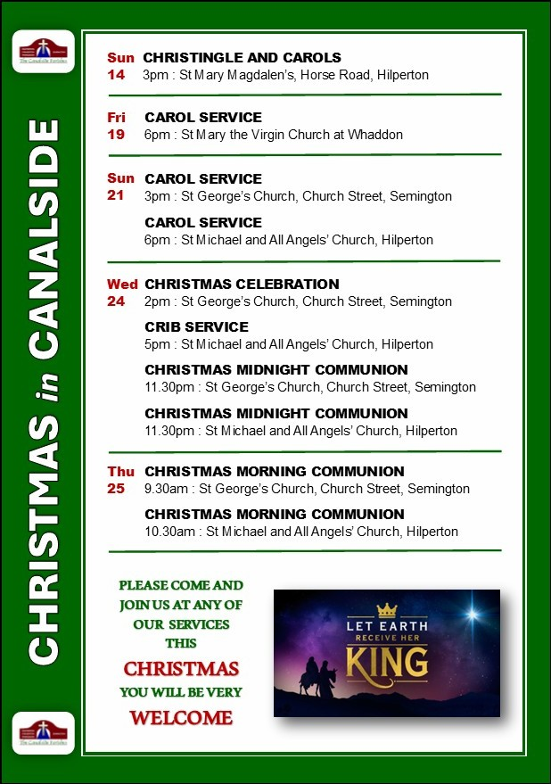
Details of all our Sunday, Midweek and Christmas Services can be found in the Diary

