Message to Marton Friends for Sunday 25th January 2026
Please find attached this week's update from Rev Steve which includes information about Lent, and also a very stirring reflection from Harold on this week's gospel reading.
There is no service in Marton Church this Sunday: our next service will be on Sunday 1st Feb at 3pm (our Celtic Communion).
Tuesday Midday Prayers continues to meet each week in a nice warm house and we enjoy the fellowship of sharing stories, encouraging each other and enjoying a moment of quiet and peace in such a busy and noisy world. Everyone very welcome.
We were blessed with surprisingly good weather for the RSPB Big Garden Birdwatch in Marton Churchyard this morning! Many thanks to Tim Pope for leading this as I depended entirely on him for identifications! This was our return to the RSPB:
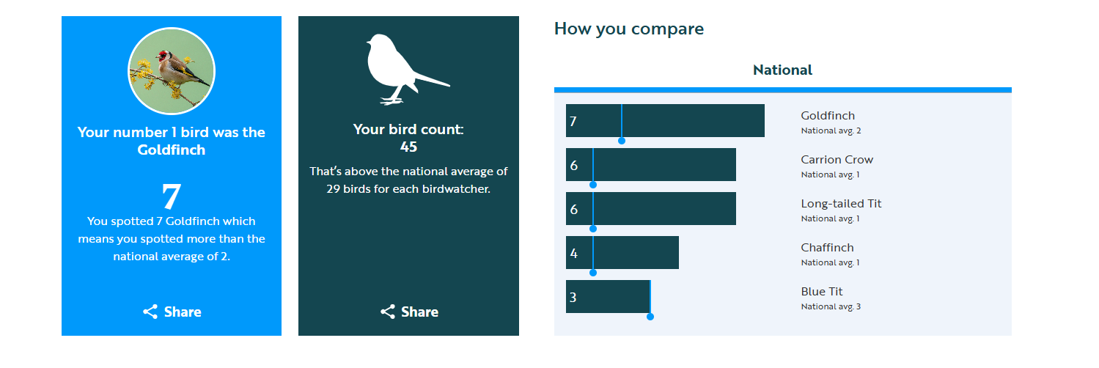
I have had a lovely time this week, trying to collate all our wildlife observations using our wildlife book (dating back to 2008), Sarah's photos (from 2016) and our 'Count on Nature' audits (since 2021). This has resulted in a list of over 100 plants, 55 insects, 55 different birds and any other wildlife visitors which have been reported at some time. I've attached this 'labour of love' for anyone interested! There will be some omissions and some mistaken IDs in there, but it is a work in progress, and should be a helpful starting point. We will have our annual 'Count on Nature' wildlife audit in June 2026, but if you have an area of specific interest or expertise (grasses, trees, insects etc) then any help identifying wildlife at any time of the year would be very much appreciated!
In addition to our application to join the 'Small Pilgrim Places Network', I've also registered Marton Church as a 'Pilgrim Place' with 'Faith in the North'. This venture is leading up to recognising and celebrating the 1400th anniversary since Bishop Paulinus baptised King Edwin of Northumbria in York in 627: the first Christian monarch in the North of England! In readiness for the actual anniversary in 2027, churches in 'the northern provinces' are being encouraged to think about pilgrimage, visitors, welcome and providing a space that offers beauty, peace, comfort and hope. I watched a webinar about this and honestly think Marton Church ticks most of the boxes already so I registered us, and we'll appear on their map in due course. I'll keep following their
information and seeing what else we can do. We already have some of their 'pilgrim prayer cards' in the chancel. You can look at their website here
https://faithinthenorth.org/pilgrim%20places/ and this includes their description of pilgrim places...
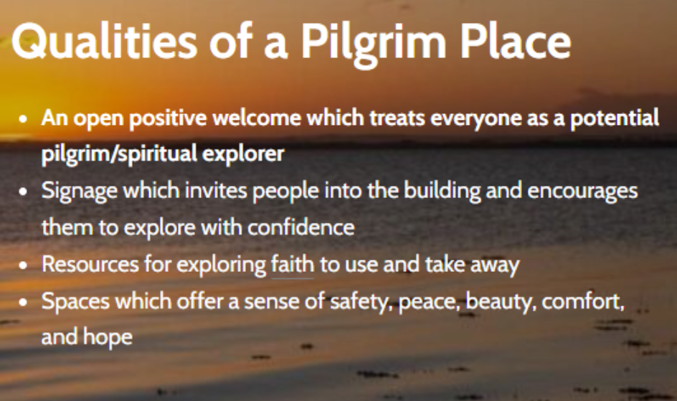

I've enjoyed seeing so many little hopeful signs of spring this week - snowdrops in the churchyard, new leaves on the honeysuckle, daffodils pushing through and something definitely plopped in the pond when I walked past! I know we still have a way to go, but other people have also mentioned how much they are enjoying the lighter mornings and later sunsets.
Here is the blessing for 'The Glory of Christ in Creation' from Ruth Burgess's collection.
O Christ whose glory shines through the stars:
fill our lives with your light.
O Christ whose glory is seen in every plant and creature:
fill our lives with your love.
O Christ whose glory fills the earth:
fill our lives with your power.
Bless us, teach us to live in peace
with you and the earth and all its creatures,
that your glory may continue to be witnessed among us.
Amen.
Every blessing
Caroline
878242

