

LENT, HOLY WEEK & EASTER 2026

ST MARY’S WELWYN,
ST MICHAEL’S WOOLMER GREEN
AYOT ST PETER

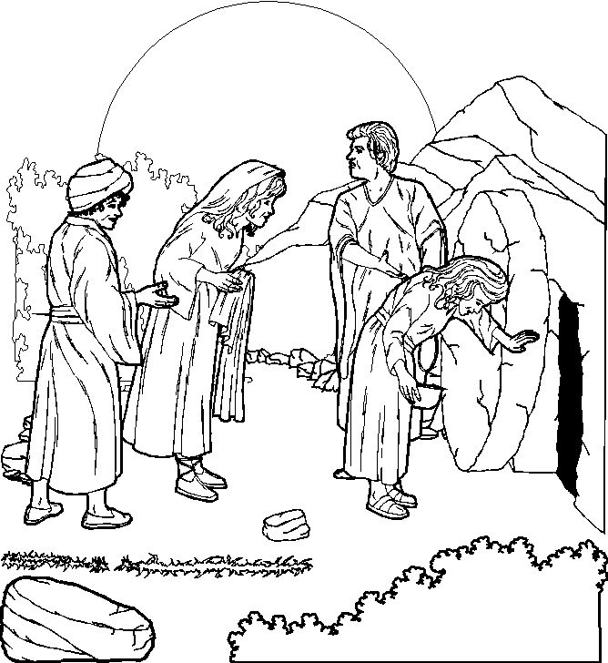

Shrove Tuesday (February 17th)

As Shrove Tuesday falls in half term this year there will be a Team Pancake Race with different age categories at 11am on Burnham Green – all welcome.

Ash Wednesday (February 18th)


At 9.30am and 8pm there will be a Eucharist with Imposition of Ash at St Mary’s Welwyn. All are welcome and encouraged to make this start to the Lenten season.



There are various ways to keep this theme in Lent on the Church of England Website at - https://www.churchofengland.org/our-faith/what-we-believe/lent-holy-week-and-easter/livelent-embracing-justice-our-lent-reflections

This includes daily reflections for adults and children, as well as other resources. You can sign up for them on the website

Lent course

Our Lent course this year is about the Church’s Mission, and will study and reflect on Bible Passages concerned with various aspects of Mission. There will be time for discussion in the groups. It will be written by members of our own Ministry Team.
Lent Groups 2026

Groups start on or after Monday 23rd February
there are five weeks in the course

Tuesday 7.30 – St Michael’s Woolmer Green group
Led by Nicky Jackson, Colin and Usha Hull, Host: Sue Keach, 4 Roundabout Lane, AL6 0TH, 01438 716657

Wednesday 10.30am - St Mary’s Church House
Led by David Munchin - 01438 714150

Wednesday 7.45 for 8pm - 1 Codicote Road, Welwyn
Led by Gay and Mike Carpenter 01438 718439
(NB 25th March in Church house)

Thursday 7pm at Codicote Parish Centre (next to St Giles Church) led by Catherine Jupp 07811255311.

Friday 10.30am - Time for Reflection Group at St. Mary’s
Church House - Contact Mavis Francis 01438 487851

Friday 12pm – Datchworth Church Hall
Led by Susannah Underwood and Jo Sampson - 01438 817183
Beginning with soup lunch

Mothering Sunday is Sunday 15th March this year

Holy Week and Easter Services

Palm Sunday 29th March - BST begins on this day NB

- 8.00am St Mary’s, Welwyn Said Eucharist
with distribution of Palms

- 9.30am St Mary’s, Welwyn - Parish Eucharist
begins at The Plain (end of School Lane) with the blessing of the Palms and procession to St Mary’s. The service will include the reading of the Passion Gospel in dramatic form.

- 11.15 St Michael’s Woolmer Green – Family Service
Including procession, blessing of psalms and dramatic reading of Passion Gospel

- 11.15am St Peter’s, Ayot – BCP Holy Communion
with distribution of Palms

- 6.30pm Evening Prayer at Welwyn

Tuesday 31st March

- 9pm Compline at St Mary’s Welwyn

Wednesday 1st April

- 9.30am St Mary’s, Welwyn – Eucharist with prayers for healing

- 8.00pm St Mary’s, Welwyn – Taize Service

Maundy Thursday 2nd April

- 11am Chrism Mass at St Albans Cathedral

- 8.00pm St Mary’s, Welwyn -
Sung Eucharist of the Last Supper with washing of the feet followed by the Watch until midnight

Good Friday 3rd April

- 9.30 – St Michael’s Woolmer Green
All Age Stations of the Cross

- 12.00 – 1.30pm St Mary’s, Welwyn – Preaching the Passion
- 1.30-3pm Liturgy of the Passion at St Mary’s Welwyn

Easter Day, Sunday, 5th April

- 8.00am St Mary’s, Welwyn – Said Eucharist

- 9.30am All age Eucharist St Mary’s, Welwyn, plus Easter egg hunt

- 11.15 St Michael’s Woolmer Green – All Age Eucharist

- 11.15am St Peter’s, Ayot - BCP Holy Communion
plus Easter Egg hunt

NB No evening service

Easter Monday 6th April – Pilgrimage to St Albans Cathedral
Meet for Breakfast at Welwyn at 8.30am.

A new innovation! An Easter Carol service – Sunday 26th April, 6.30pm at St Mary’s Welwyn – Easter music, hymns and readings.

