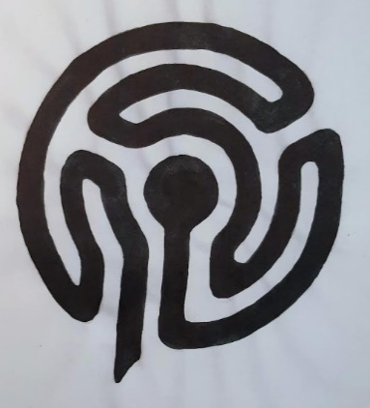
St Mary’s Church, Marton in the Forest
A prayer of dedication for our seasonal
‘Spring Meadow Prayer Labyrinth’

Sunday 4th January 2026

In your presence, Heavenly Father,
we stand together
in this sacred space
in this thin place between earth and heaven,
surrounded by nature,
by this beautiful church,
in this pocket of peace and tranquillity in a loud and hectic world.
(A moment of quiet to respond to God’s invitation to come as we are.)
Creator God, we have come together
to ask you to bless this labyrinth.
Lord Jesus, friend and companion,
let time stand still
as we commit to you this pathway, our own journeys, and all who come to walk here.
Holy Spirit, present with us now,
bless each step,
each turn,
each view,
each thought,
each memory,
each idea,
each prayer.

May we, and all who come as pilgrims,
seeking answers to life’s questions,
find space to listen to your quiet voice.
May we, and all those who come bearing burdens,
sense that this a safe place to lay them down.
May we, and all those feeling guilty and fearful,
feel released and forgiven and loved and free.
May we and all those who come feeling weary or sad or hurt,
receive your healing and wholeness and hope.
We pray that the centre of this labyrinth
will be filled to overflowing with your peace.
Let everyone who lingers here feel refreshed and renewed by your unconditional love.
Come rain, come wind, come snow, come sunshine,
we ask you to transform us, and all who visit,
until we’re ready to walk back,
to unwind our thoughts,
leave this quiet moment,
returning to the world,
with a fresh awareness of your loving presence
in all the twists and turns of our daily lives.
Amen.

