CHURCH SERVICES IN CLIFTON, THE SHELSLEYS AND LOWER SAPEY (HARPLEY)
January 2026
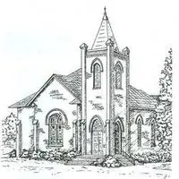

Sunday 4th January
10.30am: Holy Communion, St Kenelm’s, Clifton

Sunday 11th January
10.30am: Family Worship with Holy Communion, All Saints, Shelsley Beauchamp

Sunday 18th January
10.00am: Praise 4 All, St Kenelm’s Clifton
6.30pm: Evensong, St Kenelm’s, Clifton

Wednesday 21st January
10.30am: Holy Communion, St Andrews, Shelsley Walsh

Sunday 25th January
10.30am: Circle Service, St Bartholomew, Harpley

Sunday 1st February
10.30am: Morning Prayer, St Kenelm’s Clifton
10.30am: Morning Praise, St Bartholomew, Harpley
4.00pm: Candlemass, St Andrew’s, Shelsley Walsh

