SUNDAY READING SHEET 18th January 2nd Sunday of Epiphany

A Reading from Paul’s First Letter to the Corinthians

Paul, called to be an apostle of Christ Jesus by the will of God, and our brother Sosthenes,
To the church of God that is in Corinth, to those who are sanctified in Christ Jesus, called to be saints, together with all those who in every place call on the name of our Lord Jesus Christ, both their Lord and ours:
Grace to you and peace from God our Father and the Lord Jesus Christ.
I give thanks to my God always for you because of the grace of God that has been given you in Christ Jesus, for in every way you have been enriched in him, in speech and knowledge of every kind— just as the testimony of Christ has been strengthened among you— so that you are not lacking in any spiritual gift as you wait for the revealing of our Lord Jesus Christ. He will also strengthen you to the end, so that you may be blameless on the day of our Lord Jesus Christ. God is faithful; by him you were called into the fellowship of his Son, Jesus Christ our Lord. 1 Corinthians 1:1-9

GOSPEL

The next day John saw Jesus coming towards him and declared, ‘Here is the Lamb of God who takes away the sin of the world! This is he of whom I said, “After me comes a man who ranks ahead of me because he was before me.” I myself did not know him; but I came baptizing with water for this reason, that he might be revealed to Israel.’ And John testified, ‘I saw the Spirit descending from heaven like a dove, and it remained on him. I myself did not know him, but the one who sent me to baptize with water said to me, “He on whom you see the Spirit descend and remain is the one who baptizes with the Holy Spirit.” And I myself have seen and have testified that this is the Son of God.’

The next day John again was standing with two of his disciples, and as he watched Jesus walk by, he exclaimed, ‘Look, here is the Lamb of God!’ The two disciples heard him say this, and they followed Jesus. When Jesus turned and saw them following, he said to them, ‘What are you looking for?’ They said to him, ‘Rabbi’ (which translated means Teacher), ‘where are you staying?’ He said to them, ‘Come and see.’ They came and saw where he was staying, and they remained with him that day. It was about four o’clock in the afternoon. One of the two who heard John speak and followed him was Andrew, Simon Peter’s brother. He first found his brother Simon and said to him, ‘We have found the Messiah’ (which is translated Anointed). He brought Simon to Jesus, who looked at him and said, ‘You are Simon son of John. You are to be called Cephas’ (which is translated Peter). John 1:29-42

Royston Parish Church
Where all are welcome and God’s love is shared
Sunday 18th January 2026 - 2nd Sunday of Epiphany

If you would like regular copies of the Notice Sheet emailed to you please email the Parish Office at admin@roystonparishchurch.org.uk

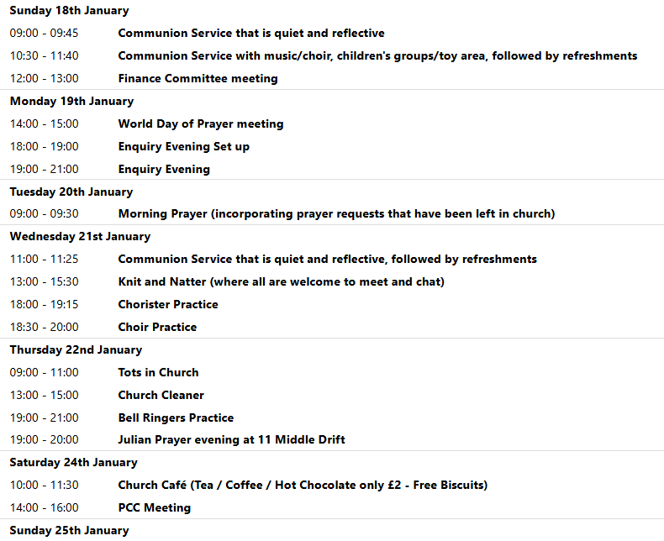
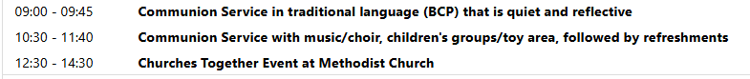

We pray for all Christians worldwide:
For all Christians in Bahrain, Kuwait
For all who are worship at Royston Catholic Church: Fr. Philip Knights
For the work of our mission partners: The Bible Society

Pray for the community of Royston:
For our local health centres
For all our local Civic Centre Amenity and Sewage Plant

We pray for our world and ECO projects:
We pray that people will engage with the RSPB's Big Garden Birdwatch taking place 23-25 January 2026 (You can sign up to find out more and join in via the RSPB website).

We pray for the sick and suffering:
4th January 11th January 18th Janury 28th December
Lee Cockerill Chris Christou Val Brown Peter Coates Pat Pritchard Paul & Pat Tidey Angie & Ken Rushall Emma & Phil Heath Jackson Herbert Mike Brown Paula Walker Peter Foster Marion Keith & Elaine Edwards Gwen Simmons
Laura O’nyamul (On-Ya-Mul) Maria Turi Katie

We pray for those who have died in the faith of Christ:
Deceased | Bereaved
Harry McDonald | Ruth, Family and friends
Barry Piper | Family and friends
Jamie Covington | Adam and Samantha Covington, family and friends

We pray for those whose anniversaries fall at this time:
Evelyn Bland, Vera Hall, Ann Smith, Bob Green, Wendy Stocker

NOTICES

Sunday 25th January – 12.30pm – Royston Methodist Church - Bring and Share lunch in the church hall followed at 1.30pm by an Ecumenical Churches Together Service to celebrate the Week of Prayer for Christian Unity – The Methodist Church are so pleased to be hosting this event and are welcoming all those from Royston and neighboring churches. We hope as many of you as possible can attend and support this event. It would be great if you could bring a small contribution to the lunch. The service will be led by Revd Kevin Highfield, who is superintendent and minister for Wesley, Chesterton, and Orwell Churches. If you would like further information about this event, please call Tracy on 07815 148022 or email tracy.aggett@btinternet.com

CHRISTMAS CARDS: If you would like to re-use youe Christmas Cards this year, please consider removing the picture, punching a hole in the card and if possible attach some string. These can then be used on on our Christmas Tree next yeay. Please bring them into Church and we can keep them until then. Thank you

UPCOMING EVENTS :There are a number of events coming up over the next few months to look forward to.

Join us for an evening with GUY STAGG Monday, February 9th, 7.30pm, Royston Parish Church. Bow Books are delighted to welcome local author Guy Stagg to Royston Parish Church, where he will discuss his award-winning non-fiction books, The Crossway and The World Within, illustrated with slides. Tickets £5 per person (includes first drink free) available from Bow Books. Please see leaflet for more information.

14th February - Church Quiz 18th April - Cheese and wine evening 2nd & 4th May - Book Fayre 19th June - Hymns and PIMM’ s
20th June - Concert

QUIZ NIGHT:Saturday 14th February, 7 for 7.30 pm, Venue: Royston Parish Church, teams of up to 8, £8 per person. If you wish to register a team or interest in joining a team, please contact Duncan Rodgers email: duncanrodgers66@gmail.com
Licensed bar, bring your own nibbles, opportunity to enter a raffle on the night. All proceeds in aid of church funds.


If you wish to make a donation to the church, then please hold your phone’s
camera over this image then touch the link that appears:

