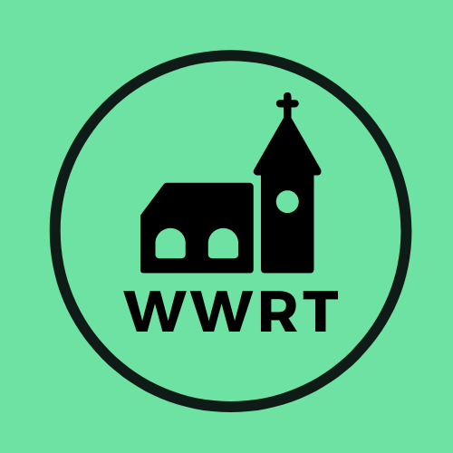

CHURCH SERVICES IN THE LOWER TEME VALLEY JANUARY 2026

Sunday 4th January
Christmas 2
10.30am Worship for all, St Mary Magdalene, Broadwas
6.00pm Evensong, St Leonard, Cotheridge

Sunday 11th January
Ephiphany 1
3.00pm Evening Worship, Knightwick Chapel

Sunday 18th January
Epiphany 2
10.30am CW Holy Communion, St Mary Magdalene, Broadwas

Sunday 25th January
Epiphany 3
10.30am Morning Worship , St Mary Magdalene, Broadwas

In January there will be Holy Communion at Heaton House, Martley on the 2nd and 4th Wednesday at 10.15am and on the 1st and 3rd Wednesday via our YouTube channel -wwrtlive1.
All services and timings are subject to review and amendment – please check the website for updates: www.achurchnearyou.com

All services and timings are subject to review and amendment in accordance with Covid lockdown easing – please contact the Rectory or check the website for updates.
01886 888664
www.achurchnearyou.com

