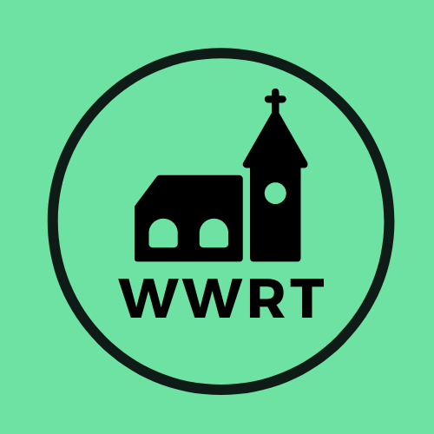
CHURCH SERVICES IN MARTLEY AND WICHENFORD
FEBRUARY 2025

Sunday 1st February
Candlemas
10.30am CW Holy Communion, St Peter, Martley
10.30am Worship for All, St Mary Magdalene, Broadwas

Sunday 8th February
2nd Sunday before Lent
10.30am CW Holy Communion, St Laurence, Wichenford

Sunday 15th February
1st Sunday before Lent
10.00am Café Church, St Peter, Martley

Sunday 22rd February
1st Sunday of Lent
10.30am CW Holy Communion, St Peter, Martley

In February there will be Holy Communion at Heaton House, Martley on the 2nd and 4th Wednesday at 10.15am and on the 1st and 3rd Wednesday via our YouTube channel -wwrtlive1.
All services and timings are subject to review and amendment – please check the website for updates: www.achurchnearyou.com

