 'Drawing on the Divine'
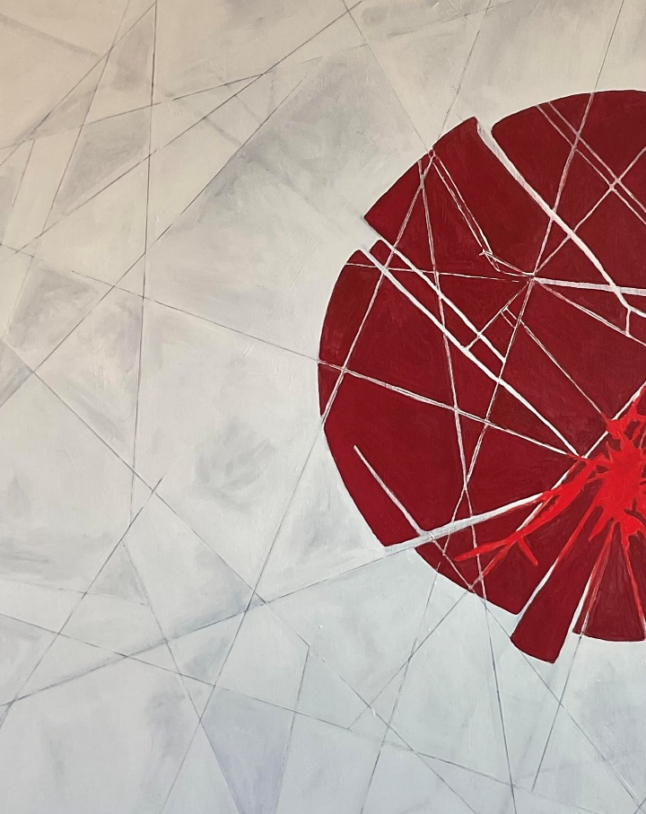
Wednesday 18th February until Saturday 28th March Free Art Exhibition
Bridlington Priory is excited to announce a new modern art exhibition during Lent by local Bridlington artist Carmen Mills.
The exhibition is free to visit and explore. Monday-Friday 11am-3pm & Saturdays 10am-Noon
On Saturday 28th February at 11am Carmen will be giving a talk in church about the exhibition and her art works.
All are welcome.

