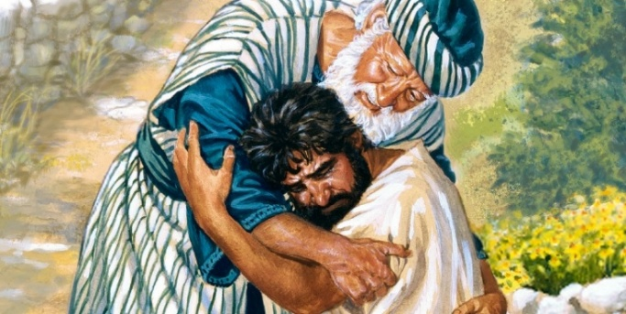

You are invited to a
Celtic Encounter
Forgiveness
Healing the past, transforming the future

Thursday, 5th February at 3pm
at the Social Club, Main Road, Brighstone
Tuesday, 10th February at 3pm
at Porchfield Village Hall
Refreshments afterwards. All welcome.
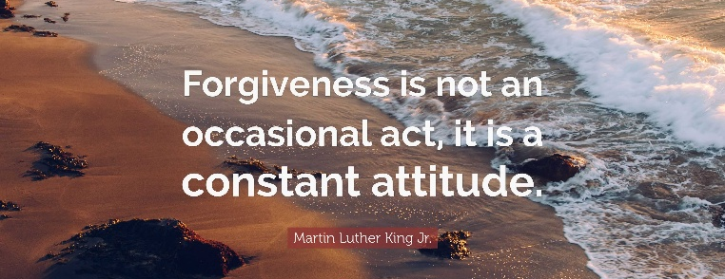

Further information text or ring Alison on 07870 509153.

