CHURCH CALENDAR AND SERVICES

JANUARY

4th Epiphany Holy Communion
11th Epiphany I Matins
18th Epiphany II Holy Communion
25th Epiphany III Matins
29th THURSDAY INDUCTION of Revd. BECCA McDOWELL
at ST MARY’S, GILLINGHAM 7 p.m.

FEBRUARY

1st Septuagesima Holy Communion
8th Sexagesima Matins
15th Quinquagesima Holy Communion
18th ASH WEDNESDAY Imposition of Ashes and Holy
Communion 6 p.m.
22nd Lent I Matins

MARCH

1st Lent II Holy Communion
8th Lent III Matins

All services are from the Book of Common Prayer and are at 10.30 a.m. unless otherwise stated.

All services will be publicised on the website and may be subject to alteration.

Next PCC Meeting: Monday 26th January 2.30 p.m. in Village Hall

PCC CHARITY GIVING COMMITTEE
In addition to various donations made throughout 2025, the following donations have been made from proceeds from the Stall at Bagmore Farm and two Coffee Mornings:
Air Ambulance 100.00
Alabare 200.00
Breakthrough T1D (Formerly JDRF) 100.00
Citizens’ Advice, Gillingham 100.00
Fire Fighters Charity 100.00
Friends of North Dorset Women’s Refuge 100.00
Friends of Salisbury Cathedral 50.00
Gillingham Food Bank 150.00
Growing Space, Wincanton 100.00
Guy’s & St Thomas’ Kidney Patients Association 100.00
Hope For Tomorrow Chemo Van 150.00
Julia’s House Children’s Hospice 100.00
Lyme Disease UK 100.00
Medicins Sans Frontiers 200.00
Mere District Link Scheme 200.00
National Churches Trust 50.00
Salvation Army 200.00
Seeds for Success 200.00
Silverline 200.00
Stars Appeal 200.00
Wessex Medical Research 200.00

INSTALLATION BY THE BISHOP OF SHERBORNE AND INDUCTION BY THE ARCHDEACON OF DORSET OF REVD REBECCA McDONNELL AS RECTOR OF THE BENEFICE OF GILLINGHAM, MILTON ON STOUR AND SILTON
This will take place at 7 p.m. on Thursday 29th January at St Mary’s Church, Gillingham followed by refreshments. Anyone wishing to attend is asked to RSVP to the Parish Office - Miriam Light Tel: 01747 821598 or gillinghamanglican@gmail.com
SILTON VILLAGE HALL
Creative Stitch - Every 3rd Monday in the month 10am-4pm. All details on Village Hall website
Castle Hill Quilters – Every Thursday 1.30pm - 4.30pm
Hannah Monksummers - Wellness & Healing Classes: Fridays evenings. Contact her on 07824510186 or hannah@whitefeatherhealing.net
Evergreen: Education & Therapy: Tuesday & Wednesday during term times
Friday Markets: will be back on Friday 6th February 10-12.30 in the Village Hall. Fresh Fruit and Veg, Home baked cakes, Pies, Bread, Jams, Chutneys and pickles as well as other goodies and of course Teas and Coffees.
The Village Hall Calendar: This can be viewed online - you can also now make an enquiry though the website www.siltonvillage.co.uk.
For Village Hall enquiries contact Sue@siltonmanor.co.uk or Tel: 07970 865790
SOFOS
Dates for the diary:
There's a Quiz Night booked in for Saturday 21st March and the Plant Sale will be on Saturday 9th May.

CHURCH AND PARISH OF
ST. NICHOLAS, SILTON, SP8 5PR
www.siltonchurch.org

JANUARY - FEBRUARY 2026
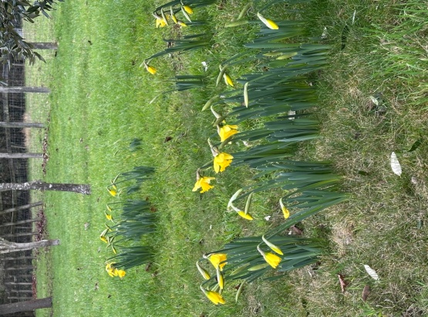
Church Wardens:
Anne Bridge (01963 31983) bridgetoofar42@gmail.com
Peter Williams (01747 840275) peterwilliams53@gmail.com

Society of Friends of Silton:

Chairman: Charles Peel: (01747 840303)
Secretary: Jackie Dyer (01747 840087) jack27.dyer@gmail.com

Parish Meeting:

Chairman: Diana Masters (01747 840288) mastersbagmore@btinternet.com
Acting Parish Clerk: Chris Woodhouse (01747 841243) cardsfarmhouse@btinternet.com

Village Hall:

Chairman: Keith Harris (07966166905) keith@siltonmanor.co.uk
Secretary: Sue Harris (07970865790) sue@siltonmanor.co.uk

Silton Village Website: www.siltonvillage.co.uk

Parish Office:

Miriam Light 01747 821598 gillinghamanglican@gmail.com

