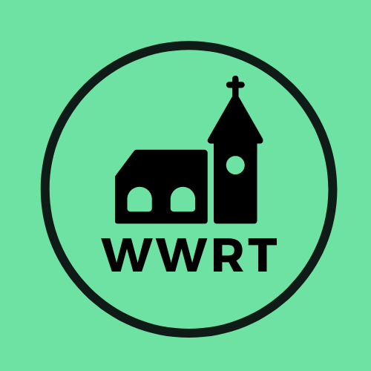

CHURCH SERVICES IN THE LOWER TEME VALLEY FEBRUARY 2025

Sunday 1st February
Candlemas
9.00am BCP Said Communion, St Leonard, Cotheridge
10.30am Worship for all, St Mary Magdalene, Broadwas

Sunday 8th February
2nd Sunday before Lent
3.00pm Evening Worship, Knightwick Chapel

Sunday 15th February
1st Sunday before Lent
10.30am CW Holy Communion, St Mary Magdalene, Broadwas

Sunday 22nd February
1st Sunday of Lent
10.30am Morning Worship , St Mary Magdalene, Broadwas

In February there will be Holy Communion at Heaton House, Martley on the 2nd and 4th Wednesday at 10.15am and on the 1st and 3rd Wednesday via our YouTube channel -wwrtlive1.
All services and timings are subject to review and amendment – please check the website for updates: www.achurchnearyou.com

All services and timings are subject to review and amendment in accordance with Covid lockdown easing – please contact the Rectory or check the website for updates.
01886 888664
www.achurchnearyou.com

