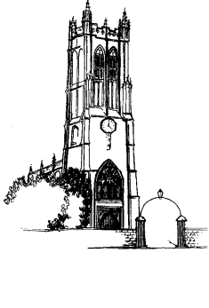
St Peter, Evercreech with St Mary, Chesterblade
Policy
Livestreaming and recording services,
including funerals, weddings and baptisms

- This policy should be shared with our local funeral directors. and with others as need arises.
- It covers services taken by members of the Evercreech with Chesterblade ministry team, whether in church, or elsewhere (e.g. at the crematorium), and any services that take place in Evercreech or Chesterblade church.
- The minister taking the service must be consulted (e.g. by the funeral director or the family) well in advance if the family want to live-stream and/or record.
- The minister taking the service must be asked for their consent for live-streaming and/or recording — and if they're not willing, either another minister must be found, or the service must not be live-streamed or recorded.
- The minister should be reassured that the live-streaming / recording will be password protected, so that only those to whom the family gives access can watch it.
- The minister should be told how long the recording will be kept for.
- The recording may not be used for commercial purposes
- The organist must give their consent — an additional fee will usually be payable.
- Others taking part (reading, eulogy etc.) need to give their consent. The family is responsible for this.
- If there is music, the family is responsible for ensuring that the correct licences are in place and copyright restrictions are observed (see below). If a commercial organisation is doing the live-streaming / recording, they may have the necessary copyright licences.
- At the start of the service, those present should be told that it's being live-streamed / recorded. There must be a designated part of the church where people will not be seen on the live-stream / recording.
- For a service in church, the camera operator must stay in one place, not move around, and be as discreet as possible. (At Mendip Crematorium there is a fixed camera.)
- All those taking part must use the microphones— if they don't, they won't be heard on the streaming / recording, however loud their voice!
- More information, including about copyright, can be found here: https://ccli.com/uk/en/weddings-funerals and here: https://www.elydiocese.org/parish-support/communications/filming-in-your-church.php#stage%203

