WILL KEATING & TRUE FOXES
CANDLE-LIT TOUR 2026

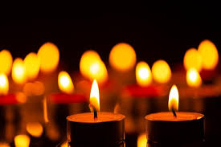

at MAWGAN CHURCH on
TUESDAY, 3rd FEBRUARY
at 7.00pm

BOOK TICKETS AT
willkeatingcornwall.com/tickets
also available on the door - £12.00

