SUNDAY MORNING READING SHEET 1st February 4th Sunday of Epiphany
A Reading from Paul’s First letter to the Corinthians
For the message about the cross is foolishness to those who are perishing, but to us who are being saved it is the power of God. For it is written, ‘I will destroy the wisdom of the wise, and the discernment of the discerning I will thwart.’ Where is the one who is wise? Where is the scribe? Where is the debater of this age? Has not God made foolish the wisdom of the world? For since, in the wisdom of God, the world did not know God through wisdom, God decided, through the foolishness of our proclamation, to save those who believe. For Jews demand signs and Greeks desire wisdom, but we proclaim Christ crucified, a stumbling-block to Jews and foolishness to Gentiles, but to those who are the called, both Jews and Greeks, Christ the power of God and the wisdom of God. For God’s foolishness is wiser than human wisdom, and God’s weakness is stronger than human strength. Consider your own call, brothers and sisters: not many of you were wise by human standards, not many were powerful, not many were of noble birth. But God chose what is foolish in the world to shame the wise; God chose what is weak in the world to shame the strong; God chose what is low and despised in the world, things that are not, to reduce to nothing things that are, so that no one might boast in the presence of God. He is the source of your life in Christ Jesus, who became for us wisdom from God, and righteousness and sanctification and redemption, in order that, as it is written, ‘Let the one who boasts, boast in the Lord.’ 1 Corinthians 1:18-31

GOSPEL

On the third day there was a wedding in Cana of Galilee, and the mother of Jesus was there. Jesus and his disciples had also been invited to the wedding. When the wine gave out, the mother of Jesus said to him, ‘They have no wine.’ And Jesus said to her, ‘Woman, what concern is that to you and to me? My hour has not yet come.’ His mother said to the servants, ‘Do whatever he tells you.’ Now standing there were six stone water-jars for the Jewish rites of purification, each holding twenty or thirty gallons. Jesus said to them, ‘Fill the jars with water.’ And they filled them up to the brim. He said to them, ‘Now draw some out, and take it to the chief steward.’ So they took it. When the steward tasted the water that had become wine, and did not know where it came from (though the servants who had drawn the water knew), the steward called the bridegroom and said to him, ‘Everyone serves the good wine first, and then the inferior wine after the guests have become drunk. But you have kept the good wine until now.’ Jesus did this, the first of his signs, in Cana of Galilee, and revealed his glory; and his disciples believed in him.
John 2:1-11

LENT COURSE: As we approach Lent, everyone is invited to take part in our parish Lent course, Draw Near: Life-Giving Habits for Lent, based on the Church of England resource offering short daily reflections to help deepen our relationship with God. Sunday preaching and home groups will follow shared weekly themes, creating a common rhythm of worship, reflection, and conversation across the church. Home groups will meet weekly where possible, with most able to welcome newcomers as well as three newly formed groups for Lent only. Further details about booklets and groups will be shared soon.


If you wish to make a donation to the church, then please hold your phone’s
camera over this image then touch the link that appears:

Royston Parish Church
Where all are welcome and God’s love is shared
Sunday 1st February 2026 - 4th Sunday of Epiphany

If you would like regular copies of the Notice Sheet emailed to you please email the Parish Office at admin@roystonparishchurch.org.uk

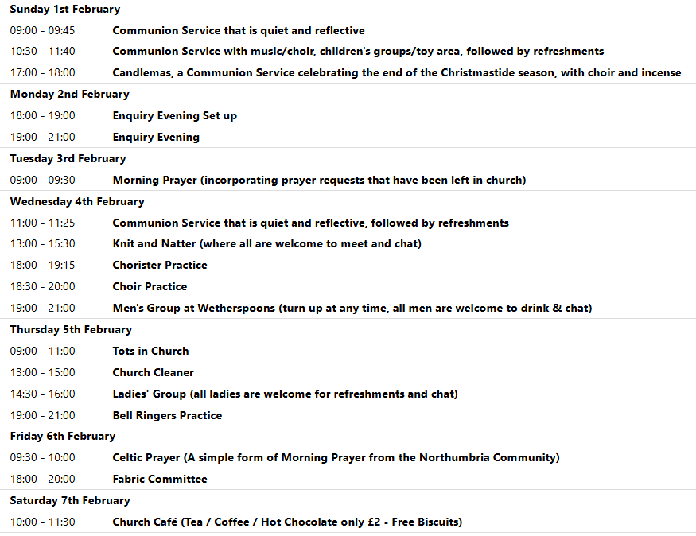
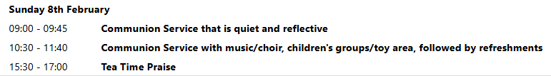

SUNDAY 1ST FEBRUARY 5 pm– CANDLEMAS: Please bring a candle with you to be blessed.

We pray for all Christians worldwide:
For all Christians in Algeria, Libya, Morocco, Western Sahara, Tunisia
For all who are worship at Trinity Life Church: Peter Chapman
For the work of our mission partners: Tear Fund

Pray for the community of Royston:
For our local health centres
For all who Volunteer or make use of Royston Community Transport
We pray for our world and ECO projects:
We pray for people participating in the Big Garden Birdwatch taking place this weekend. We pray for the habitats of our birdlife.
We pray for the sick and suffering:
1st February 8th February 15th February 2nd February
Lee Cockerill Chris Christou Val Brown Peter Coates Pat Pritchard Paul & Pat Tidey Angie & Ken Rushall Emma & Phil Heath Jackson Herbert Mike Brown Paula Walker Peter Foster Marion Keith & Elaine Edwards Gwen Simmons
Laura O’nyamul (On-Ya-Mul) Maria Turi Katie
Margaret Green
We pray for those who have died in the faith of Christ:
Deceased | Bereaved
Harry McDonald | Ruth, Family and friends

We pray for those whose anniversaries fall at this time:
Mary Taylor, Austen McMurrough
NOTICES

BASIC AWARENESS SAFEGUARDING COURSE Three years ago, after the church re-opened, we ran a Basic Awareness Safeguarding Course for anyone who was unable to access the training online and would find it easier to come along to the church to do the training as a group. For some people it is now time to renew their training after three years, for others it will be the first time. This is a relaxed, non threatening way for everyone to join together and learn how we can, as a church, keep everyone safe whether it is children or vulnerable adults. If you would like to take advantage of this opportunity we will be running the course on Monday 23rd February 2026 at 9.30 am in church. Please let me know if you would like to join us.
Alison Bailey, Parish Safeguarding Officer, 01763 250637, safeguarding@roystonparishchurch.org.uk
QUIZ NIGHT:Saturday 14th February, 7 for 7.30 pm, Venue: Royston Parish Church, teams of up to 8, £8 per person. If you wish to register a team or interest in joining a team, please contact Duncan Rodgers email: duncanrodgers66@gmail.com
Licensed bar, bring your own nibbles, opportunity to enter a raffle on the night. All proceeds in aid of church funds.

PETITION TO "RETAIN THE NAME BANYERS HOTEL INSTEAD OF CHALK HARE" The company who is doing the refurbishment of The Banyers is running a poll on a name change. Please click on this link to voice your opinion https://www.surveymonkey.com/r/ZCPWJL5
NEW SUNG SETTING In our 10.30 services from the 8th February (with the choir singing it at the Candlemas service on the 1st February) we shall be singing a new setting of the communion setting (where we sing Lord, have mercy, Glory to God, Holy, Holy, Holy Lord and Lamb of God). The setting is written by David Thorne and is called the Mass of St Thomas. If you would like to get to know it before we start singing it then you can hear it at this link: https://www.youtube.com/watch?v=vVMJxiIXQMs

QUIZ RAFFLE: We are having a small raffle at the quiz on Saturday 14th February and are looking for contributions for this. At the back of the Church is a list of items that we need, if you feel able to contribute please cross off an item.
The hampers will be made up on the morning of the quiz so please bring items before then, thank you.
Looking forward, we will also be looking for donations of Easter eggs for the egg hunt on Easter Sunday, 5th April and chocolate items for a chocolate tombola at the Book Fayre, 2nd and 4th May. We are happy to take these at any time from now on so we can take advantage of any offers.
Please leave all items in the kitchen. As always we ask that all food items have good dates on them as we cannot include out of date items!
Thank you so much, the Events Committee.

HELP NEEDED PLEASE: We are helping with Lent Lunch on Wednesday 11th March which is held at the Roman Catholic Church Hall. Lunches usually run from 12 until 1.30pm, consist of a selection of soups, bread, butter, cheese and fruit. Help is also needed to put out/put back chairs and tables (men please). There is a suggested donation of £5 per person. Profits after costs go to Christian Aid and CAFOD.
If you are able to help in anyway, there is a sign up sheet up at the back of Church, or please speak to Kay for any more information. Thank you.
UPCOMING EVENTS :There are a number of events coming up over the next few months to look forward to.
Join us for an evening with GUY STAGG Monday, February 9th, 7.30pm, Royston Parish Church. Bow Books are delighted to welcome local author Guy Stagg to Royston Parish Church, where he will discuss his award-winning non-fiction books, The Crossway and The World Within, illustrated with slides. Tickets £5 per person (includes first drink free) available from Bow Books. Please see leaflet for more information.
12th February -Julian Prayer meeting at 11 Middle Drift
18th April - Cheese and wine evening 2nd & 4th May - Book Fayre 19th June - Hymns and PIMM’ s
20th June - Concert

