CHURCH SERVICES IN CLIFTON, THE SHELSLEYS AND LOWER SAPEY (HARPLEY)
February 2026
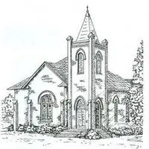

Sunday 1st February
10.30am: Morning Prayer, St Kenelm’s Clifton
10.30am: Morning Praise, St Bartholomew, Harpley
4.00pm: Candlemass, St Andrew’s, Shelsley Walsh

Sunday 8th February
9.30am: Holy Communion, Stoke Bliss Church
3.00pm: Snowdrop Songs of Praise, Rochford Church

Sunday 15th February
10.00am: Praise 4 All, St Kenelm’s Clifton
6.30pm: Evensong, St Kenelm’s, Clifton

Start of Lent
Wednesday 18th February
10.30am: Holy Communion with Ashing,
St Andrews, Shelsley Walsh

Sunday 22nd February
10.30am: Circle Service, St Bartholomew, Harpley

Sunday 1st March
10.30am: Holy Communion, St Kenelm’s Clifton
10.30am: Morning Praise, St Bartholomew, Harpley

