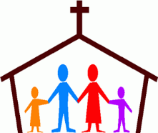

St John’s church Higham and St Anne’s church Fence
YOUNG PEOPLE’S CONFIRMATION
PARENTAL CONSENT FORM

Name of Young Person:
Address:
Telephone number:
Date of Birth:
Date and place of Baptism:

Please complete a separate form for each child if applicable

Under recent Church directives, it is a requirement that both parents give their consent for their child to be Confirmed. Please state this by completing the details below. If for any reason this is not possible, please outline any problems on this form or in a separate letter.

I confirm that both parents of (name of young person) ___________________________give their consent for *him/her/ them to be Confirmed.
*delete as appropriate

Parent 1
Name: __________________________
Signed: __________________________Date: ________________

Parent 2
Name: __________________________
Signed: __________________________Date: _________________

Contact email address: ___________________________________

PARENTS – PLEASE RETURN THIS COMPLETED FORM WITH THE YOUNG PEOPLES APPLICATION FORM TO REVEREND LESLEY BY SUNDAY 22nd FEBRUARY 2026

