Into his Courts
with Praise...



A Service of the Word

Sunday 14 December 2025
Third Sunday in Advent.

A Service of the Word for Sunday morning

This service is taken from A Service of the Word,
Morning and Evening Prayer, Night Prayer,
which is copyright (c) The Archbishops' Council, 2000,
with permitted variations.

Advent Liturgy – Advent 3.

The origins of the evergreen wreath are ancient and probably pagan, but there is a symbolism with the wreath and its five candles that is useful in retelling the Christmas story.
The circle of greenery reminds us that God is eternal, the Alpha and Omega without beginning or end, and also of the hope we have in God, of newness, renewal and eternal life.
The candles symbolise the light of God entering the world through the birth of Jesus, and the four outer candles represent a period of waiting, perhaps the four centuries between the prophet Malachi (the last book in the Old Testament) and the birth of Jesus. Whilst the light from the candles reminds us that Jesus is the light of the world that comes into the darkness of our lives it also reminds us that we are called to be a light to the world as we reflect the light of God's love and grace to others.
The centre candle is white and is called the Christ Candle. It is traditionally lit on Christmas Eve or Day where there is a service on these days.

We are a people who seek to be brought together
by the love of Christ.
Our faith teaches us that God gives us
unconditional love and forgiveness.
Acknowledging God’s free gift of grace,
we light the Candle of Love.
We light the third candle;



We thank God for his unconditional love.

INTRODUCTION

“Are you the one who is to come, or are we to wait for another?”
Matthew 11:3.

THE CONFESSION
The grace of God has dawned upon the world with healing for all. Though we have grieved him, yet he will heal us if we confess our sins in penitence and faith.

Almighty God,
I confess that I have sinned against you
in thought, word and deed;
I have not loved you with all my heart;
I have not loved my neighbours as myself.
Have mercy upon me,
cleanse me from my sins,
and help me to overcome my faults,
through Jesus Christ our Lord. Amen.

Receive God’s forgiveness
May the Father forgive us
By the death of His Son
And strengthen us
To live in the power of the Spirit
All our days. Amen.

PRAISE
O Lord, open my lips...
and my mouth shall proclaim your praise.
Give me the joy of your saving help...
and sustain me with your life-giving Spirit.

THE COLLECT
God for whom we watch and wait, you sent John the Baptist to prepare the way of your Son: give us courage to speak the truth, to hunger for justice,
and to suffer for the cause of right, with Jesus Christ our Lord.
Amen.
Suggested hymn to sing or read Hark! A thrilling voice is sounding.

THE WORD OF GOD.
Psalm 72

Give the king your judgements, O God, ♦︎
and your righteousness to the son of a king.
Then shall he judge your people righteously ♦︎
and your poor with justice.
May the mountains bring forth peace, ♦︎
and the little hills righteousness for the people.
May he defend the poor among the people, ♦︎
deliver the children of the needy and crush the oppressor.
May he live as long as the sun and moon endure, ♦︎
from one generation to another.
May he come down like rain upon the mown grass, ♦︎
like the showers that water the earth.
In his time shall righteousness flourish, ♦︎
and abundance of peace
till the moon shall be no more.

Isaiah 35:1-10

The wilderness and the dry land shall be glad,
the desert shall rejoice and blossom;
like the crocus it shall blossom abundantly,
and rejoice with joy and singing.
The glory of Lebanon shall be given to it,
the majesty of Carmel and Sharon.
They shall see the glory of the Lord,
the majesty of our God.

Strengthen the weak hands,
and make firm the feeble knees.
Say to those who are of a fearful heart,
‘Be strong, do not fear!
Here is your God.
He will come with vengeance,
with terrible recompense.
He will come and save you.’

Then the eyes of the blind shall be opened,
and the ears of the deaf unstopped;
then the lame shall leap like a deer,
and the tongue of the speechless sing for joy.
For waters shall break forth in the wilderness,
and streams in the desert;
the burning sand shall become a pool,
and the thirsty ground springs of water;
the haunt of jackals shall become a swamp,
the grass shall become reeds and rushes.

A highway shall be there,
and it shall be called the Holy Way;
the unclean shall not travel on it,
but it shall be for God’s people;
no traveller, not even fools, shall go astray.
No lion shall be there,
nor shall any ravenous beast come up on it;
they shall not be found there,
but the redeemed shall walk there.
And the ransomed of the Lord shall return,
and come to Zion with singing;
everlasting joy shall be upon their heads;
they shall obtain joy and gladness,
and sorrow and sighing shall flee away.

The Magnificat (The Song of Mary)

My soul proclaims the greatness of the Lord,
my spirit rejoices in God my Saviour; •
he has looked with favour on his lowly servant.
From this day all generations will call me blessed; •
the Almighty has done great things for me
and holy is his name.
He has mercy on those who fear him, •
from generation to generation.
He has shown strength with his arm •
and has scattered the proud in their conceit,
Casting down the mighty from their thrones •
and lifting up the lowly.
He has filled the hungry with good things •
and sent the rich away empty.
He has come to the aid of his servant Israel, •
to remember his promise of mercy,
The promise made to our ancestors, •
to Abraham and his children for ever.
Luke 1.46-55

Glory to the Father and to the Son
and to the Holy Spirit;
as it was in the beginning is now
and shall be for ever. Amen.

James 5:7-10

Be patient, therefore, beloved, until the coming of the Lord. The farmer waits for the precious crop from the earth, being patient with it until it receives the early and the late rains. You also must be patient. Strengthen your hearts, for the coming of the Lord is near. Beloved, do not grumble against one another, so that you may not be judged. See, the Judge is standing at the doors! As an example of suffering and patience, beloved, take the prophets who spoke in the name of the Lord.

Suggested hymn to sing or read Long ago prophets knew.

GOSPEL
Matthew 11:2-11

When John heard in prison what the Messiah was doing, he sent word by his disciples and said to him, ‘Are you the one who is to come, or are we to wait for another?’

Jesus answered them, ‘Go and tell John what you hear and see: the blind receive their sight, the lame walk, the lepers are cleansed, the deaf hear, the dead are raised, and the poor have good news brought to them. And blessed is anyone who takes no offence at me.’

As they went away, Jesus began to speak to the crowds about John: ‘What did you go out into the wilderness to look at? A reed shaken by the wind? What then did you go out to see? Someone dressed in soft robes? Look, those who wear soft robes are in royal palaces. What then did you go out to see? A prophet? Yes, I tell you, and more than a prophet.

This is the one about whom it is written,
“See, I am sending my messenger ahead of you,
who will prepare your way before you.”
Truly I tell you, among those born of women no one has arisen greater than John the Baptist; yet the least in the kingdom of heaven is greater than he.

REFLECTION – Are you the one to come?

This week continues the story of the relationship between Jesus and John the Baptist. Last week we saw him accusing the Sadducees and Pharisees of being a “Brood of Vipers.” Perhaps not guaranteed to make him popular with the authorities which may be why this week we find him banged up in the slammer. It seems that John’s faith may be failing. He sends his disciples to ask Jesus;

‘Are you the one who is to come, or are we to wait for another?’

We can assume that John’s disciples have been keeping him informed of what’s going on in the outside world so does his question mean that he is not impressed with Jesus’ work? Does he perhaps think that he was wrong in his prophecy? After all he probably has a good deal of thinking time just now. Maybe he had been expecting reports of revolution, demonstrations and the overthrow of the ruling Roman occupation. That was what the Messiah was supposed to do, restore the right order of the world.

Jesus’ ministry didn’t look like that in the least. He healed the sick, consorted with tax gatherers and with the poor. What kind of Messiah was that?

At the beginning of the passage we read that “When John heard in prison what the Messiah was doing” that’s when he sent to find out the truth.

Matthew refers to Jesus as “the Messiah”, letting his readers know that Jesus was the Messiah despite any doubts that John, or they, might have.

Jesus answers John, pointing out what he’d been doing;

“Go and tell John what you hear and see: the blind receive their sight, the lame walk, the lepers are cleansed, the deaf hear, the dead are raised, and the poor have good news brought to them.”
Maybe preaching hope to poor and marginalized people did not seem like much, especially if anyone had been hoping that what the Messiah would be doing was speaking truth to power and attacking authority. Challenging the rule of Pontius Pilate or Herod. No, Jesus was bringing good news to the poor and insignificant. That was something that they surely needed.

So where does this fit into the Advent season? How does it help us to prepare for the coming of the Messiah that we celebrate at Christmas? Should we as the Church of Christ be organising unrest, trying to bring rulers down? No, that isn’t our job. Our work is to carry on the ministry of Jesus Christ, the prince of peace. Our work is to bring help to those who need it, feed those who are hungry and comfort the lost and the forlorn.

Jesus uses John’s doubts to remind us of what is important. We may not share John the Baptist’s doubts about whether Jesus is the Messiah or not. But if we do believe that Jesus is the Messiah, our Redeemer and Saviour, we can examine ourselves to see how well we’re following him.

As part of our preparation for and celebration of Christmas are we quietly carrying out the work of reaching out to those who need help and hope, in the name of Jesus Christ? I want to leave you with a “prayer poem” by David Adam;

Christmas Poor

You are the caller,
You are the poor,
You are the stranger at my door.

You are the wanderer,
The unfed,
You are the homeless
With no bed.

You are the man,
Driven insane,
You are the child,
Crying in pain.

You are the other who comes to me,
If I open to another, you’re born in me.

Brian Pateman.

Suggested hymn to sing or read When I Needed a Neighbour.

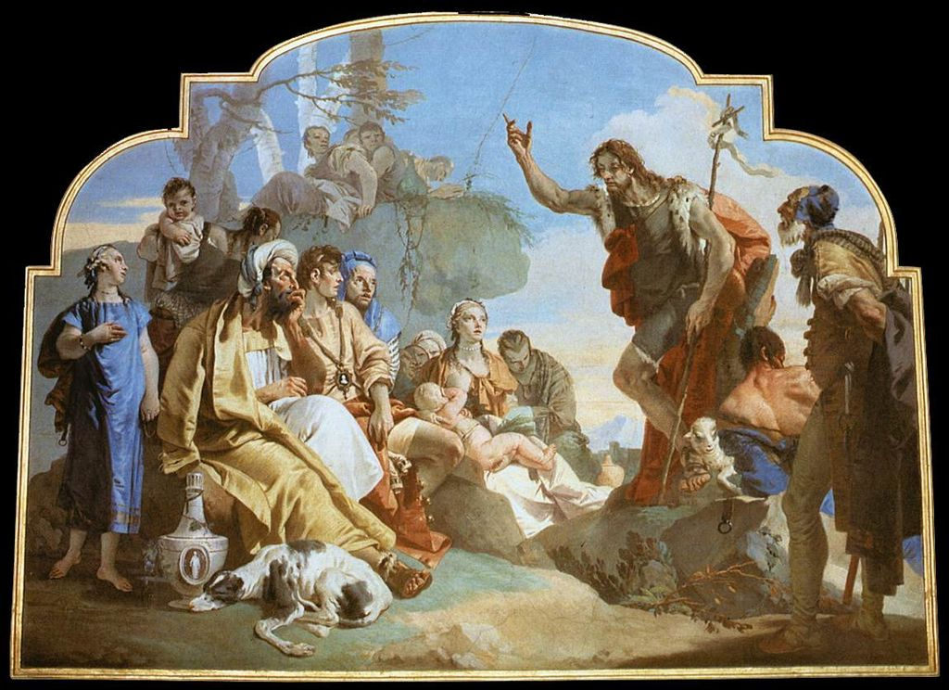

THE CREED

All I believe in God the Father,
whose loving care is the pattern for family life.
I believe in Jesus, the Son of God,
who lives in my heart through faith,
and fills me with his love.
I believe in God the Holy Spirit,
who strengthens me with power from on high.
I believe in one God;
Father, Son and Holy Spirit. Amen.

A time of quiet prayer for
• The universal Church - Bishops, synods and all leaders church
• The leaders of the nations
• The natural world and the resources of the earth

Loving God I see the news and I am afraid. Violence is spiralling out of control. I don’t know what to think or feel. The temptation to fall into hatred, or despair feels very close at hand.
Help me to remember that nothing in all creation can separate me from your love that I know in Jesus. May your perfect love for me cast out my fear and free me to discern what is mine to do amidst the chaos of this suffering world.
Amen.

Finishing with the South Calder Mission Community prayer...
Heavenly Father we thank you for the life of your Church
in this place, and in all the villages of the South Calder Mission Community;
for all who have served and worshipped you in years gone by,
for all who make up your family in our churches today, for the faith we have in common, and for the people and traditions which make each church unique.
By your Spirit, guide and equip us, that together we might find new ways to reach out to our local community, to show your love to our neighbours, and to encourage them to follow the Lord Jesus in their lives. Father, we offer ourselves to your service. In the unity of the Holy Spirit, And in the name of Jesus Christ our Lord. Amen.

and the Lord’s prayer...
Our Father, who art in heaven,
hallowed be thy name; thy kingdom come;
thy will be done; on earth as it is in heaven.
Give us this day our daily bread.
And forgive us our trespasses,
as we forgive those who trespass against us.
And lead us not into temptation;
but deliver us from evil.
For thine is the kingdom,
the power and the glory,
for ever and ever. Amen.

THE CONCLUSION

Suggested hymn to sing or read Tell out my soul.

The following prayer is said
Be with me, Lord, as I finish my prayer today.
May my lips always speak the truth;
may my eyes which have read your word
see only what is good;
and may my life as well as my worship
be always pleasing in your sight,
for the glory of your name. Amen.

And now may the Lord who brought us to birth by his Spirit,
strengthen us for the Christian life.
May the Lord who provides for all our needs
sustain us day by day.
May the Lord whose steadfast love is constant as a mother's care,
send us out to live and work for others.
And the blessing of God Almighty.
the Father, the Son, and the Holy Spirit,
be with us and remain with us always.
Amen.
So now may I go in peace to love and serve the Lord.
In the name of Christ. Amen.

Links for the hymns

Hark! A thrilling voice is sounding.

https://youtu.be/6V0J9Rgsr7A

Long ago prophets knew.

https://youtu.be/S63rjDtYRYg

When I Needed a Neighbour.

https://youtu.be/quBKGeg8_hw

Tell out my soul.

https://youtu.be/vz-FkqobgXY

