Message to Marton Friends for Sunday 14th December 2025
Dear Marton Friends
Please find attached this week's update from Rev Steve with his reflection for this week's Gospel Reading. This week we light our 3rd Advent Candle, remembering John the Baptist. He was a very interesting character - a voice crying out in the wilderness - and I've always thought of him as fearless and driven, so this week's reflection casts a new angle on his story. Thank you to Steve, Rob, Harold and Margaret, who help to bring alive our regular Bible readings and make us think!
I'm really looking forward to our Candlelit Carols tomorrow at 3pm (Sunday 14th December). Don't forget there is parking available at Church Farm, and also on the back lane behind St Mary's Barn (through the open gate with the Farm-Tec sign). We hope you'll be able to stay for some seasonal refreshments after this lovely service of traditional carols and readings, interspersed with some reflective poetry. The heating will be on, and blankets are available, but do wear layers!
We'll also be grateful to accept any last items for Christmas boxes for the I am Reusable foodbank, and our collection of money at this service will also be for this amazing charity and its ENORMOUS and ambitious outreach, especially at Christmas. I was talking to Hannah, a Big Issue vendor in York this week, and she was completely in awe of John McGall - apparently he always remembers to bring her something for her children whenever he's in York. She told me that she's praying for his health as she's very aware that he's not a well man. Not too long ago I saw a photo of him on Facebook and he was sitting in a wheelchair. We give thanks for him and his amazing work and pray for a miracle of healing for him this Christmas. This is a special push for items for Christmas, but if you're not able to contribute please don't worry - we fully intend to continue with the 'Marton and Moxby Pantry' as a collection point for donations of food items in the New Year too.
Marton Midday Prayers continues on Tuesdays, 11-12, and will probably keep going through the festive season. We plan to meet on Tuesday 23rd December in church to sing some carols around the Christmas Tree - I'll confirm this next week! Otherwise we are tending to meet in a house for Tuesday prayers during these colder months, so please let me know if you would like to join us and I'll confirm the time and venue.
I've just received the York Minster 'Parish Pass' for 2026. This allows any members of churches within the Diocese of York to visit York Minster (our 'mother church') free of charge. As an adult ticket costs £20, this is worth remembering! I have printed out and laminated some passes - please just let me know if you would like to borrow them at any point. I am meant to keep tabs on these paper copies rather than emailing the pass to you for further printing - and I'm afraid this does only give free entry to you as a parishioner, not to your visitors from elsewhere. (You are, however, allowed to take up to 4 children aged under 17 in with you for free, as if you were a paying adult). There is no need to book for your visit but it is always recommended that you check on the website before visiting in case there are any events, services or restrictions. Tower trips are not included (but can be purchased on the day for £6). Do let me know if you'd like to borrow a pass!
I'm delighted to confirm that Marton Church and churchyard remain open every day to visitors and there is no charge at all :) As you know, I love reading the comments in the Visitor's Book, and I'm planning to circulate a collection of 2025 highlights before the end of the year. We give thanks for this beautiful special place and pray for all who will visit during Christmas and New Year. You may notice some planters on each side of the outside door - thank you to Clive for donating these - we look forward to signs of spring before too long!
As we draw closer to Christmas, finish decorating our churches and our own houses, and get ready to sing carols, the story of the nativity - a baby born in a stable - can continue to surprise and fill us with wonder, however many times we have heard it before! Despite countless pictures and paintings, Christmas card designers still keep trying to put words into pictures...
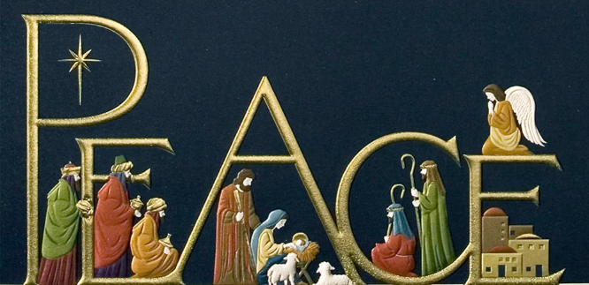
This week's prayer from Ruth Burgess's collection, is based on a blessing by Jan Sutch Pickard (a poet, storyteller and creator of church services) who now lives on Mull, having served as a Warden for the Iona Community and a peace monitor in Palestine and Israel. We are invited to be blessed by reflecting on all the characters and scenes in the nativity...
May the blessing of the manger -
God's creation all around;
the blessing of the shepherds -
God's people with feet on the ground;
the blessing of the kings -
travellers, seekers of truth and promise;
the blessing of the angels -
good news for all and peace for the world;
be with you
now and forever.
Amen.
Don't forget, the Carol Service tomorrow will be our last Sunday service in Marton Church until the New Year - but you are always welcome to visit at any time to enjoy a little peace & quiet.
Every blessing
Caroline

