
Rector & Pioneer Priest, Rev Nicki Farr
01840 219376 / 07587 001320

A bumper issue - December 2025
& January 2026
Dear Friends
As the days grow shorter and December is upon us, we move into the season of Advent.
Advent is the 4 weeks before Christmas and is marked by people counting down the days to Christmas by opening little windows on an Advent calendar, lighting an Advent candle and making preparation for the festivities. However, alongside this preparation, there is a time of waiting. Waiting for light in the darkness, for peace and for the anticipation of the coming Christ. The 4 candles on the Advent wreath
represent hope, peace, joy and love. As they are lit week by week we pray for an increase in these virtues in our world and our lives. Finally, the central candle is lit reminding us that Jesus came as a light into a dark world.
Then comes Christmas bursting forth in celebration. The waiting is over, and God is with us - Emmanuel. Jesus born in a humble setting, God quietly taking human form, a miracle where divine love entered history, not in power and wealth but in vulnerability and grace. Christmas is not just a day but a season that reminds us of God’s gift of love to humanity. As we look at the gifts we give and receive, let us
remember the gift of Christ given to each of us with an invitation to receive.
Finally comes Epiphany, celebrated on 6th January. This marks the visit of the magi, the wise travellers who followed a star to find the newborn Christ. As the magi travelled a long and challenging journey so too do we travel through life with its joys and challenges. As they saw the Christ-Child, they recognised something special, we too can recognise Jesus as someone special when we seek him and
allow his love to flow through us to others through acts of justice, mercy and love.
December and January take us on a journey from waiting, to receiving, to recognising and reminds us that light still enters the darkness, that hope still stirs our hearts, and that even in a world that feels weary, love continues to arrive. It offers a timeless message: the light has come and darkness has not overcome it.
May God bless you this Christmas with his gifts of hope, peace, joy and love.
Revd Nicki
_________________________________________________________________

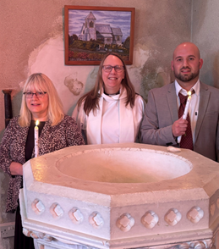
Last month’s records…

We are delighted that mother and son
Karen and Jamie, were baptised at
St John’s Church, on 23rd November
in a very special, gentle and personal service.

If you have Children or Grandchildren and
might be interested in Baptism, please
contact Rev Nicki for a chat; adults of any
age are also very welcome to begin a walk
with Jesus through Baptism; again, contact Rev Nicki to find out more.

In Sad News… we have given thanks for the life of and said, ‘Farewell’ to Mr Malcolm Warman, a long-time member of St Teath Church; warden, choir member and friend. We keep Malcolm’s family and friends in our thoughts and prayers.

It is important to the Ministry Team to be aware when people in our parishes are unwell, have suffered a bereavement or other situation. YOU are the eyes and ears in our communities! Please do pass on details when you hear of them – tho’ please ask for permission from the person / family before giving us a ‘phone number. Thank you
.
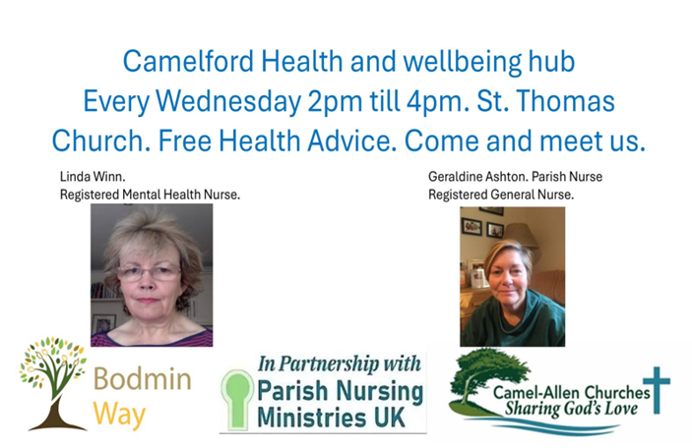


Coffee at No.10, Mary & John’s home, will run every second Friday, so 12th December & 9th January, .10 – 12noon.

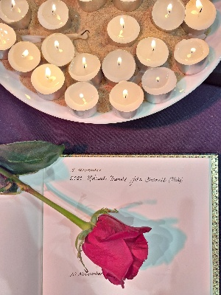
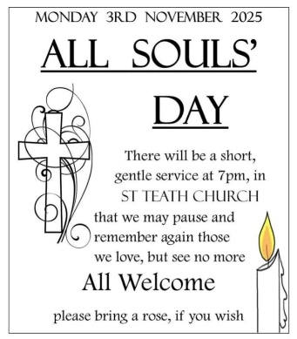
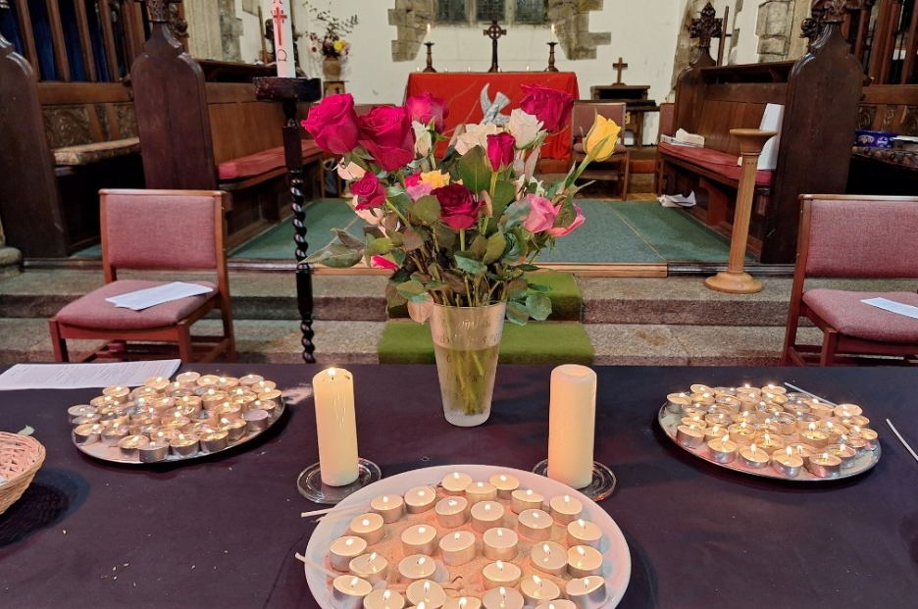

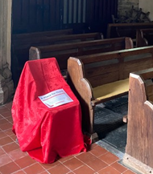
The Red Chair Project

You will notice over the next couple of weeks, a red chair in each of our churches.

This is part of a Mothers’ Union project, supporting a charity called, ‘Restored’. The empty chair serves as a reminder of the lives lost to gender-based violence; it calls us to pray for the situations in which lives are damaged and lost at the hands of one they should be able to love and trust
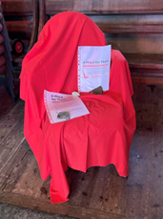
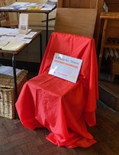
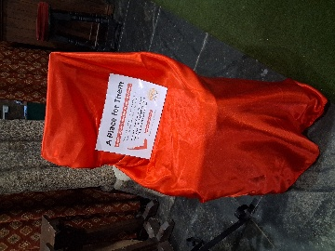

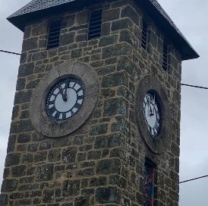
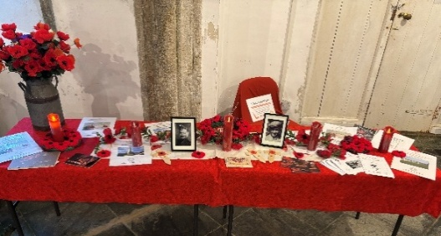

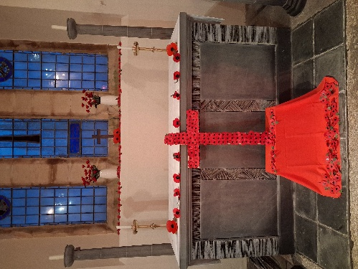



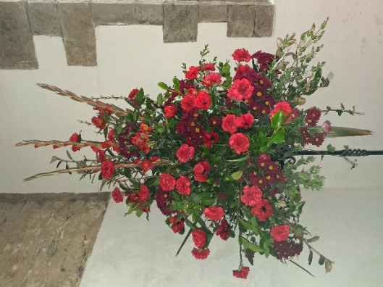
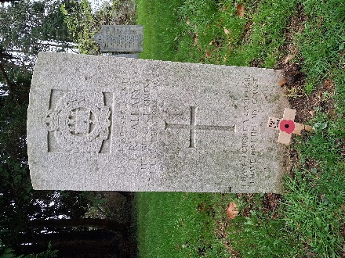
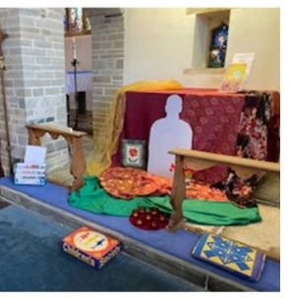

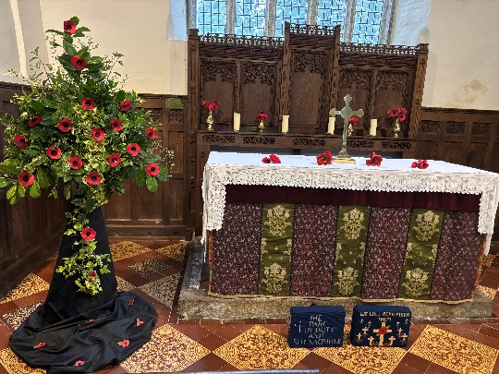

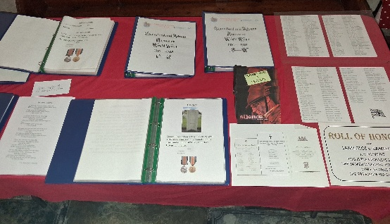


December 4th and 11th
with a Christmas Holiday
restarting on 8th January
Donations of children’s clothing to The Grace Project can be left in the containers in St John’s Delabole, St Teath and St Thomas’ Camelford Churches. A huge ‘Thank You’ to all who have contributed items which have been gratefully received by TGP and passed on to others.
Details of how to receive items are available on the postcards in each of the above churches, or on The Grace Project Facebook page. They visit BBTT on the fourth Thursday of the month.
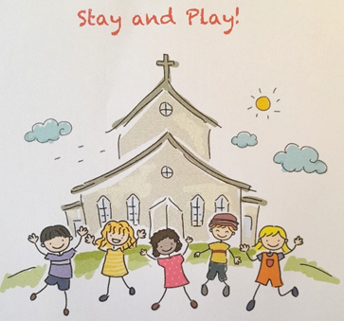

New for St Teath,
Stay and Play!

Monday afternoons
3.30pm in St Teath Church.

December 8th
January 12th & 26th

All welcome!

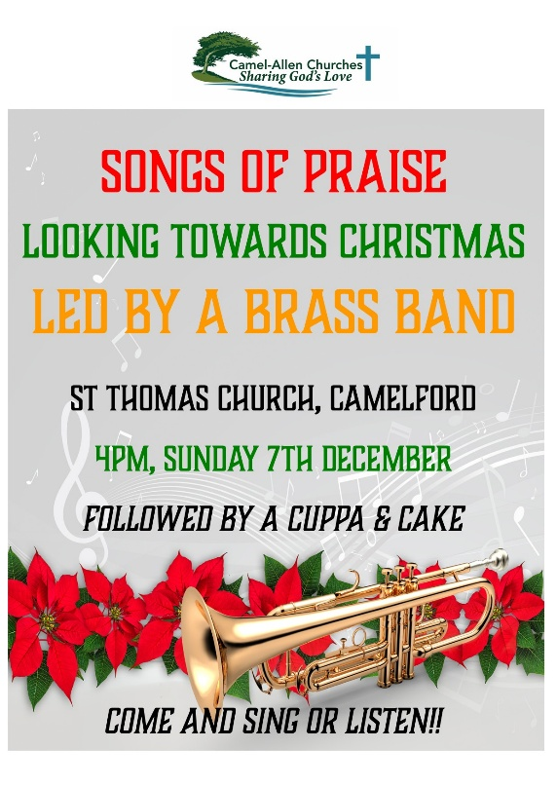




November Sunday 30th Advent Sunday
The countdown to the celebration of our Saviour’s birth begins, do join us for the benefice services
10.30am – Holy Communion for all – St Julitta
3pm – Advent Carol Service – St Adwena

December & January

Delabole Prayer Walk, a small group meet 9am each Tuesday, and walk the village for an hour, stopping and praying God’s blessing over the people and activities. Please contact Nicki for each week’s start place.

Camelford Prayer Walk, starting at St Thomas Church, 3pm on the first Sunday of each month, followed by the 4pm Songs of Praise

Morning prayer is said at 9am each Wednesday at St Adwena
and Friday at Lanteglos

Compline is said at 6pm, at St Adwena each Friday and at St Julitta at 7pm on the second Thursday
December’s Services

Friday 5th 8.30am - St Julitta – Breakfast Communion [BCP]

Thursday 4th 7pm – Blue Christmas – a gentle service for those
for whom Christmas hurts. St Thomas, C/ford

Sunday 7th Advent 2
11am – A Celebration of Holy Communion - St Teath
11am – Village Christingle at Delabole Methodist Chapel
4pm - Christmas Songs of Praise, led by a brass band,
in St Thomas; with a cuppa & cake

Sunday 14th Advent 3
9.30am – Morning Worship – St John’s, Delabole
11am – Morning Worship - St Teath
11.15am - Holy Communion [BCP] - St Adwena, Advent
4pm – Christingle - St Teath
5pm – Carols around the bonfire – St Julitta

Monday 15th 6pm – Carol Service – St Adwena

Sunday 21st Advent 4
9.30am – Holy Communion – St Thomas
11am – Choral Communion – St Teath
3pm – Carol Service – in the White Hart, St Teath
6pm – Delabole Village Carol Service – St John’s

For Christmas Eve and Christmas Day – see poster opposite

Sunday 28th The Holy Innocents
10.30am – Holy Communion for all – St Teath

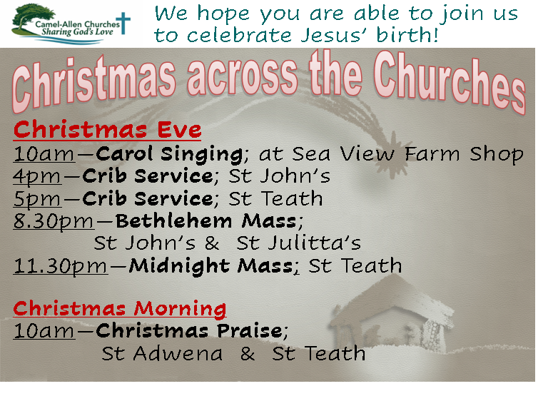

BIBLE READINGS for Sunday Services [not all used at each service]


30th Nov - Isaiah 2: 1-5; Romans 13: 11-end; Matthew 24: 36-44
7th Dec – Isaiah 11: 1 – 10; Romans 15; 4 – 13: Matthew 3: 1 – 12
14th Dec – Isaiah 35: 1 – 10; James 5: 7 – 10; Matthew 11: 2 – 11
21st Dec – Isaiah 7: 10 – 16; Romans 1; 1 – 7; Matthew 1; 18 – end
28th Dec – Jeremiah 31: 15 - 17; 1 Cor 1: 26 - 29; Matthew 2: 13 – 18
4th Jan – Isaiah 60: 1 – 6; Ephesians 3: 1 - 12; Matthew 2: 1 - 12
11th Jan – Isaiah 42: 1 - 9; Acts 10: 34 – 43; Matthew 3: 13 - end
18th Jan – Isaiah 49: 1 - 7; Corinthians 1: 1 – 9; John 1: 29 -v 42
25th Jan – Isaiah 9: 1 - 4; 1 Corinthians 1: 10 - 18; Matthew 4: 12 - 23
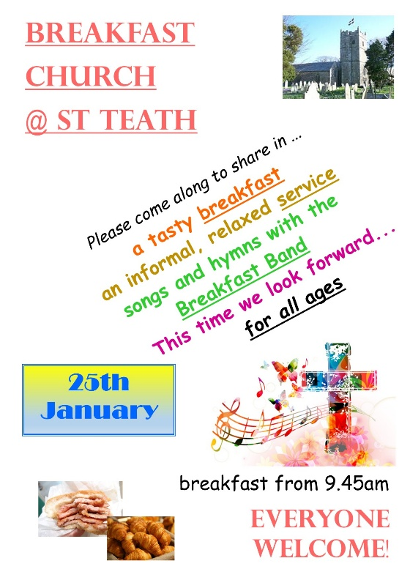
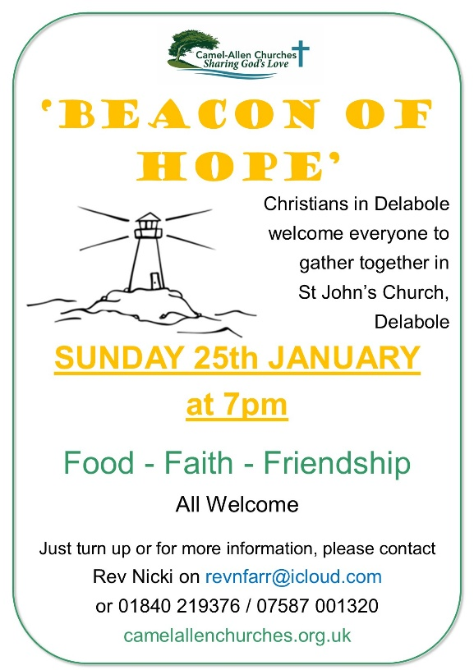
January’s Services

Friday 2nd 8.30am - St Julitta – Breakfast Communion [BCP]

Sunday 4th Epiphany
11am – A Celebration of Holy Communion - St Teath
4pm - Songs of Praise - in St Thomas;
with a cuppa & cake

Sunday 11th Baptism of Christ
9.30am – Morning Worship – St John’s, Delabole
11am – Morning Worship - St Teath
11.15am - Holy Communion [BCP] - St Adwena, Advent
4pm - Epiphany Songs of Praise - St Julitta

Sunday 18th 2nd of Epiphany
9.30am – Holy Communion – St Thomas
11am – Choral Communion – St Teath
11am – Service for the Week of Prayer
for Christian Unity – Delabole Chapel

Sunday 25th 3rd of Epiphany
9.30am – Holy Communion – St John’s
10am – Breakfast Church - St Teath
11.15am - Holy Communion [BCP] - St Julitta
7pm – Beacon of Hope – St John’s

Thursday 29th 7pm – A gentle service of Holy Communion and Healing
at St Thomas, Camelford

Congratulations
to Mrs Kerstin Lewis, who has been presented with the Prayer Book Society Kilminster Award.
More details and a photo in the next letter

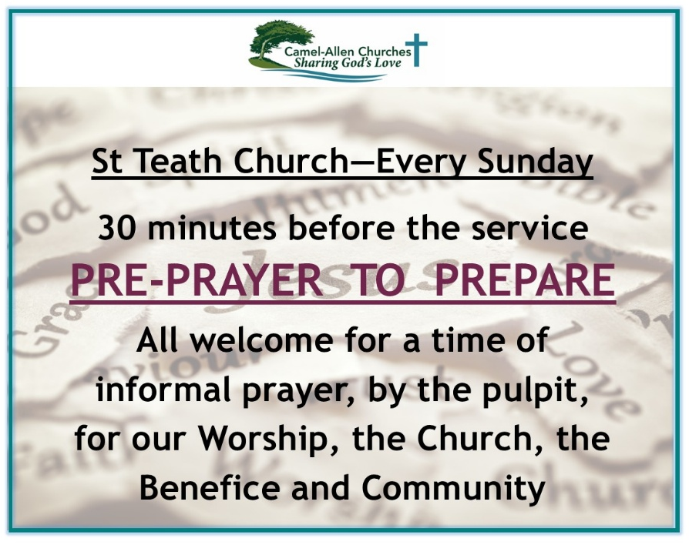


Rev Jeffrey Terry writes, thanking us for the gift given when he left us to take up his new position.
‘On leaving Camel-Allen, with some reluctance, I was kindly given a generous cash gift which I decided to put towards a weekend course on “Photography & Spirituality, Photography with Deeper Vision” at Sarum College in the Cathedral Close at Salisbury.
‘To capture the essence of the course: there is a risk, particularly with digital photography, that one is exercising shallow, not deep, vision when freely clicking the shutter. It is only by mindfully “receiving” not “taking” the vision seen through the lens, by absorbing oneself in what the image has to offer on a spiritual level, that one can see more deeply into what God and his created reality have to say to us in any particular place and moment.

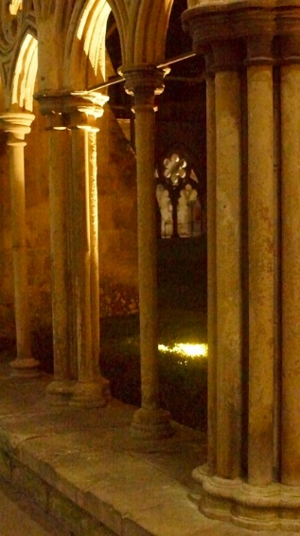
‘Approached in this way, photography can become a form of Christian meditation both in capturing the vision and in theologically reflecting upon it subsequently.
‘We were afforded an opportunity to take photographs in Salisbury Cathedral and, at night, in the Cathedral Cloisters and Close.’



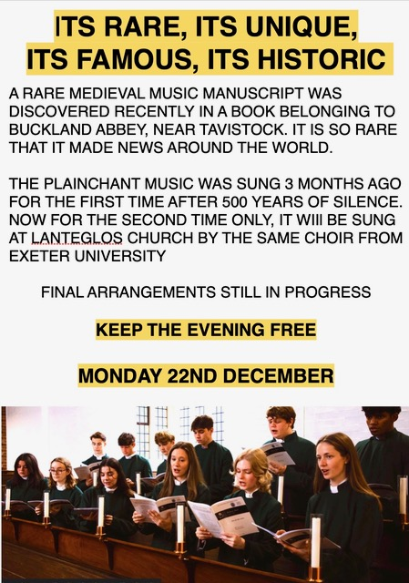

Keep up to date via the Camel-Allen Churches Facebook page,
and our website https://www.camelallenchurches.org.uk

We are here to assist; so please keep these contacts handy….

Ministry Team

Rev Nicki Farr revnfarr@icloud.com 01840 219376
07587 001320

Rev Geraldine Ashton parishnurse@bodminway.org 07957 609085

Claire Salzmann salzmannclaire@gmail.com 01840 212713
Church Wardens

St Adwena, Advent
William Gore thegores@hotmail.co.uk 01840 212800
Kerstin Lewis kerstinlewis@hotmail.com 01840 211161

St John’s, Delabole
Lesley George george1359@btinternet.com 01840 770462

St Julitta, Lanteglos & St Thomas, Camelford
Vacancy please contact a member of the ministry team

St Teath
Gareth Stubberfield stubbery2@hotmail.co.uk 07498 580454



Safeguarding

The Camel-Allen Churches have all adopted the House of Bishops ‘Promoting a Safer Church’ Safeguarding Policy Statement.

- Our commitments are:
- Promoting a safer environment and culture
- Safely recruiting and supporting all those with any responsibility related to children and vulnerable adults
- Responding promptly to every safeguarding concern or allegation
- Caring pastorally for victims/survivors of abuse or other affected persons
- Caring pastorally for those who are the subject of concerns/allegations of abuse and other affected persons
- Responding to those that may pose a present risk

If you are concerned that someone you know is at risk of, or is being abused, or presents a risk to others, please seek advice from a Safeguarding Advisor or if necessary, report the matter to the Local Authority Social Care Services or the Police without delay.

Ensuring that children and young people as well as adults are kept safe whilst in our care is an integral part of our church life. If you have any concerns about safeguarding please contact:

Revd Nicola Farr, Rector
01840 219376/07587 001320 email:revnfarr@icloud.com

or Church Safeguarding Officers:

St Julitta’s Lanteglos and St Thomas’ Camelford
Kerstin Lewis tel 01840 211161 email: kerstinlewis@hotmail.com
Advent
Kerstin Lewis tel 01840 211161 email: kerstinlewis@hotmail.com
St Teath
Julie Vollum 07835 263727
St Johns Delabole
Lesley George george1359@btinternet.com

Truro Diocese Safeguarding Advisor
Andy Earl tel 01872 274351 ext 231
email: safeguardingconcerns@truro.anglican.org

Assistant Diocesan Safeguarding Officer
Jo Pomery tel 01872 360037
email: safeguardingconcerns@truro.anglican.org

In an emergency situation please contact:
Local Authority Children’s Social Care: 0300 123 1116
Local Authority Adult’s Social Care: 0300 1234131
Police: 101 or 999
safespacesenglandandwales.org.uk
firstlight.org.uk

