Into his Courts
with Praise...



A Service of the Word

Sunday 28 December 2025
First Sunday of Christmas.

A Service of the Word for Sunday morning

This service is taken from A Service of the Word,
Morning and Evening Prayer, Night Prayer,
which is copyright (c) The Archbishops' Council, 2000,
with permitted variations.

INTRODUCTION

“Because he himself was tested by what he suffered, he is able to help those who are being tested.”
Hebrews 2:18.
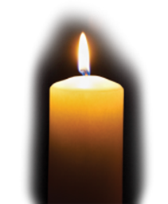

THE CONFESSION
The grace of God has dawned upon the world with healing for all. Though we have grieved him, yet he will heal us if we confess our sins in penitence and faith.

Almighty God,
I confess that I have sinned against you
in thought, word and deed;
I have not loved you with all my heart;
I have not loved my neighbours as myself.
Have mercy upon me,
cleanse me from my sins,
and help me to overcome my faults,
through Jesus Christ our Lord. Amen.

Receive God’s forgiveness
May the Father forgive us
By the death of His Son
And strengthen us
To live in the power of the Spirit
All our days. Amen.

PRAISE
O Lord, open my lips...
and my mouth shall proclaim your praise.
Give me the joy of your saving help...
and sustain me with your life-giving Spirit.

THE COLLECT
God in Trinity, eternal unity of perfect love:
gather the nations to be one family, and draw us into your holy life
through the birth of Emmanuel, our Lord Jesus Christ.
Amen.

Suggested hymn to sing or read Good Christians all rejoice.

THE WORD OF GOD.
Psalm 148

1 Alleluia.
Praise the Lord from the heavens; ♦︎
praise him in the heights.
2 Praise him, all you his angels; ♦︎
praise him, all his host.
3 Praise him, sun and moon; ♦︎
praise him, all you stars of light.
4 Praise him, heaven of heavens, ♦︎
and you waters above the heavens.
5 Let them praise the name of the Lord, ♦︎
for he commanded and they were created.
6 He made them fast for ever and ever; ♦︎
he gave them a law which shall not pass away.
7 Praise the Lord from the earth, ♦︎
you sea monsters and all deeps;
8 Fire and hail, snow and mist, ♦︎
tempestuous wind, fulfilling his word;
9 Mountains and all hills, ♦︎
fruit trees and all cedars;
10 Wild beasts and all cattle, ♦︎
creeping things and birds on the wing;
11 Kings of the earth and all peoples, ♦︎
princes and all rulers of the world;
12 Young men and women,
old and young together; ♦︎
let them praise the name of the Lord.
13 For his name only is exalted, ♦︎
his splendour above earth and heaven.
14 He has raised up the horn of his people
and praise for all his faithful servants, ♦︎
the children of Israel, a people who are near him.
Alleluia.

Isaiah 63:7–9

I will recount the gracious deeds of the Lord,
the praiseworthy acts of the Lord,
because of all that the Lord has done for us,
and the great favour to the house of Israel
that he has shown them according to his mercy,
according to the abundance of his steadfast love.
For he said, ‘Surely they are my people,
children who will not deal falsely’;
and he became their saviour
in all their distress.
It was no messenger or angel
but his presence that saved them;
in his love and in his pity he redeemed them;
he lifted them up and carried them all the days of old.

Hebrews 2:10–end

It was fitting that God, for whom and through whom all things exist, in bringing many children to glory, should make the pioneer of their salvation perfect through sufferings. For the one who sanctifies and those who are sanctified all have one Father. For this reason Jesus is not ashamed to call them brothers and sisters, saying,
‘I will proclaim your name to my brothers and sisters,
in the midst of the congregation I will praise you.’
And again,
‘I will put my trust in him.’
And again,
‘Here am I and the children whom God has given me.’

Since, therefore, the children share flesh and blood, he himself likewise shared the same things, so that through death he might destroy the one who has the power of death, that is, the devil, and free those who all their lives were held in slavery by the fear of death. For it is clear that he did not come to help angels, but the descendants of Abraham. Therefore he had to become like his brothers and sisters in every respect, so that he might be a merciful and faithful high priest in the service of God, to make a sacrifice of atonement for the sins of the people. Because he himself was tested by what he suffered, he is able to help those who are being tested.

Suggested hymn to sing or read Just as I am, without one plea.

GOSPEL
Matthew 2:13–end

Now after they had left, an angel of the Lord appeared to Joseph in a dream and said, ‘Get up, take the child and his mother, and flee to Egypt, and remain there until I tell you; for Herod is about to search for the child, to destroy him.’ Then Joseph got up, took the child and his mother by night, and went to Egypt, and remained there until the death of Herod. This was to fulfil what had been spoken by the Lord through the prophet, ‘Out of Egypt I have called my son.’

When Herod saw that he had been tricked by the wise men, he was infuriated, and he sent and killed all the children in and around Bethlehem who were two years old or under, according to the time that he had learned from the wise men. Then was fulfilled what had been spoken through the prophet Jeremiah:
‘A voice was heard in Ramah,
wailing and loud lamentation,
Rachel weeping for her children;
she refused to be consoled, because they are no more.’

When Herod died, an angel of the Lord suddenly appeared in a dream to Joseph in Egypt and said, ‘Get up, take the child and his mother, and go to the land of Israel, for those who were seeking the child’s life are dead.’ Then Joseph got up, took the child and his mother, and went to the land of Israel. But when he heard that Archelaus was ruling over Judea in place of his father Herod, he was afraid to go there. And after being warned in a dream, he went away to the district of Galilee. There he made his home in a town called Nazareth, so that what had been spoken through the prophets might be fulfilled, ‘He will be called a Nazorean.’

REFLECTION – .

It’s interesting that the lectionary readings seem to have slipped out of gear this week. Matthew is telling us that the wise men have tricked Herod. But wait a minute – they haven’t arrived yet! If we want the story of the Magi and their journey we need to wait until next week.

Leaving aside the vagaries of the lectionary compilers, the Gospel story for today is a significant one with resonance for us in our present day world.

At the heart of the story is Joseph, prompted by an angelic appearance, taking his family out of Israel and into Egypt. But surely isn’t that similar to another journey, or return trip?

Matthew’s Gospel includes a number of parallels between Jesus and Moses. This Gospel reading includes several such parallels:

Jesus’ flight to Egypt to escape Herod draws a parallel with Moses being hidden in the bulrushes to escape Pharaoh, He was murdering infant Jewish boys to lessen the danger of a Jewish takeover (Exodus 1 – 2:10).

The murder of baby boys by Herod recalls that wiping out of baby boys by Pharaoh. Jesus and Moses both escaped the murderous plans of their respective rulers.

Jesus’ return to Israel reminds us of Moses’ acceptance into Pharaoh’s palace as an infant.

There are, of course, differences as well as similarities. Jesus was not Moses – their stories do have points in common and Matthew’s audience would recognize them.

First, let’s consider the things which God does.
As part of Moses’ story God killed the firstborn sons of the Egyptians when Pharaoh refused to free the Israelites. Moses then led the exodus of the Israelites, leading to the destruction of the Egyptian army in the Red Sea.

The God of the Old Testament was a God of retribution, a God of power. In Matthew’s Gospel God is a more gentle force. He doesn’t kill Herod (who seems to die later of natural causes as far as we are aware) nor the soldiers sent to carry out his orders.

There is a tendency among Christians to expect God to favour the innocent over evildoers. What happens in this narrative raises the question whether the God who allows such things to happen is just at all.

If Joseph was warned by the angel and removed the baby Jesus to safety in Egypt, was Jesus the only baby in Judea to be spared through God’s direct intervention?

Matthew doesn’t raise the issue of justice, at least not directly. Instead he goes back to the Old Testament quoting Jeremiah. The weeping Rachel in Jeremiah refers to Rachel as a matriarch of Israel, weeping for the children of Israel, lost because of the imperial conquest by Babylon. Matthew presents his readers with an example of two colonial powers destroying the lives of innocent people in Israel: the Babylonian kingdom and the Roman vassal kingdom of Herod.

The cry of Rachel is not just a sound of wailing. It is a cry for justice.

At this point I want to take a moment to look at the flight into Egypt in the context of our time and the stories we see on our television news. Not a day goes by without we are reminded that tens of thousands of people are moving, displaced from their homes and settled lives by war, famine, persecution, genocide, and injustice. We call them “refugees”.

Jesus and his family fit that description too. Would Jesus perhaps be in one of those migrant camps in Northern France or one of the unsafe dinghies heading for a hoped-for security?

I am certain he would not be on a protest line suggesting that the displaced be sent back to danger.

Looking forward to the five major discourses of Jesus in Matthew we find the Parable of the Sheep and Goats (Matthew 25:31–46).
Jesus separates the sheep from the goats, the righteous from the unrighteous.

The one test that Jesus employs to assure the good will find eternal life is how they treated the disadvantaged.

Then the righteous will answer him, ‘Lord, when was it that we saw you hungry and gave you food or thirsty and gave you something to drink? And when was it that we saw you a stranger and welcomed you or naked and gave you clothing? And when was it that we saw you sick or in prison and visited you?’ And the king will answer them, ‘Truly I tell you, just as you did it to one of the least of these brothers and sisters of mine, you did it to me.’

Matthew 25:37-40.

Perhaps we need to look at how our society measures up to Jesus’ criterion?

Brian Pateman.

Suggested hymn to sing or read Christ is the World’s light.

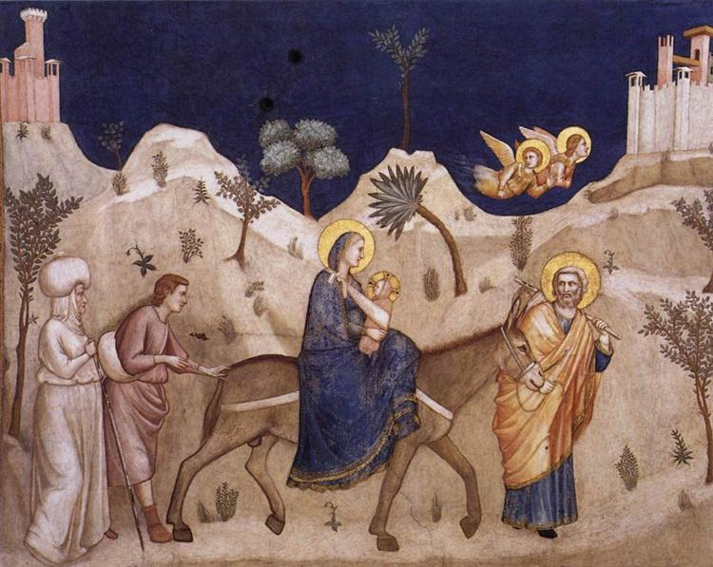

THE CREED

All I believe in God the Father,
whose loving care is the pattern for family life.
I believe in Jesus, the Son of God,
who lives in my heart through faith,
and fills me with his love.
I believe in God the Holy Spirit,
who strengthens me with power from on high.
I believe in one God;
Father, Son and Holy Spirit. Amen.

A time of quiet prayer for
• The universal Church - Bishops, synods and all leaders church
• The leaders of the nations
• The natural world and the resources of the earth

Loving God I see the news and I am afraid. Violence is spiralling out of control. I don’t know what to think or feel. The temptation to fall into hatred, or despair feels very close at hand.
Help me to remember that nothing in all creation can separate me from your love that I know in Jesus. May your perfect love for me cast out my fear and free me to discern what is mine to do amidst the chaos of this suffering world.
Amen.

Finishing with the South Calder Mission Community prayer...
Heavenly Father we thank you for the life of your Church
in this place, and in all the villages of the South Calder Mission Community;
for all who have served and worshipped you in years gone by,
for all who make up your family in our churches today, for the faith we have in common, and for the people and traditions which make each church unique.
By your Spirit, guide and equip us, that together we might find new ways to reach out to our local community, to show your love to our neighbours, and to encourage them to follow the Lord Jesus in their lives. Father, we offer ourselves to your service. In the unity of the Holy Spirit, And in the name of Jesus Christ our Lord. Amen.

and the Lord’s prayer...
Our Father, who art in heaven,
hallowed be thy name; thy kingdom come;
thy will be done; on earth as it is in heaven.
Give us this day our daily bread.
And forgive us our trespasses,
as we forgive those who trespass against us.
And lead us not into temptation;
but deliver us from evil.
For thine is the kingdom,
the power and the glory,
for ever and ever. Amen.

THE CONCLUSION

Suggested hymn to sing or read Lord, the light of your love is shining.

The following prayer is said
Be with me, Lord, as I finish my prayer today.
May my lips always speak the truth;
may my eyes which have read your word
see only what is good;
and may my life as well as my worship
be always pleasing in your sight,
for the glory of your name. Amen.

And now may the Lord who brought us to birth by his Spirit,
strengthen us for the Christian life.
May the Lord who provides for all our needs
sustain us day by day.
May the Lord whose steadfast love is constant as a mother's care,
send us out to live and work for others.
And the blessing of God Almighty.
the Father, the Son, and the Holy Spirit,
be with us and remain with us always.
Amen.
So now may I go in peace to love and serve the Lord.
In the name of Christ. Amen.

Links for the hymns

Good Christians all rejoice.

https://youtu.be/RowIQiL0jTU

Just as I am, without one plea.

https://youtu.be/enJ8JzW_A48

Christ is the world’s light.

https://youtu.be/fRfvKVbt-QQ

Lord, the light of your love is shining.

https://youtu.be/op17raOTXbk

