Date | Time | Service | Church

Wednesday 3rd | 08.30  10.00 | Morning Prayer  Holy Communion | Zoom  Bude Haven

Sunday 7th  2nd Sunday in Advent | 09.30  10.00  18.00 | Holy Communion  All Age Worship  Evening Prayer | Bude Haven  Week St.Mary
Wednesday 10th | 08.30  10.00 | Morning Prayer  Holy Communion | Zoom  Widemouth Bay

Friday 12th | 15.00 | Carol Service | Week St. Mary
Sunday 14th    3rd Sunday in Advent | 09.30  09.30  11.15  15.00  17.00  18.00 | Holy Communion  Morning Prayer  Holy Communion  Nine Lessons & Carols  Christingle  Evening Prayer | Marhamchurch  Poundstock  Whitstone  Poundstock  Marhamchurch  Week St. Mary
Wednesday 17th | 08.30  10.00 | Morning Prayer  Holy Communion | Zoom  Bude Haven

Sunday 21st  4th Sunday in Advent | 09.30  09.30  11.15  16.00 | Holy Communion  Morning Prayer  Holy Communion  Nine Lessons & Carols | Bude Haven  Marhamchurch  Week St. Mary  Bude Haven

Wednesday 24th  Christmas Eve  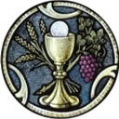 | 15.30  17.00  21.30  21.30  23.15 | Crib Service  Crib Service  Holy Communion  Holy Communion  Holy Communion | Bude Haven  Week St.Mary  Marhamchurch  Whitstone  Bude Haven
Thursday 25th  Christmas Day | 09.00  10.15 | Holy Communion  Holy Communion | Poundstock  Week St. Mary
Sunday 28th  Holy Innocents | 09.30  09.30  09.30  10.00  11.15 | Holy Communion  Holy Communion  Morning Prayer  Morning Prayer  Holy Communion | Marhamchurch  Poundstock  Whitstone  Week St. Mary  Bude Haven
Wednesday  31st | 08.30  10.00 | Morning Prayer  Holy Communion | Zoom  Widemouth Bay
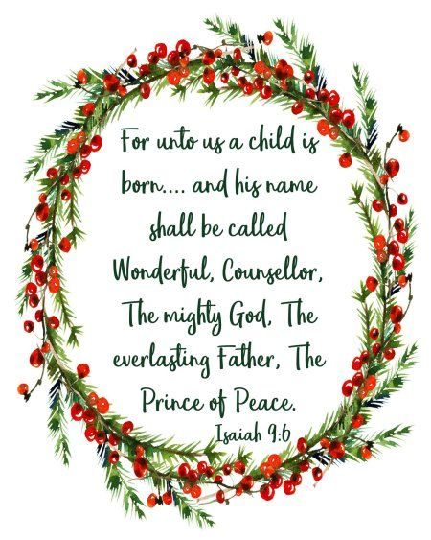
Wishing everyone a Peaceful
&
Joyful Christmas
PWW
Pentecost

