Jesse Tree
The Jesse tree holds a special meaning for Christians during the Advent season. It serves as a reminder of God’s faithfulness throughout history and his promise of salvation through the lineage of King David. As the tree is gradually decorated, it helps to build anticipation for the celebration of Christmas, marking the arrival of Jesus and the fulfilment of God’s promises. Maranatha, Come Lord Jesus.

8 December | 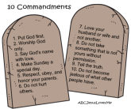 | The symbol of the stone tablets is a reminder of God’s laws given to protect and guide the people to become a great nation.
9 December |  | The symbol of the ram’s horn trumpet is a reminder of God’s promise to give the people the land and to help them in difficult situations.
10 December |  | The symbol of the sheaf of corn is a reminder of God’s care for those in need, and for us to be kind and welcoming to those who are from other countries.
11 December |  | The symbol of the gold lampstand represents the priest’s role to never let God’s light goes out.
12 December |  | The symbol of the shoot from Jesse’s tree is a reminder that God’s promised King will descend from Jesse through his son, David.
13 December |  | The symbol of the crown is a reminder that God’s promised King will be a Good Shepherd, just like his ancestor King David.
14 December | 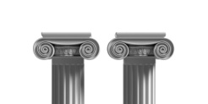 | The symbol of the temple pillars represents the presence of God among his people. The temple curtain would be split in two when God’s Great High Priest, the promised King, overcame death so that people were no longer separated from God.

