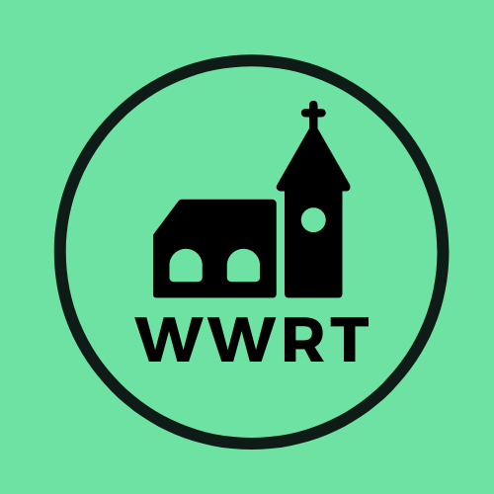
CHURCH SERVICES IN THE LOWER TEME VALLEY
DECEMBER 2025

Sunday 7th December
Advent 2
9.00am BCP HC, St Leonard, Cotheridge
10.30am All Age Service, St Mary Magdalene, Broadwas

Sunday 14th December
Advent 3
12.00 am Farmers Market, Talbot
3.00 pm Carols, Knightwick Chapel

Sunday 21st December
Advent 4
4.00pm Carol and Crib Service, St Mary Magdalene, Broadwas

Wednesday 24th December
Christmas Eve
11.00 pm Holy Communion, St Mary Magdalene, Broadwas

Thursday 25th December
Christmas Day
9.00 am Holy Communion, St Leonard, Cotheridge

Sunday 28th December
Christmas 1
10.30am Benefice CW HC, St Thomas, Crown East

In December there will be Holy Communion at Heaton House, Martley on the 2nd and 4th Wednesday at 10.15am and on the 1st and 3rd Wednesday via our YouTube channel -wwrtlive1.
All services and timings are subject to review and amendment – please check the website for updates: www.achurchnearyou.com

All services and timings are subject to review and amendment in accordance with Covid lockdown easing – please contact the Rectory or check the website for updates.
01886 888664
www.achurchnearyou.com

